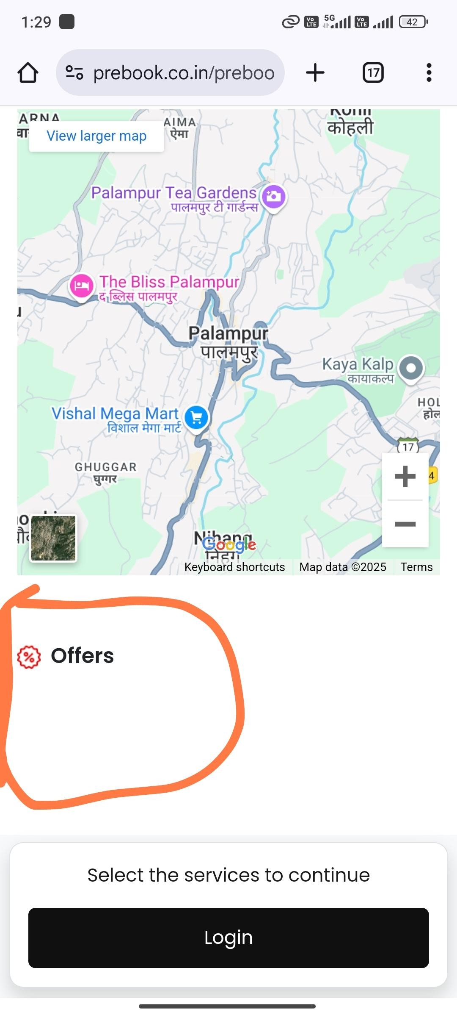

# webpage

As marked non existing clients ko offers ka button nahi dikhaai dena chaiye …. Ye tabhi dikhaai degaa jab approved to all waala offer ho.=>Done

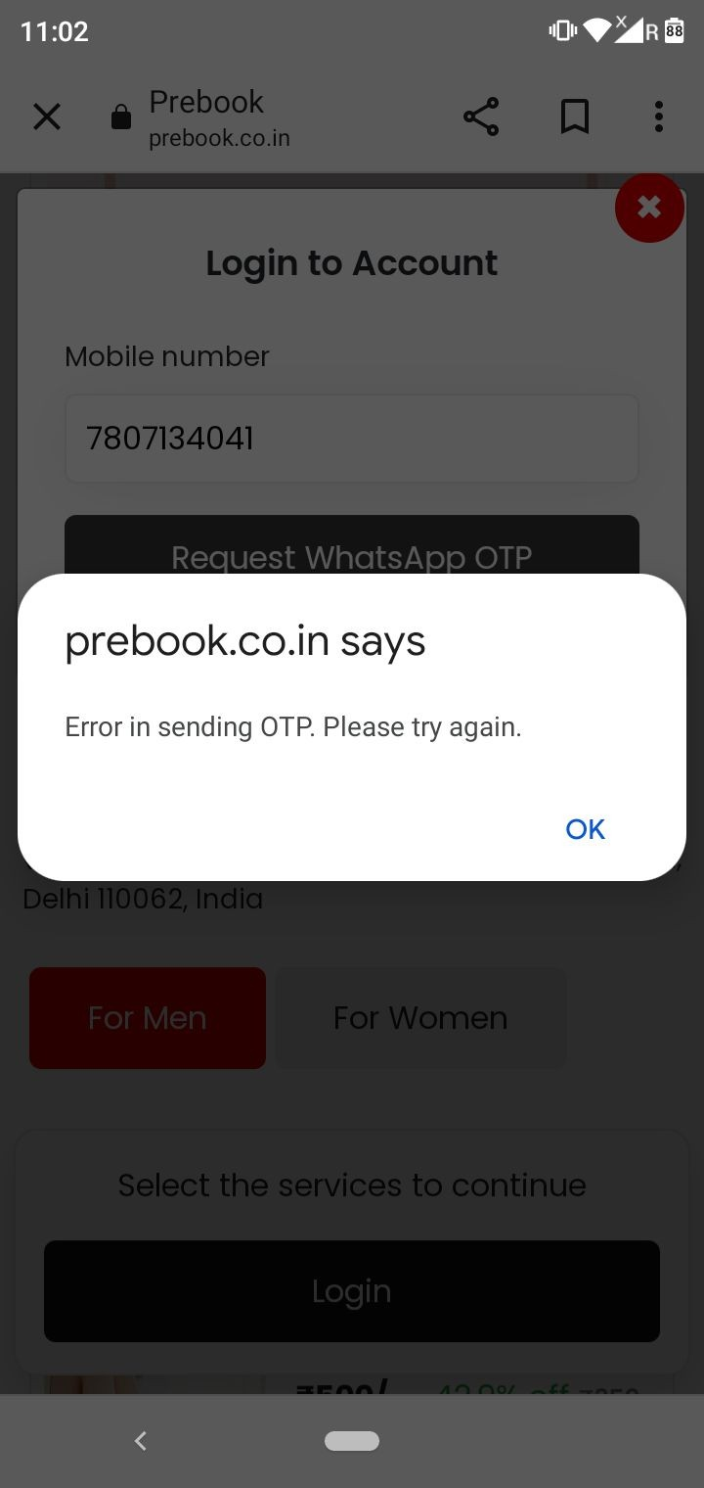

Jab new user first time web pe login krr raha to Error message aa raha shown in screenshot… But usse otp chlaa ja raha. Correct this !=>Done

* **Razorpay mein payments automatically refund ho jaa rahi webpage se bookings mein. Iska bhi check kroo sir.=>Preetam**

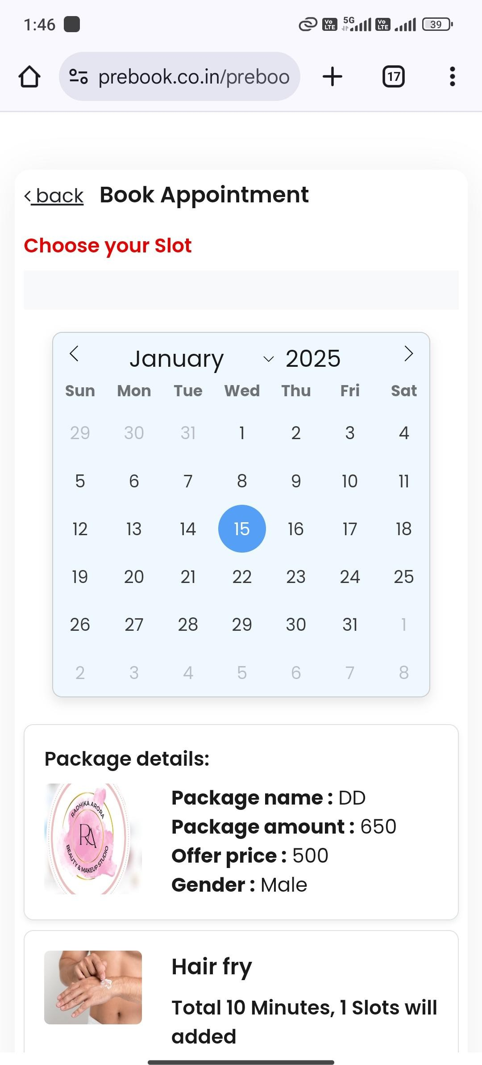

Make like this - Ki jab humm service selection ke baad cart page pe jaaye Or calendar se date change karrein to “loading spinner” aaye tab tak selected date ke slots show na ho. ( Check user app ussme sahi se working ho raa).

Service slots change mein bhi spinner aaye. Issme bhi krr dena.=>New point/Preetam

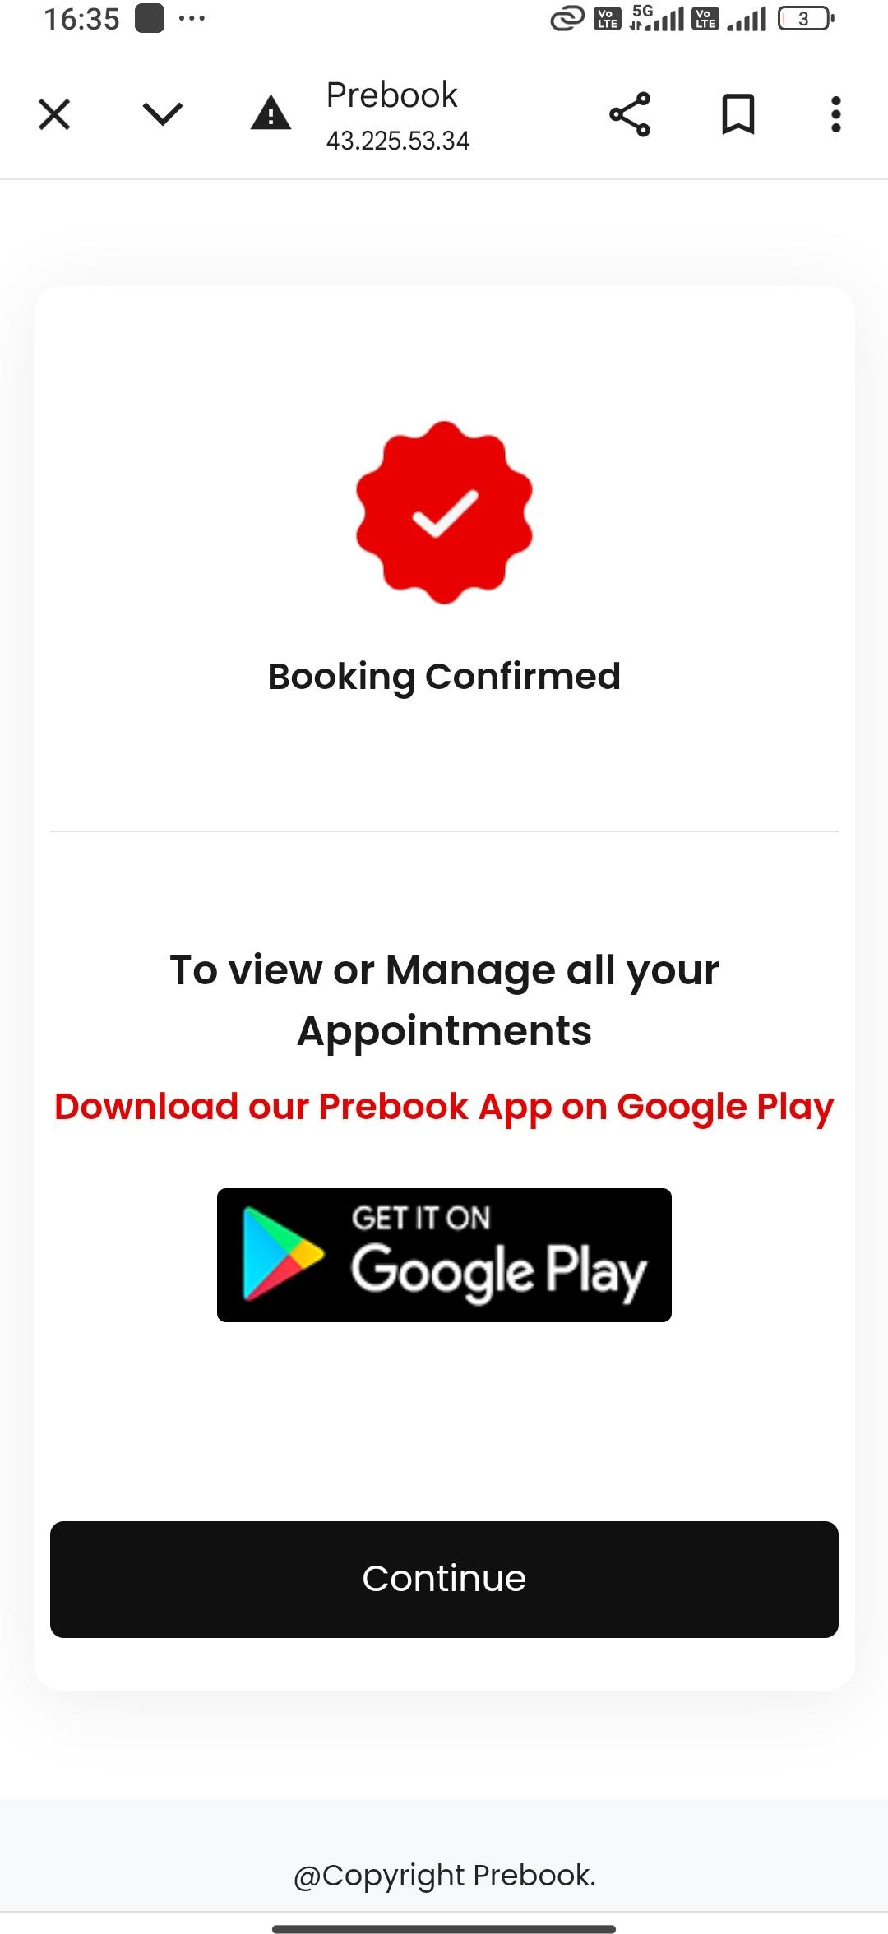

Booking place hone prr marketing page open nahi ho raa check again .

Sir ye pahele show ho jaata hai baad mein 2-3 bookings ke baad automatically gayab.=>Preetam Pending

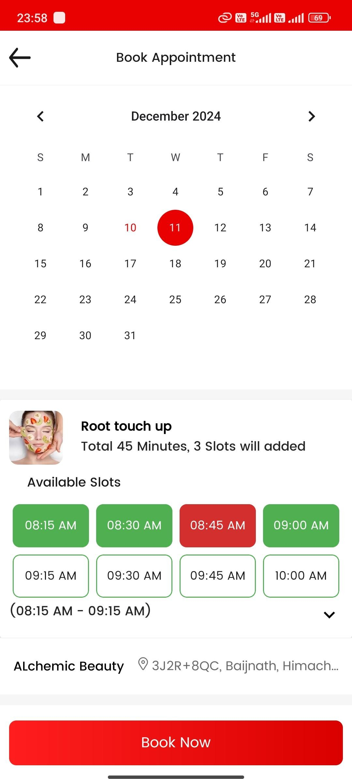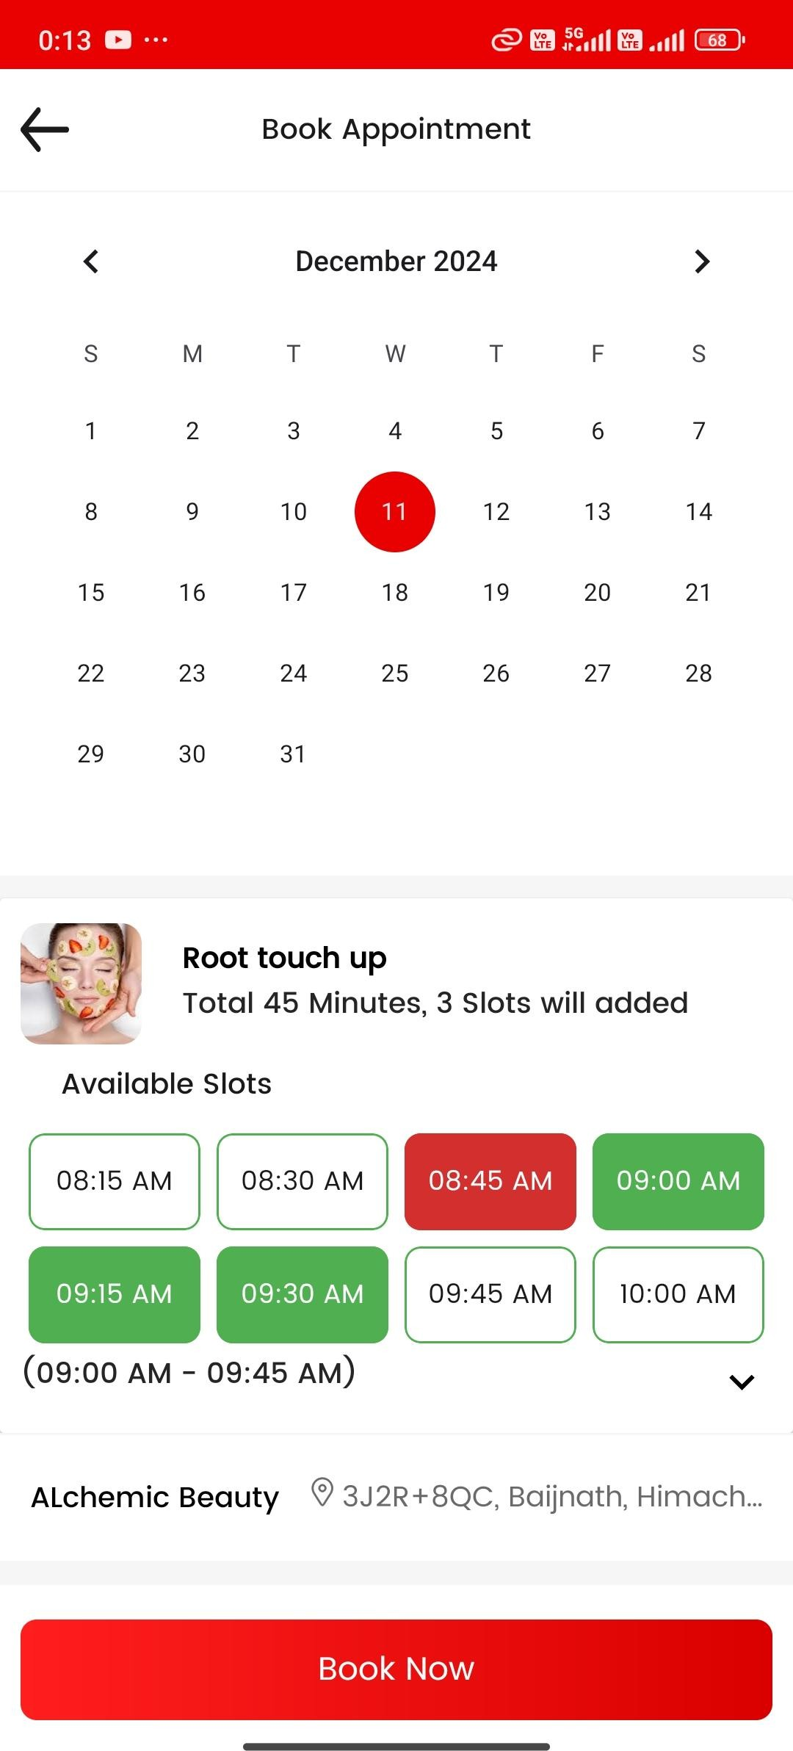

## Management repeated bug

**Single staff only case** - When the one slot is booked by user . **screen shot one**

Jab same service (Root touch up) pe second staff link kar rahe to then working properly **shown in screenshot two.=>Backend**

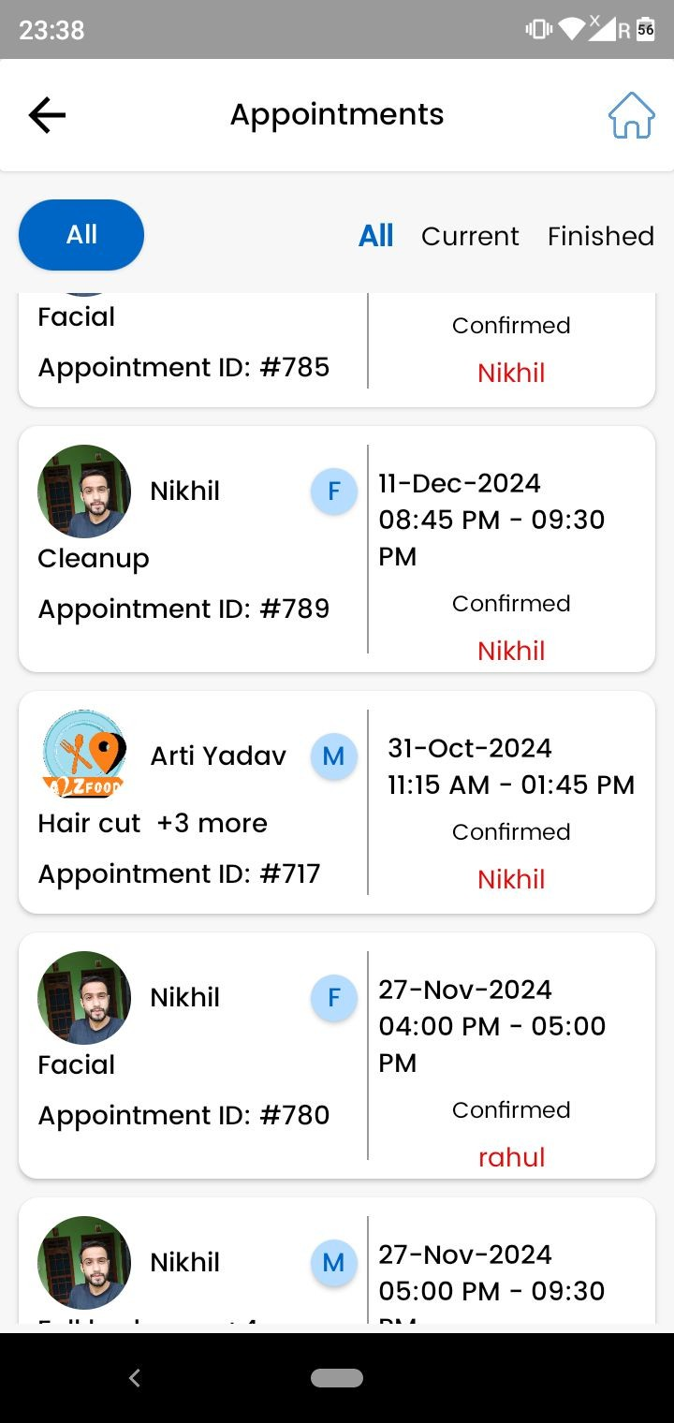

Appointment management mein data fluctuate kar raha.

Check alchemic beauty=>Amit =>Done

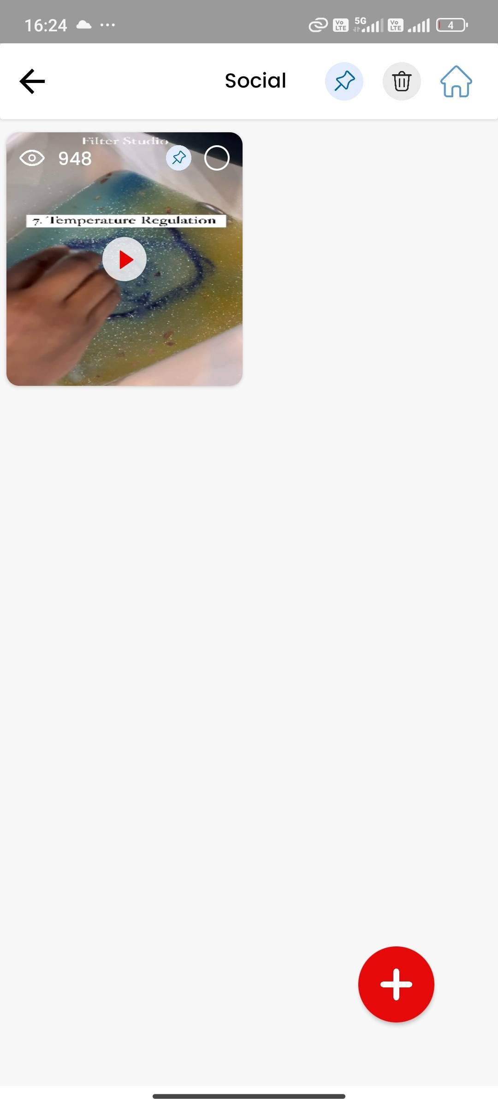

**Video add nahi ho rahi social pe.**

* **Sometime video add ho jaa rahi butt play nahi ho rahi.**
* **Major times video upload nahi ho rahi bss loading hi aa raha.=>Done**

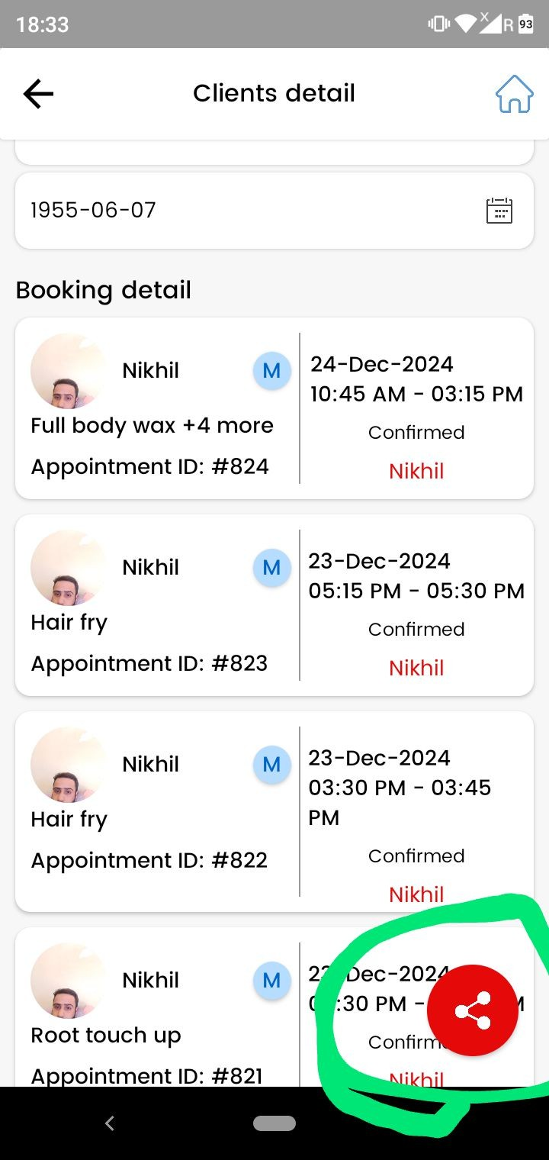

As marked the share button issme booking link is not working. ( salon id saath mein nahi jaa rahi).=>isme vendor id bhej do => Done

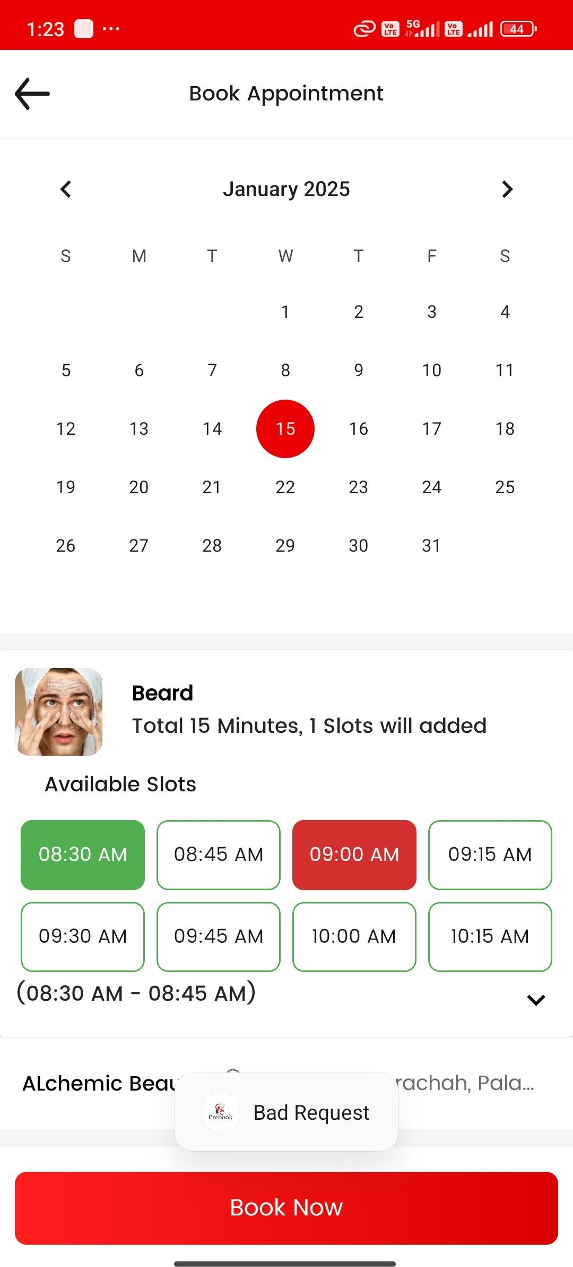

Jab prebooking amount zero hai tab booking place nahi ho rahi… Bad request ka message aa raha shown in screenshot=>Amit 0 hone par seedhe booking ho jaye = > Done

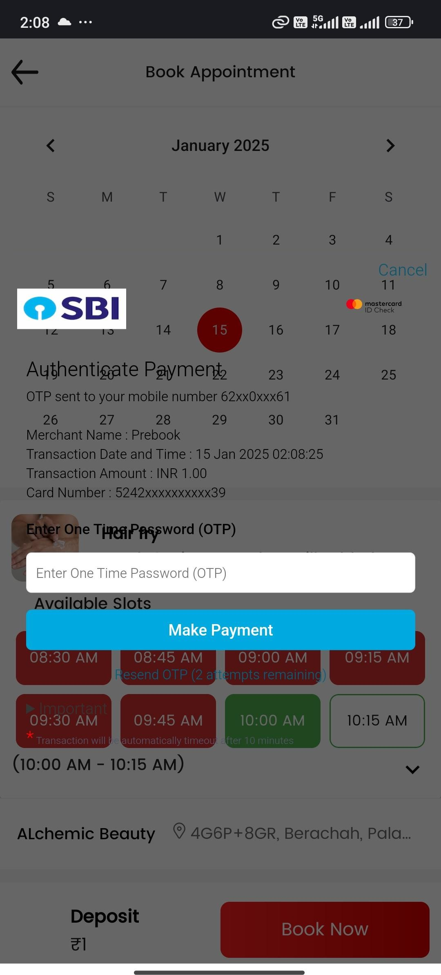

Jab humm razorpay me user app pe card details se payment ka rahe to otp screen is not showing properly. Shown in screenshot.=>Nahi Karna

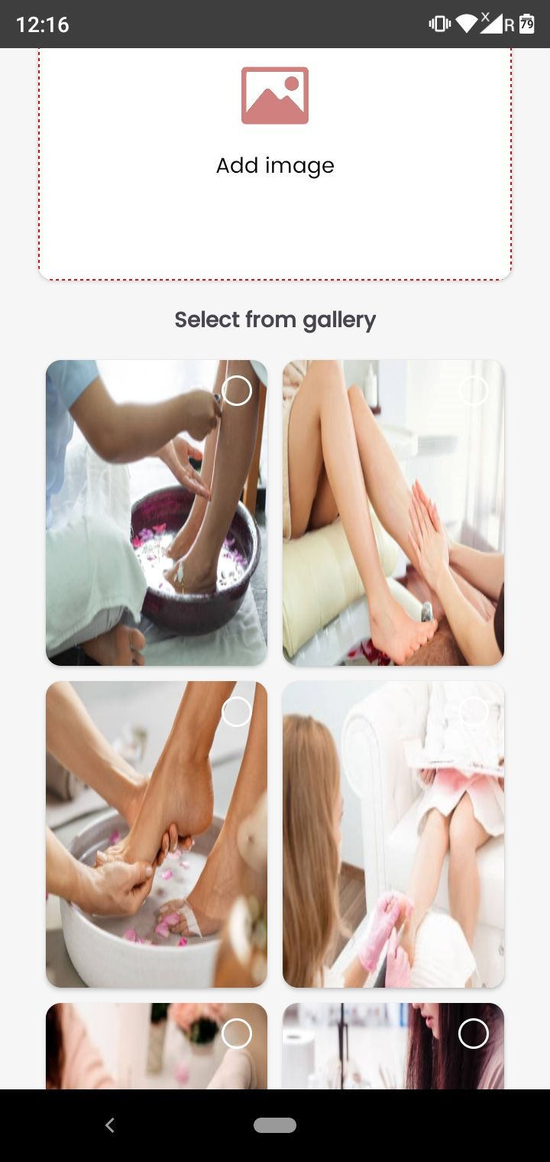

**Jab humm single service mein koi image prebook admin gallery se select kar rahe , then after koi new service ko humm enable kar rahe to same image copy ho jaa rahi newly enabled service mein.=> Imse default image jab bhi new bar aaye to blank kar do last wali ki default image chill ja rahi hai=> Done**

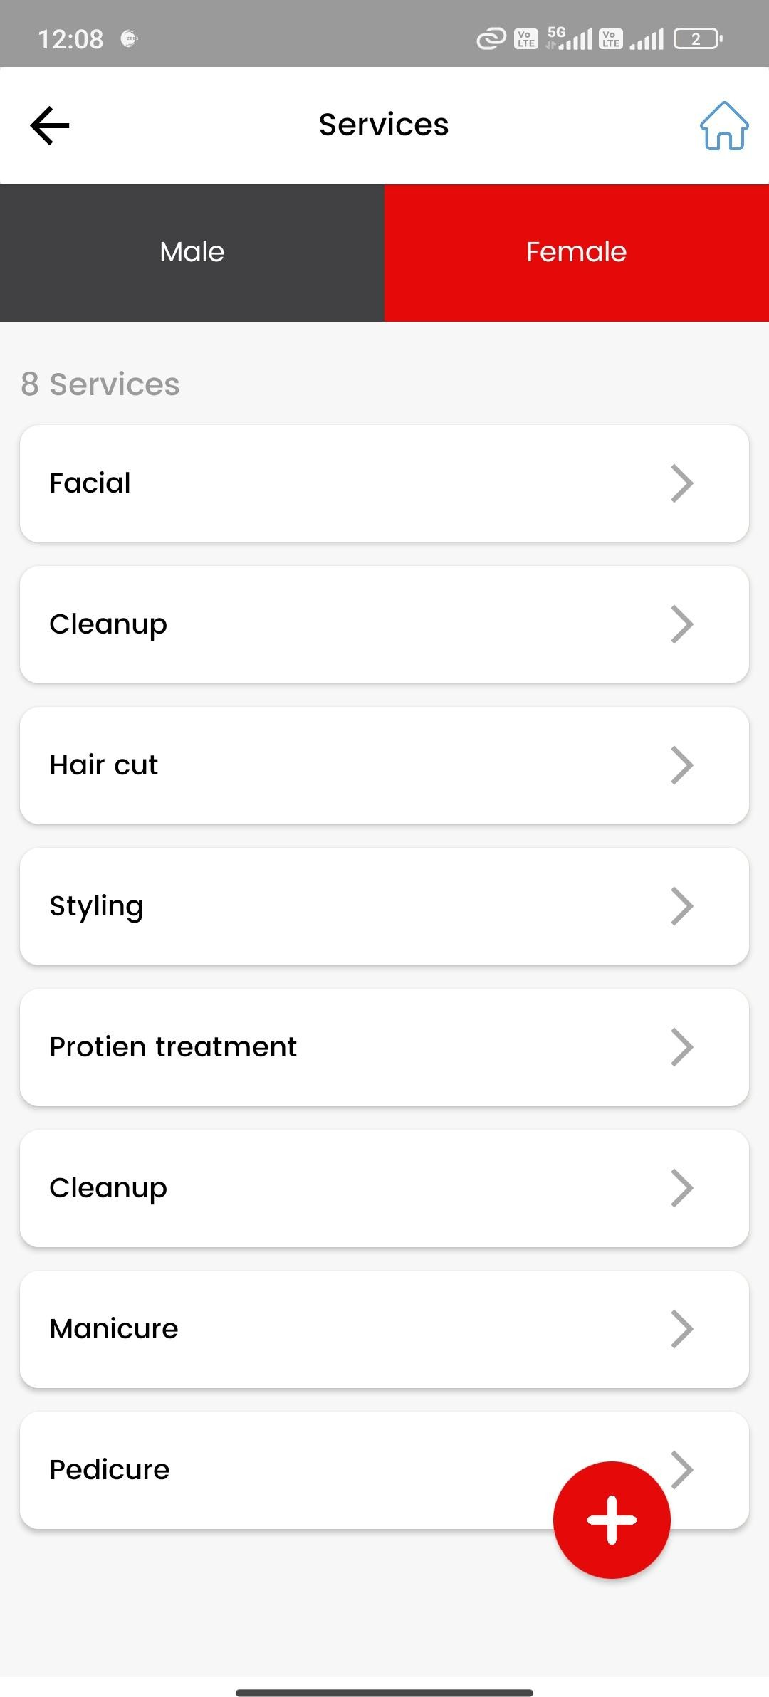

Make like this - Ki jab humm female service ko update karne ke baad back karein to female ki hi services show ho. And vice versa for male=>Nahi Karna hai

Write a message  
Please upload maximum 10 mb at the time of upload video => Done