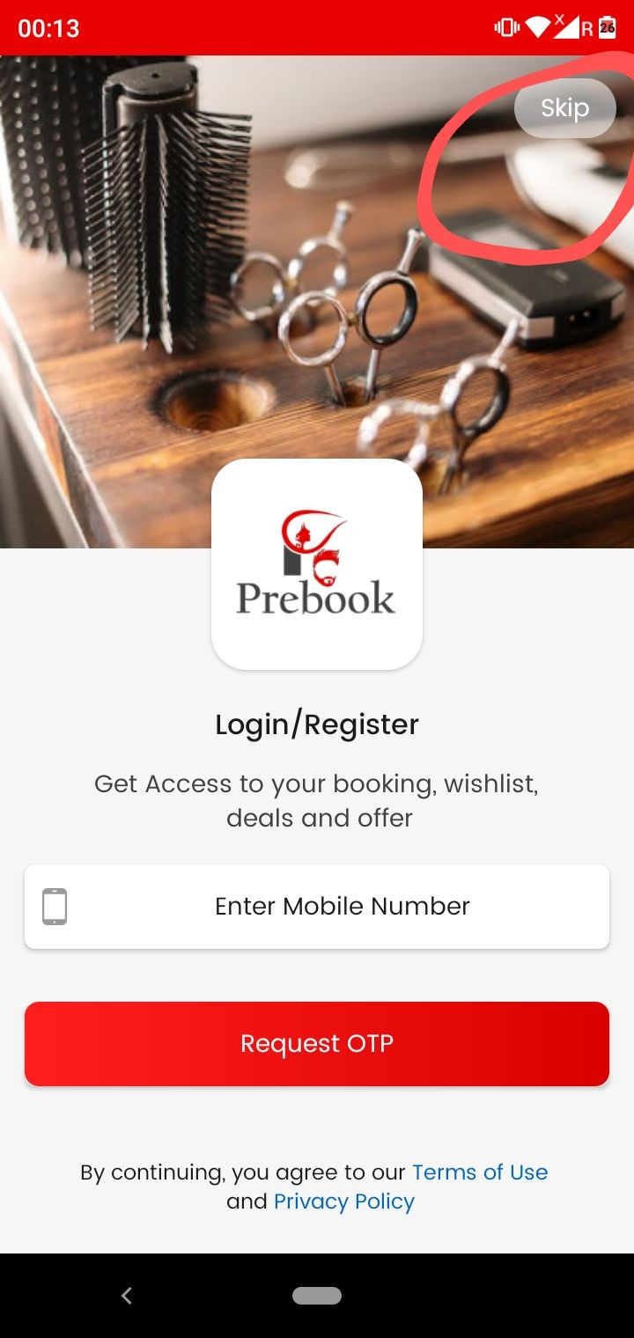

As marked in screenshot remove this skip button

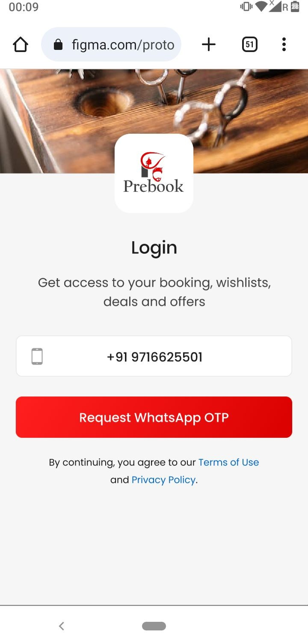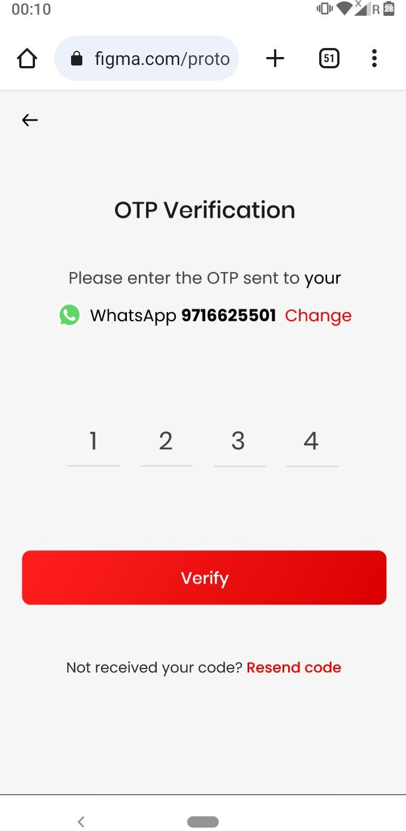

As marked in screenshot one and two…OTP content ko whatsapp ka kar do jaise screenshot mein kiya hai

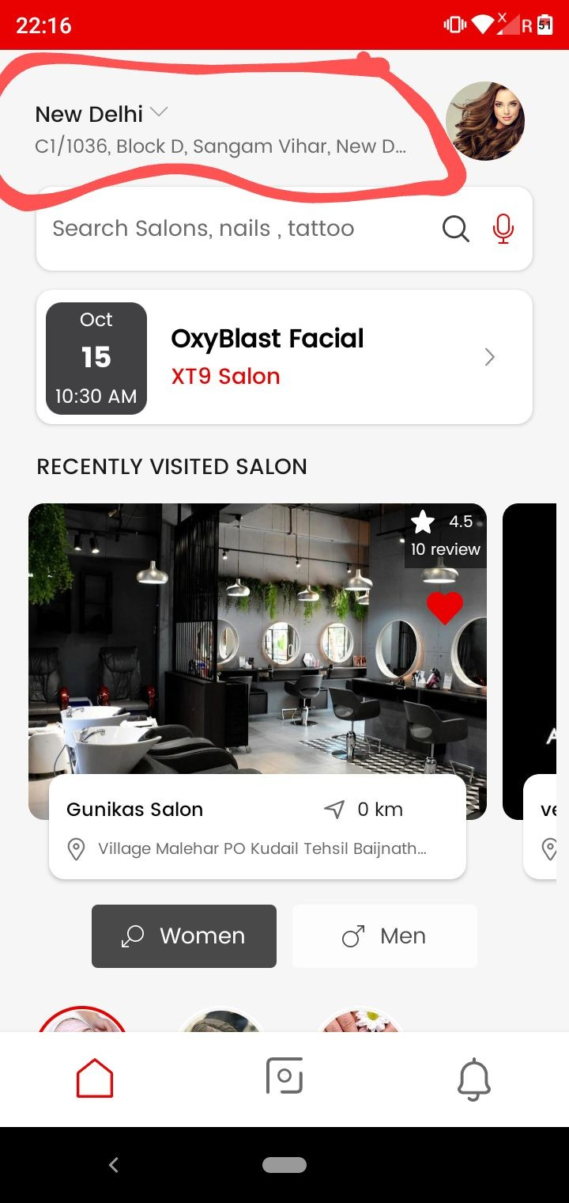

Make like this - Jab bhi user home page pe jaayegaa everytime location auto fetch kar legaa app.

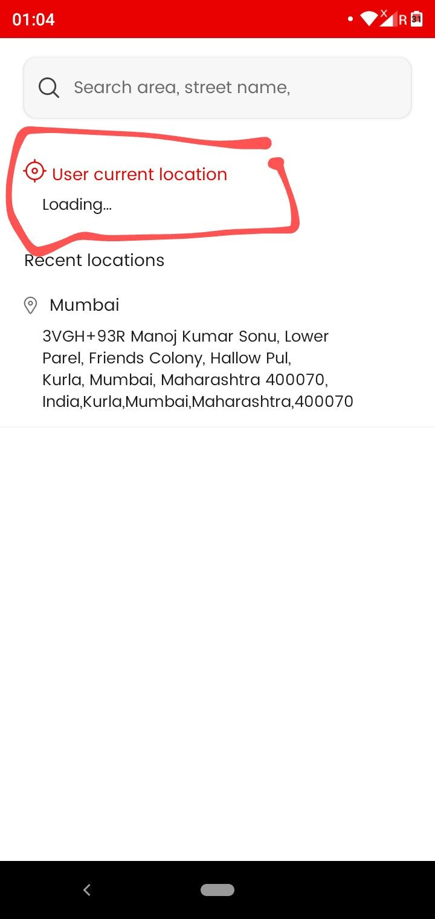

Location bar
As marked User current location is not loading.

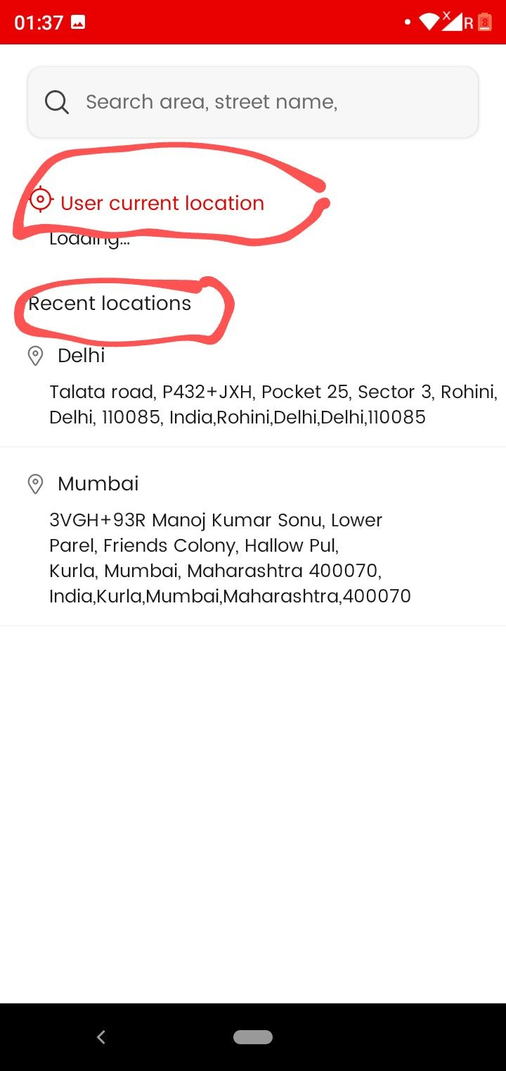
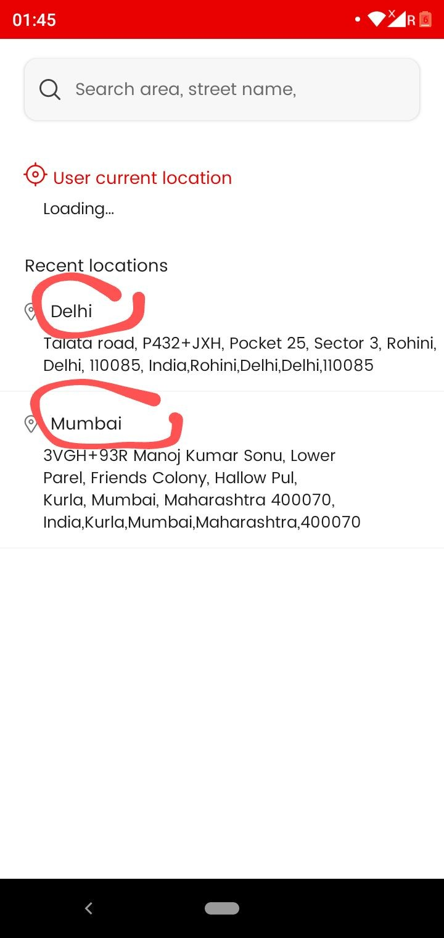

Location bar
- As marked in screenshot one user current location and recent location make this dark in color ….

- As marked in screenshot two city heading make this also dark in color.

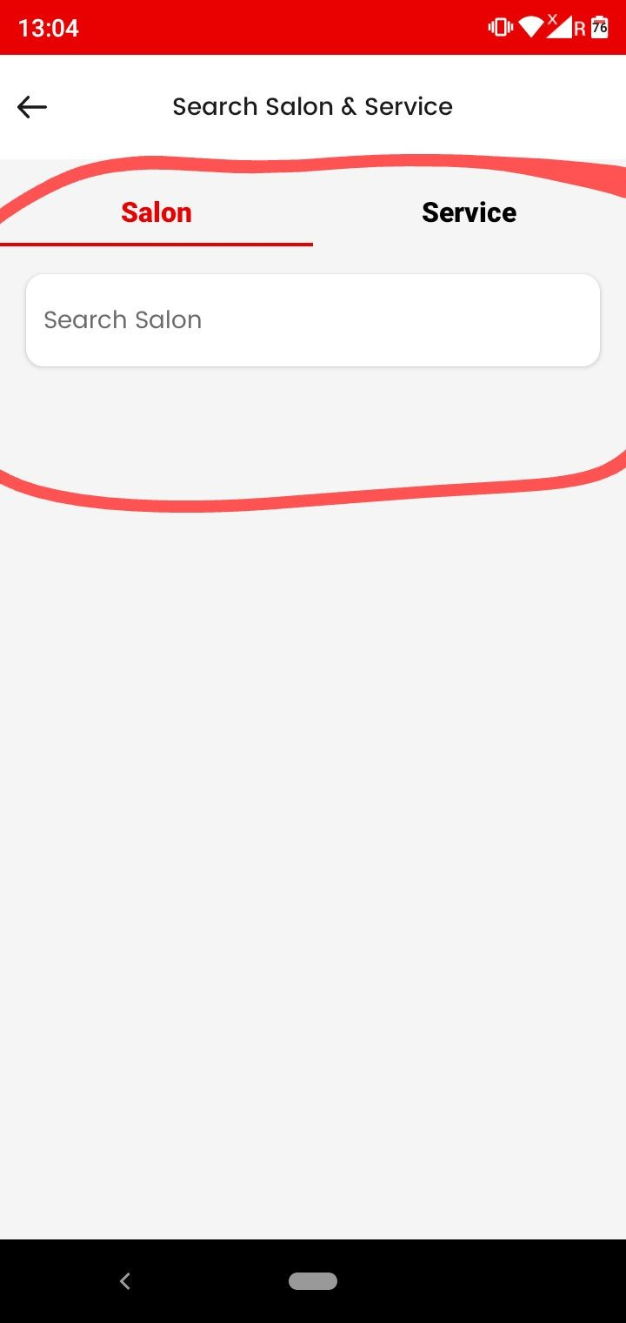
As marked in screenshot make this search bar working (Not working properly)
And issme (services search bar) ko remove kar do… humm sirf (salons search) hi rakhenge.

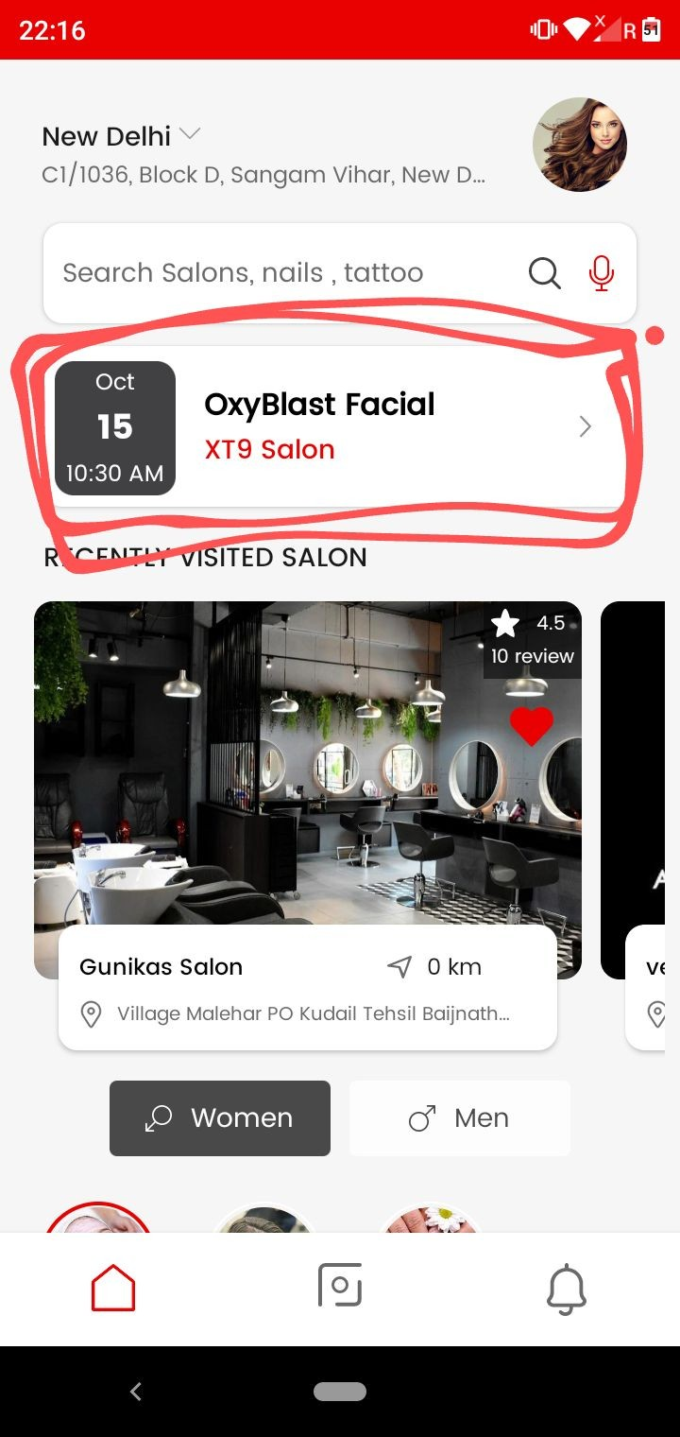
As marked make this working
Issme jo latest booking hogi wo represent karenge front mein…..
Example-

Kisi user ne three bookings place ki hai- ; (10.00 AM), (2:00PM) and (6.00 PM)...
Issme jo pahele hai i.e (10:00 am ) waali wo home page pe dikhegii
And after the completion of this booking from vendor side next upcoming show karegii that is of (
  - pm) and work soon like this. Completion ke baad hi next upcoming show karenge.
Recent upcoming appointment show hogi yaha pe. Same works for dates also

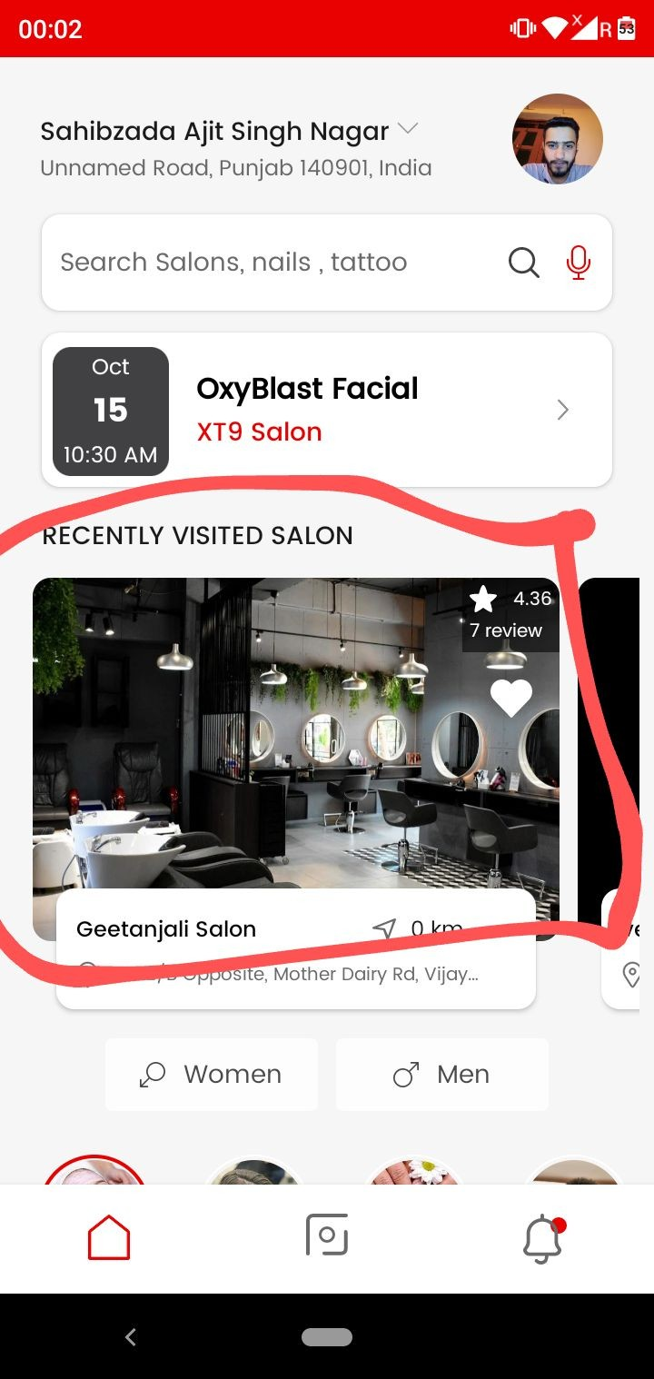
Recently visited salon
Make like this- Jab kisi user ki booking vendor side se completed ho gayi hogi…. Then after completion from vendor side user ko Salon at RECENTLY VISITED
SALON pe bhi dikhegaa.

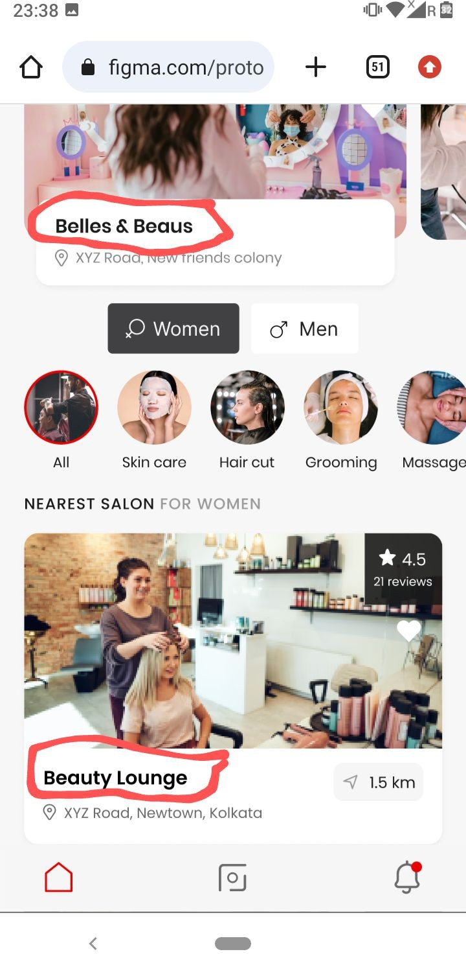
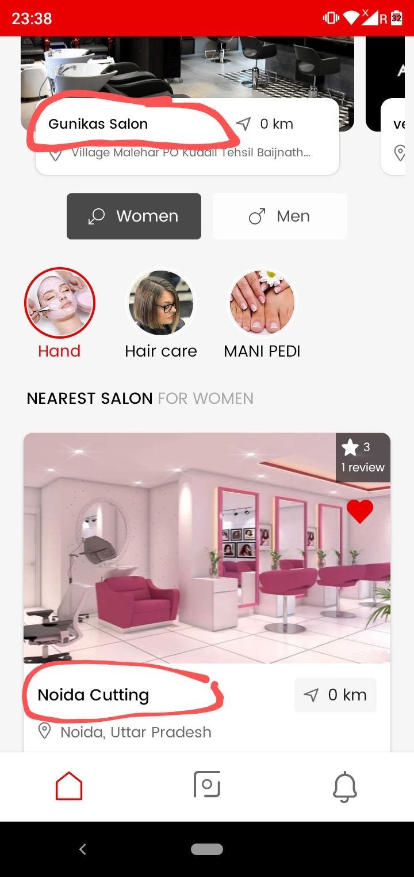

As marked in screenshot one salon name ko both Recently visited salon and Nearest salon…. mein More big and dark bold in size kar do… as done in design shown in screenshot two. For good presentation

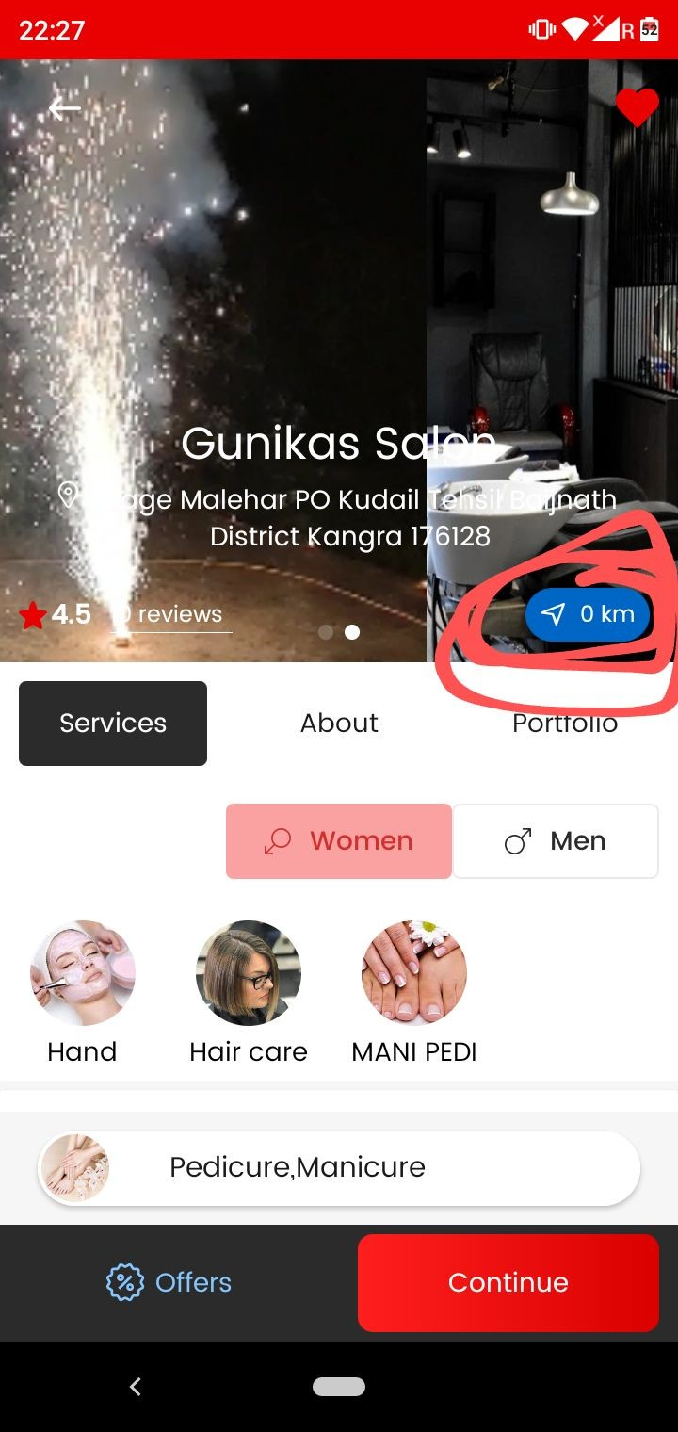
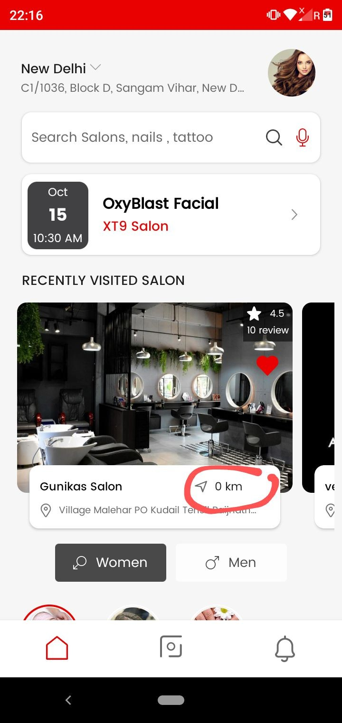

As marked in screenshot Remove the marked distance both inside and outside…Nearest salon waali section se bhi remove kar dena

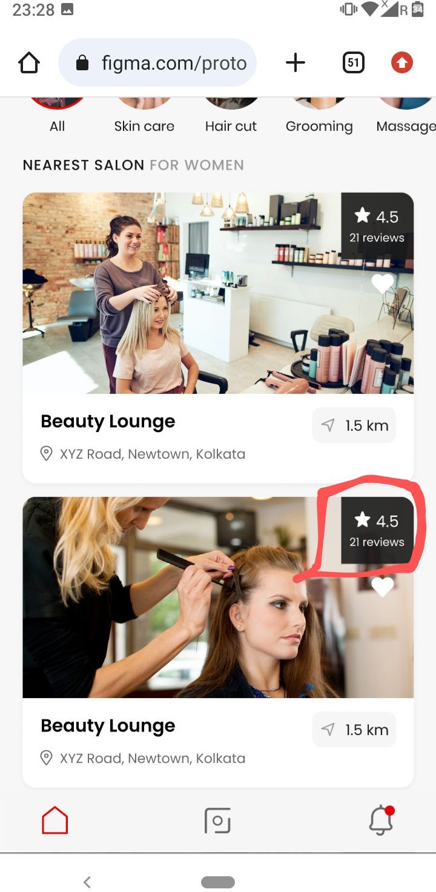
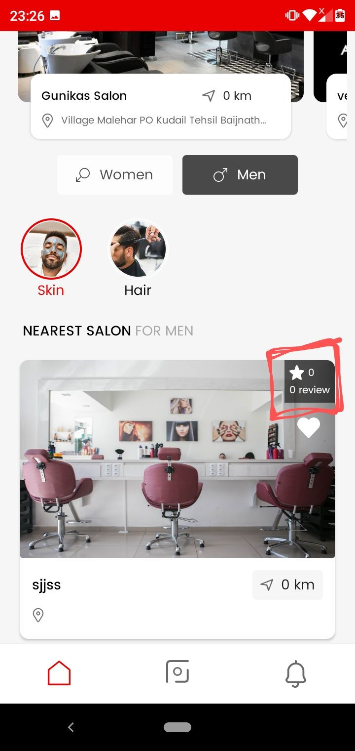

As marked in screenshot one Nearest Salon mein reviews section ko large kar do jaise design mein kiya shown in screenshot two.

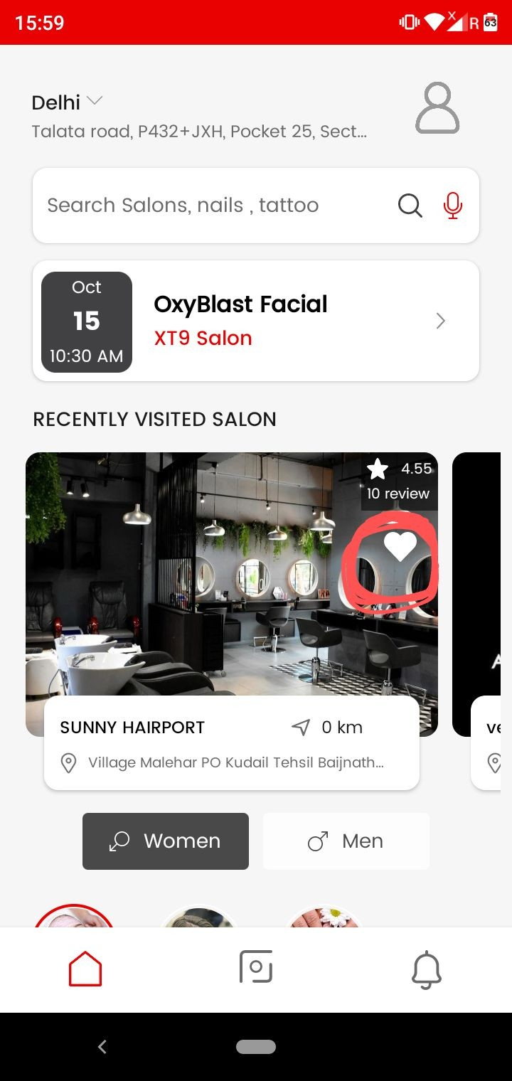

As marked in screenshot jab humm Heart pe click karein to…Added to wishlist ka message bhi aana chahiye.

- 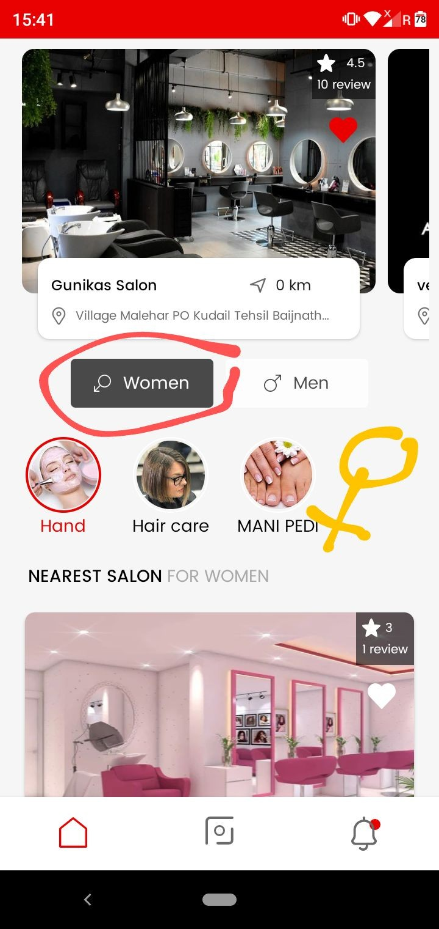As marked in screenshot remove the by default women selection..

- Nearest salon waale case pe both men ,women and unisex ke salon show honge i.e saare and jab humm men pe click karenge to
..to wahan pe Men and unisex salons dikhenge sirf….and jab women pe click karenge to Women and unisex show honge

- Correct the women gender symbol …. Jo design mein hai symbol waisa kro. Shown in screenshot two..both inside and outside change kro symbol ko

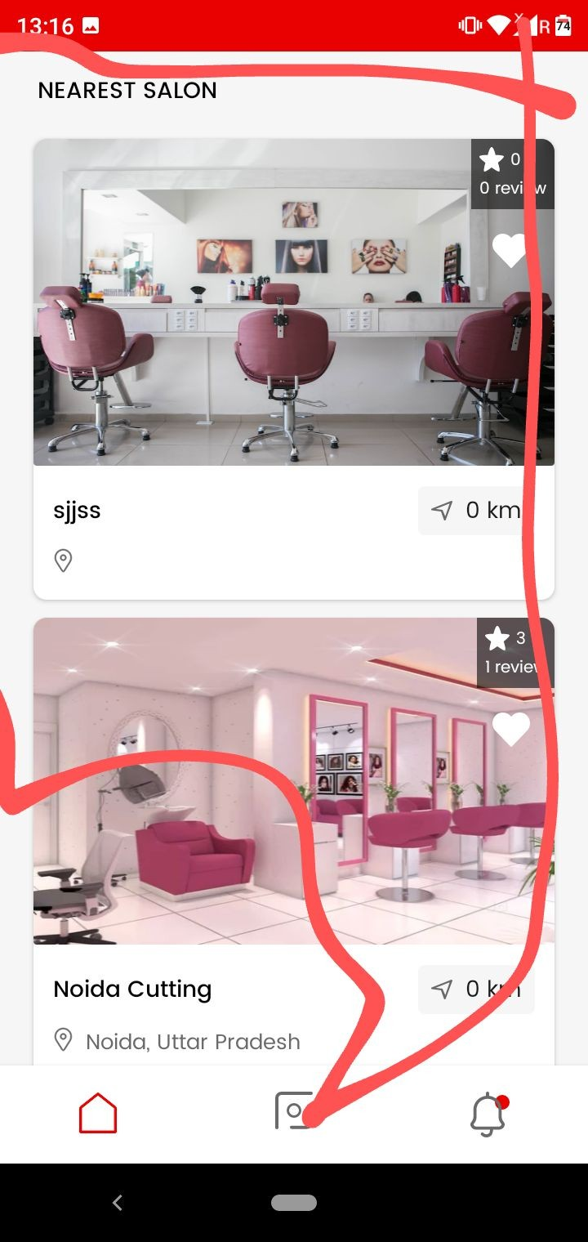

- .Marked nearest salon make it working

- Jab koi salon prebook vendor pe registration kar raha hai .… to uska account admin pe deactivated show karegaa… and after that from admin it will get approval for account activation….
Account activation from admin side pe hi vendor login kar saktaa hai otherwise not

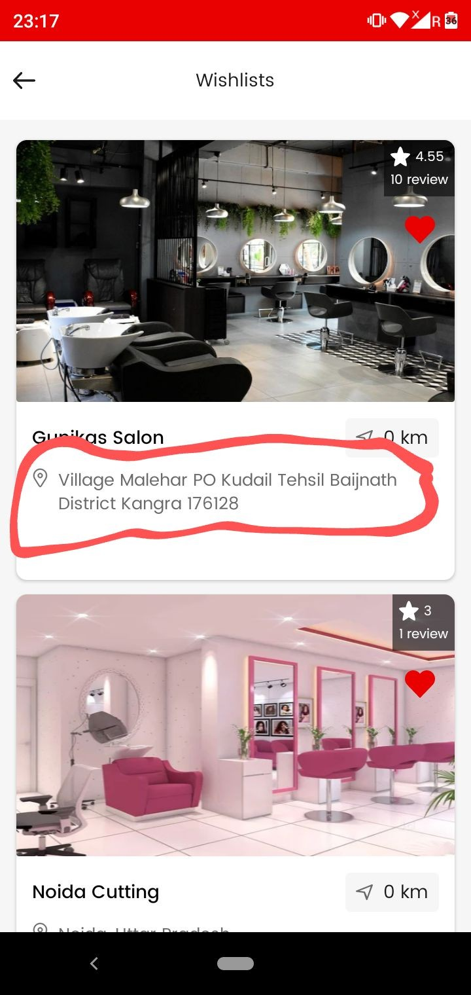

Nearest Salon ->

As marked in screenshot ye jo marked address hai ye ek single line mein aane ke baad dot dot mein ho jaaye….

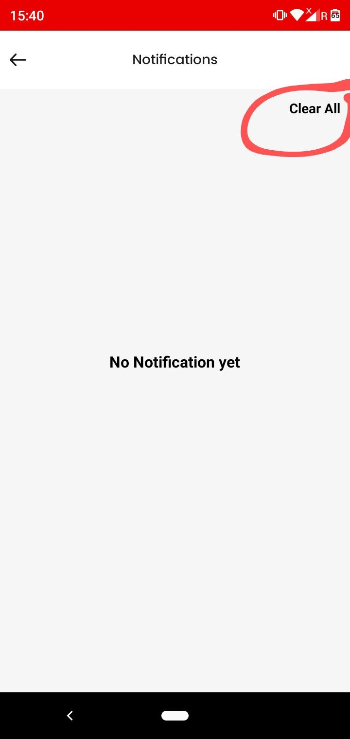

user app NOTIFICATIONS
As marked in screenshot clear all ko blue color mein kar do.

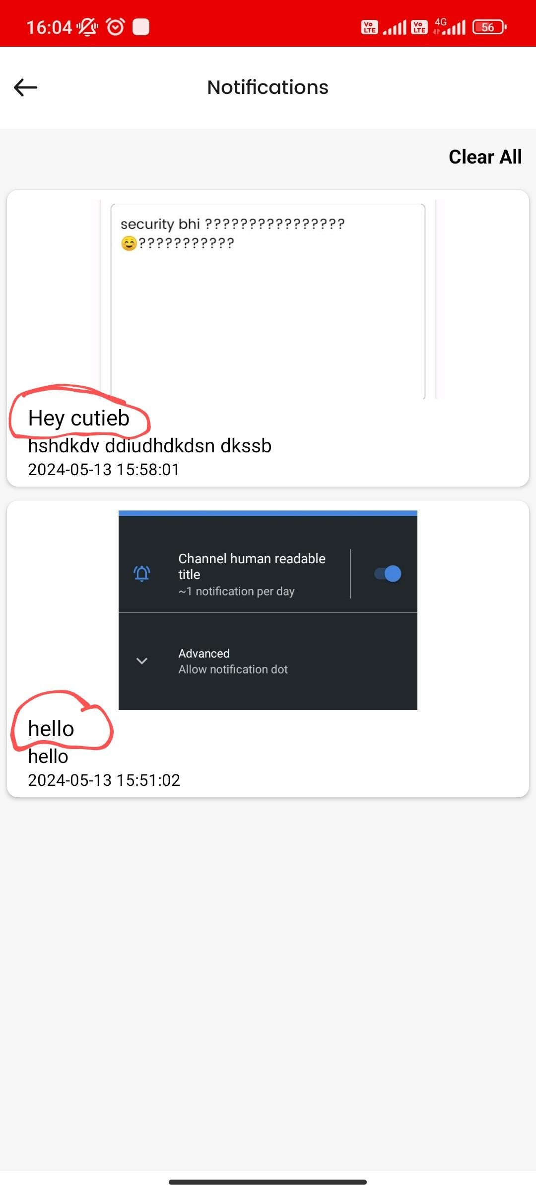
user app NOTIFICATIONS

As marked in screenshot user app notifications pe jo notification ka title hai usse more dark kar do…. Taaki differentiate bdiyaa se ho jaaye.

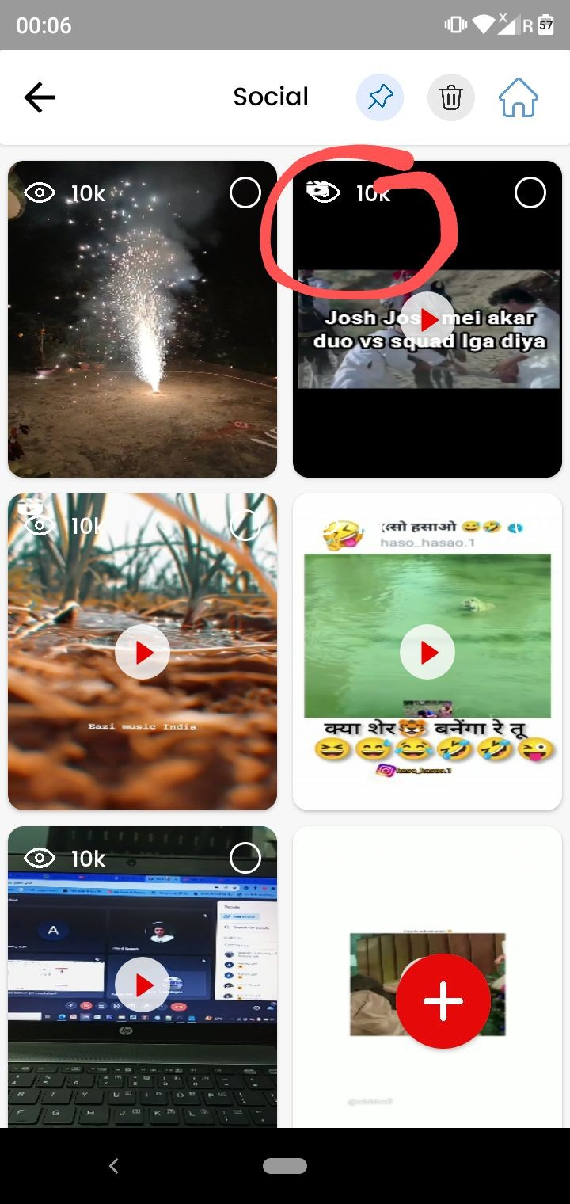
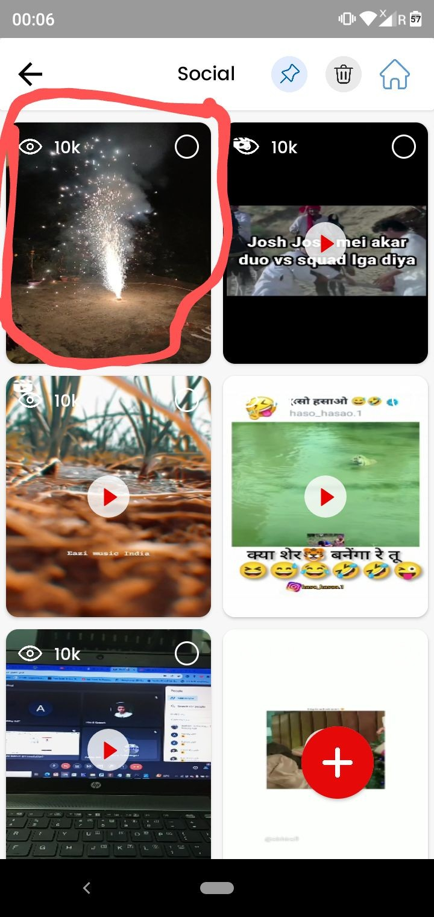

Social - vendor app
- As marked in screenshot one sometimes video upload karte time timeout aa raha and creates a image at social.

- Vendor app pe number of views not working

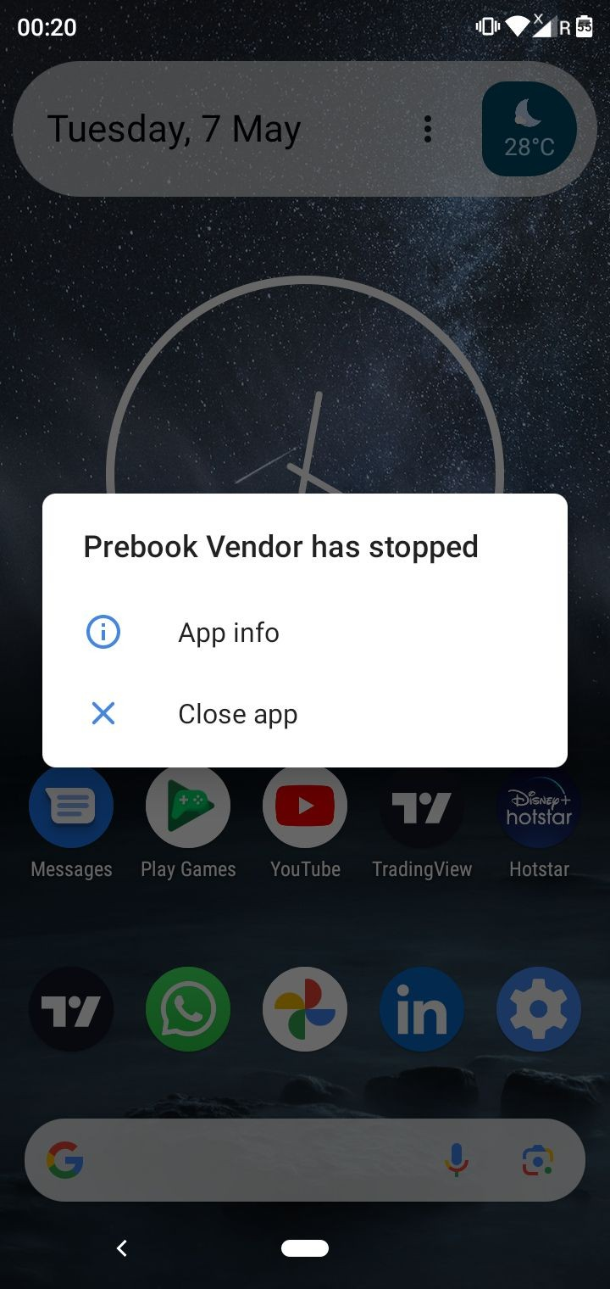

At Nokia 5.1 plus, Redmi 12 note 5g, and real me 3 mein video upload nahi ho rahi Prebook vendor stopped working aa raha

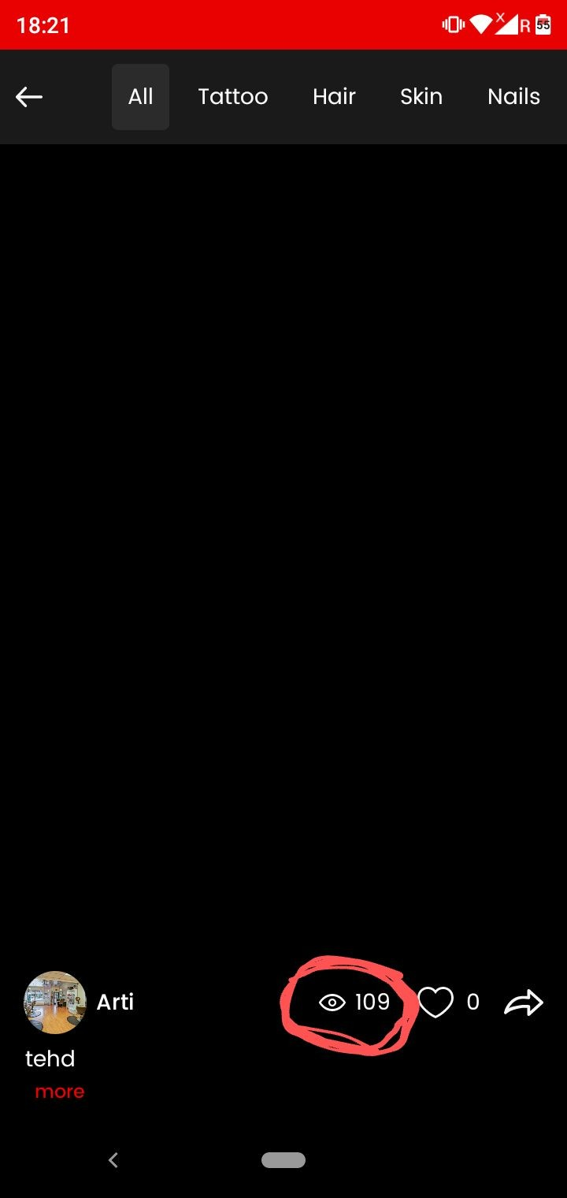

Shorts- User app

User app pe marked number of views ko hide kar do.

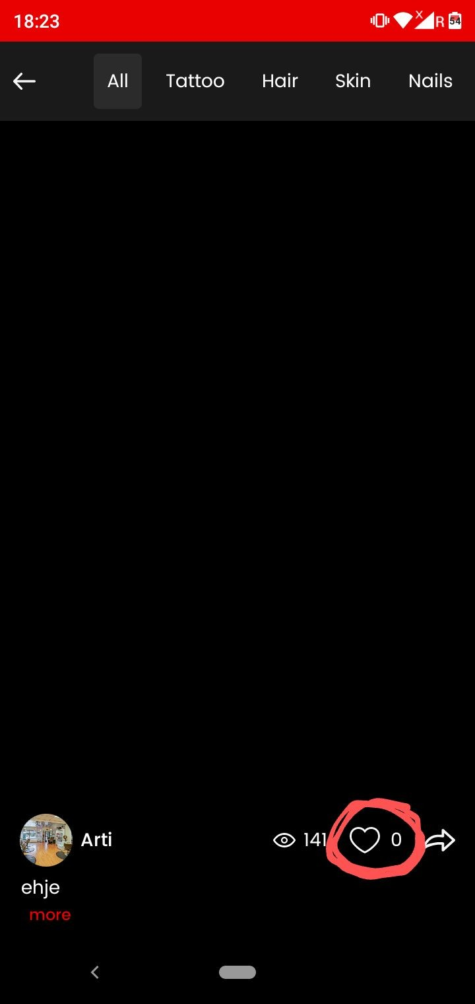
Shorts- User app
- Jab humm video like karne ke baad scroll kar rahe to like scroll karte hi remove ho jaa raha. and vice versa

- Like button fast work nahi kar raha as compared to other apps like Instagram Please make it fast.

Shorts- User app
Shorts kis tarah play honge. location jahan pe salon listed nahi hai humm waha pe bhi video dikhaayenge .( Kindly discuss the working of this)

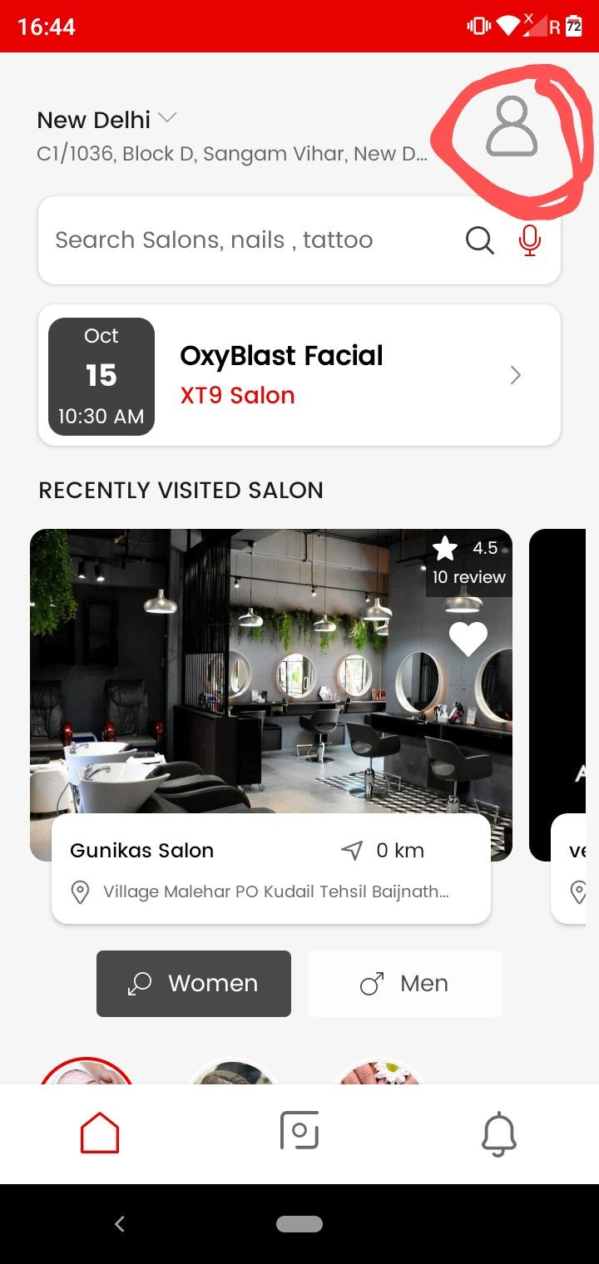


    - As marked in screenshot one profile icon ko circle mein kar do both inside and outside…jaise screenshot two mein kiya hai.

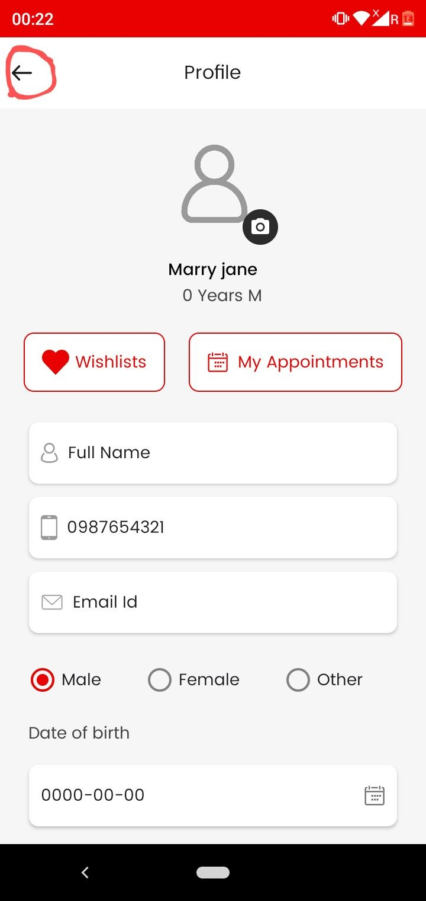
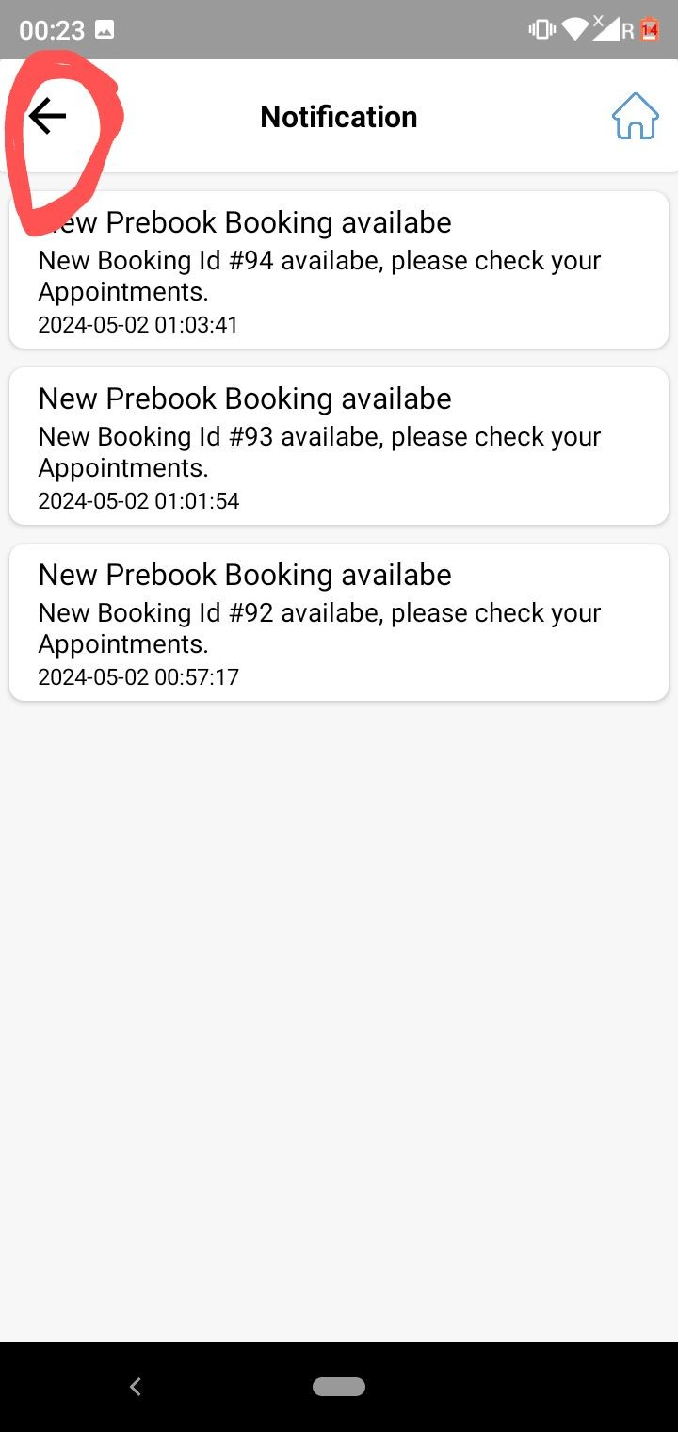
Back button is not working properly and fast in user app
As marked in screenshot one user app back button ko …..vendor app back button ki tarah thoda big kar do taaki badiyaa se back ho jaaye .
User app ki sabhi slides mein isse bdaa kar do

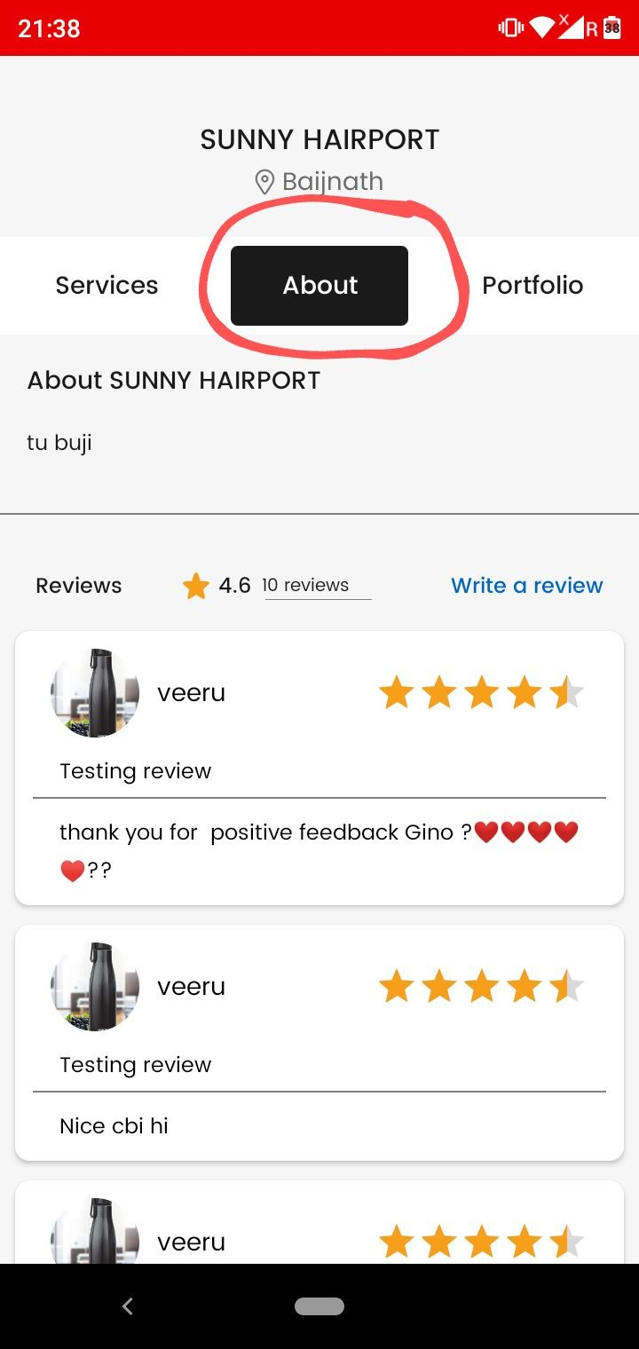
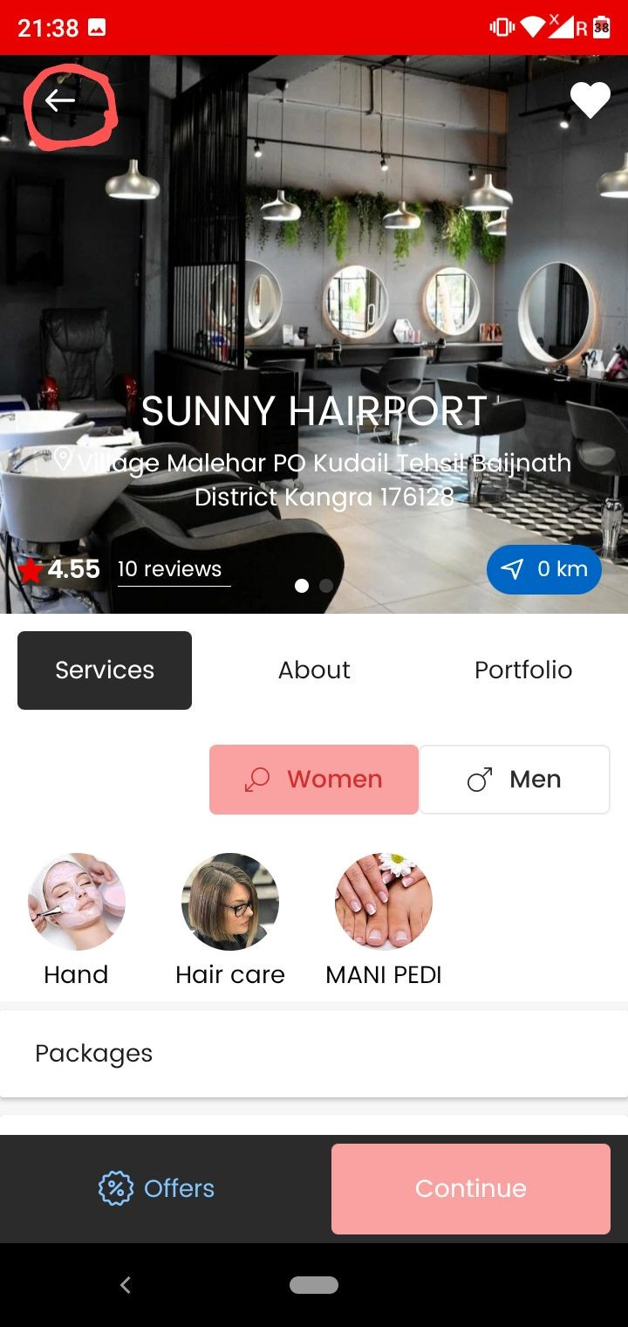

Jab humm About section and Portfolio section se ,,,Services section pe jaa rahe , and banner se back kar rahe to again (about and portfolio) wala page khul jaa raha……..
As marked in screenshot two make like this ki jab humm back karien to directly Prebook home page open ho .

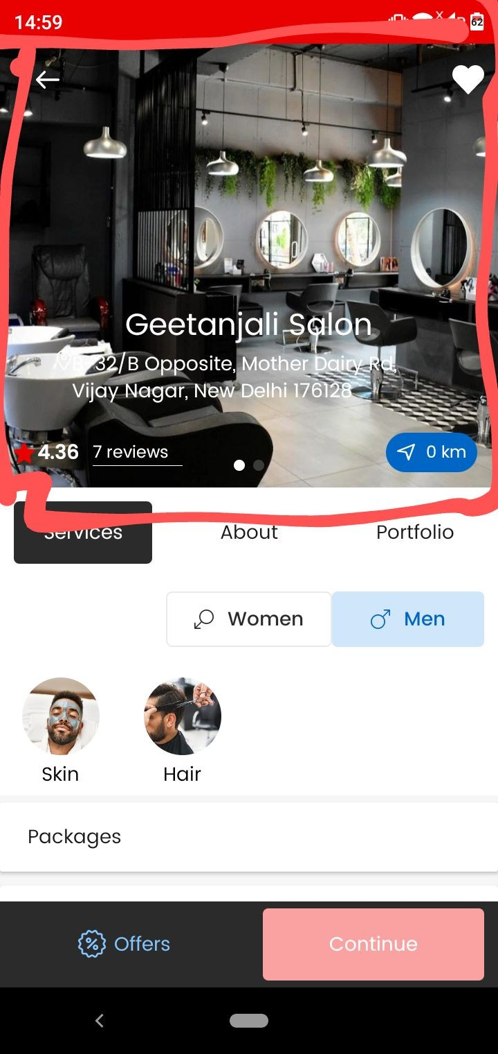

Give option to add banner images from both vendor app and admin

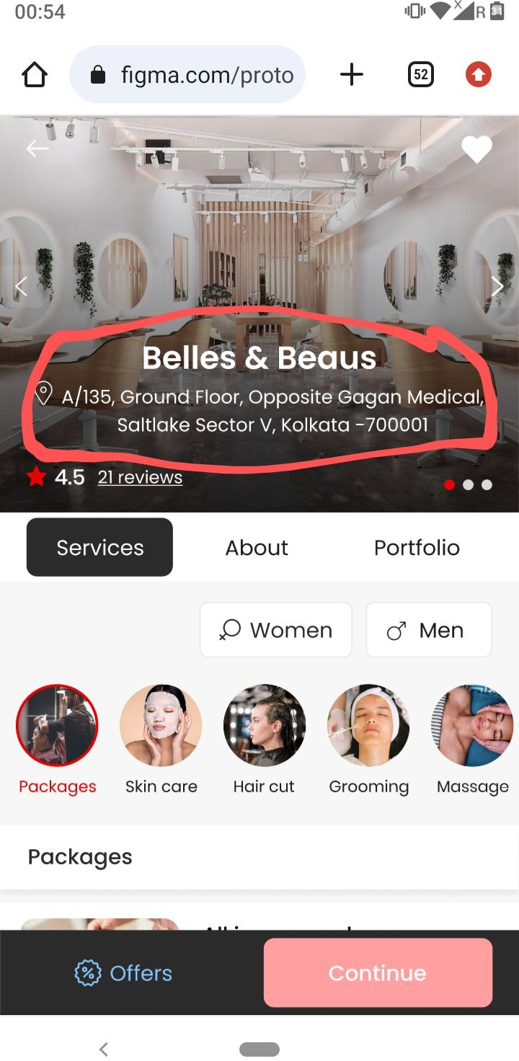
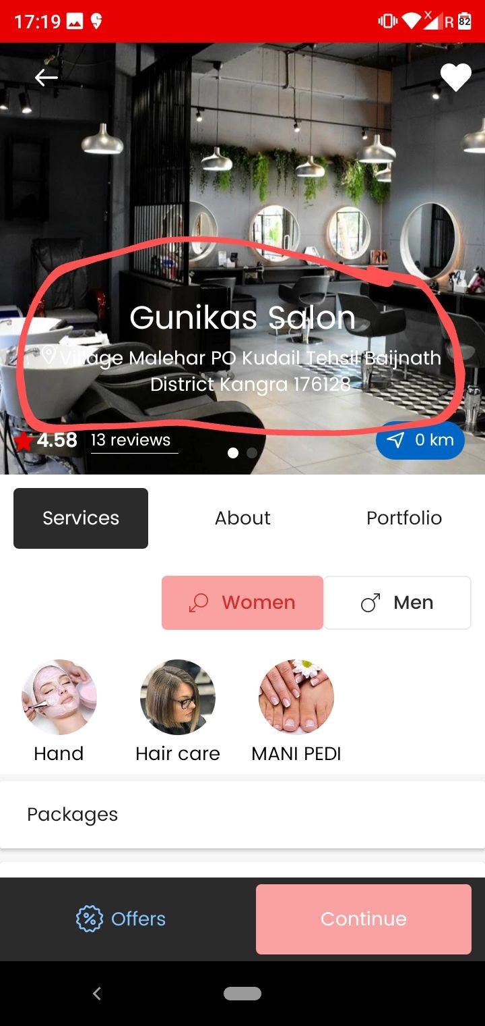

As marked Salon name and address clear dikhaai nahi de raha…. Make its visibility clean and clear as shown in screenshot two.

    - Salon ka naam bold Kar do …as done same in sceenshot two

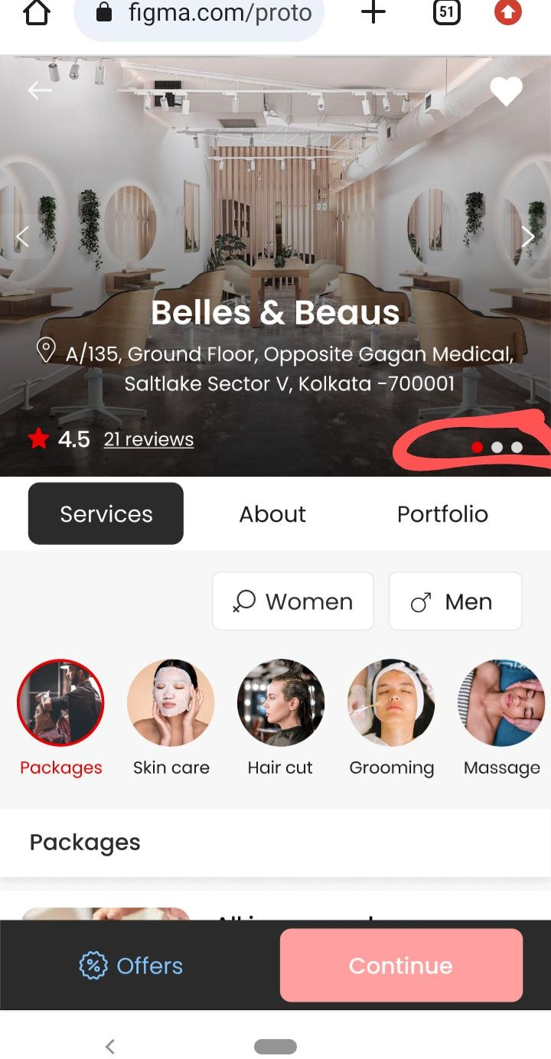

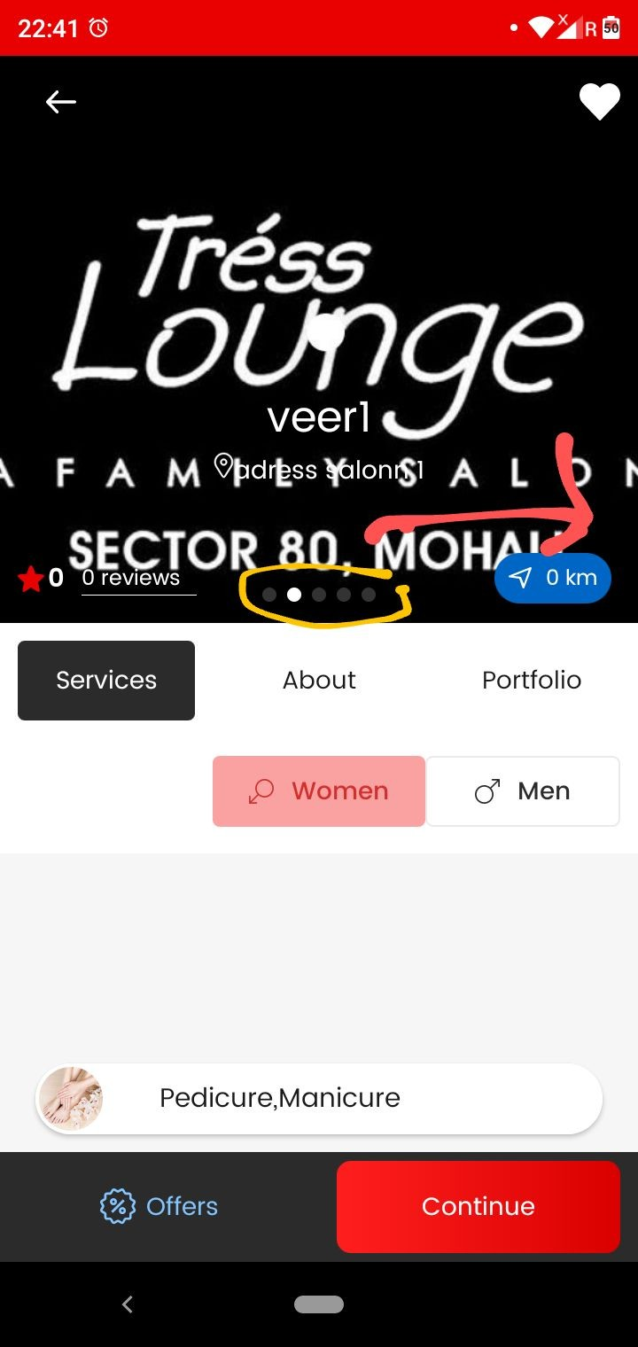
As marked in screenshot one ye jo banner images indicator hai isko right hand side move kar dejiye…As done same in design shown in screenshot two.

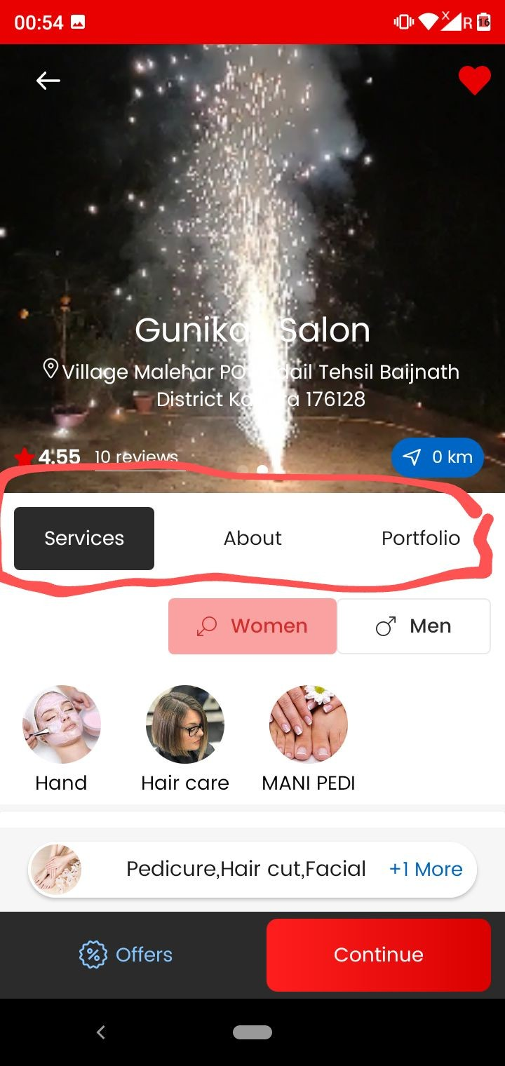
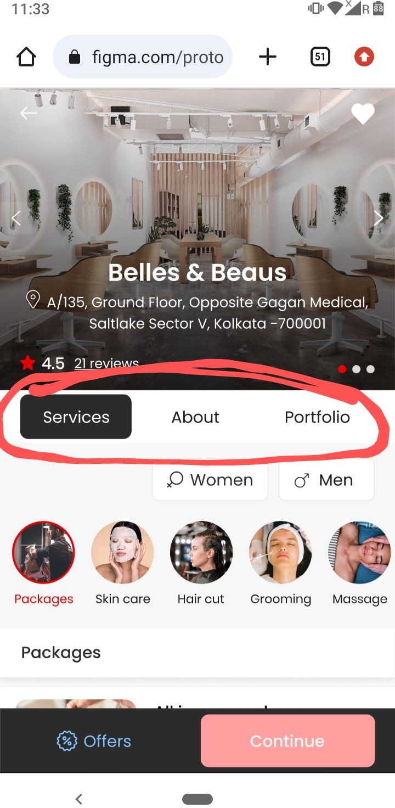
As marked in screenshot Services , About , Portfolio ..text ko thodaa saa dark in color kar do…As done same in design shown in screenshot two.

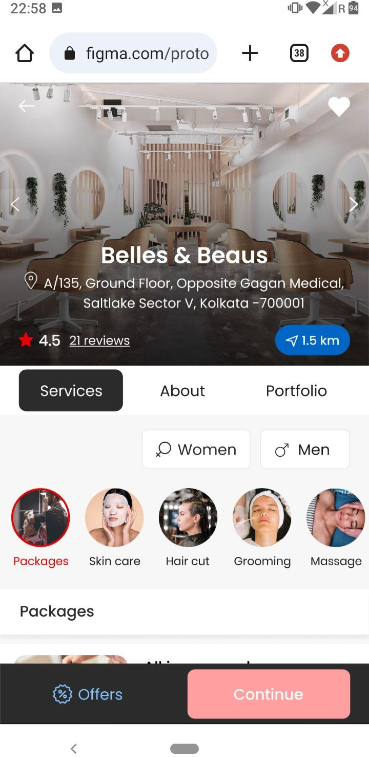
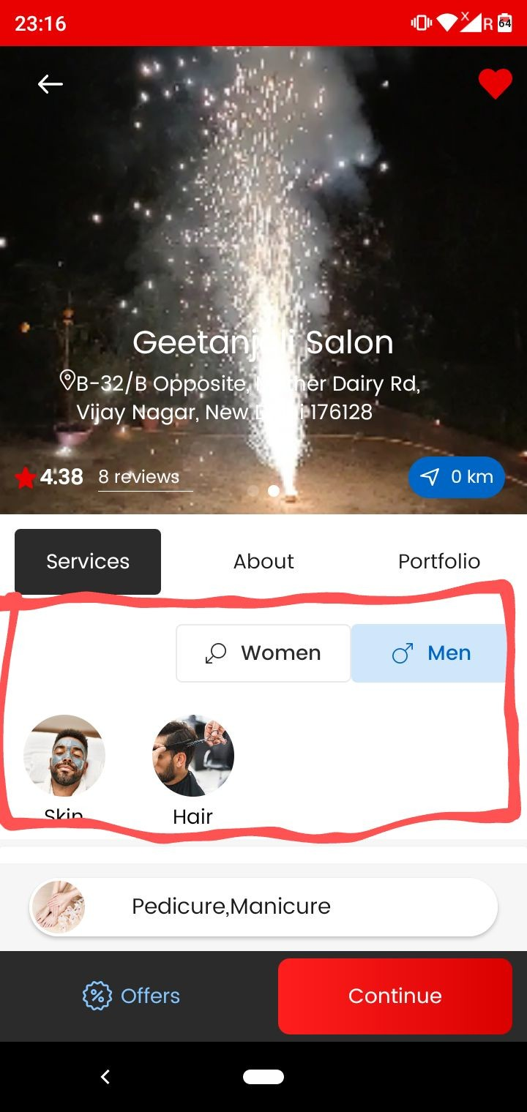

As shown in screenshot one marked area ka shade design ki tarah de do …. Figma mein check kro waha se samaj jaaoge

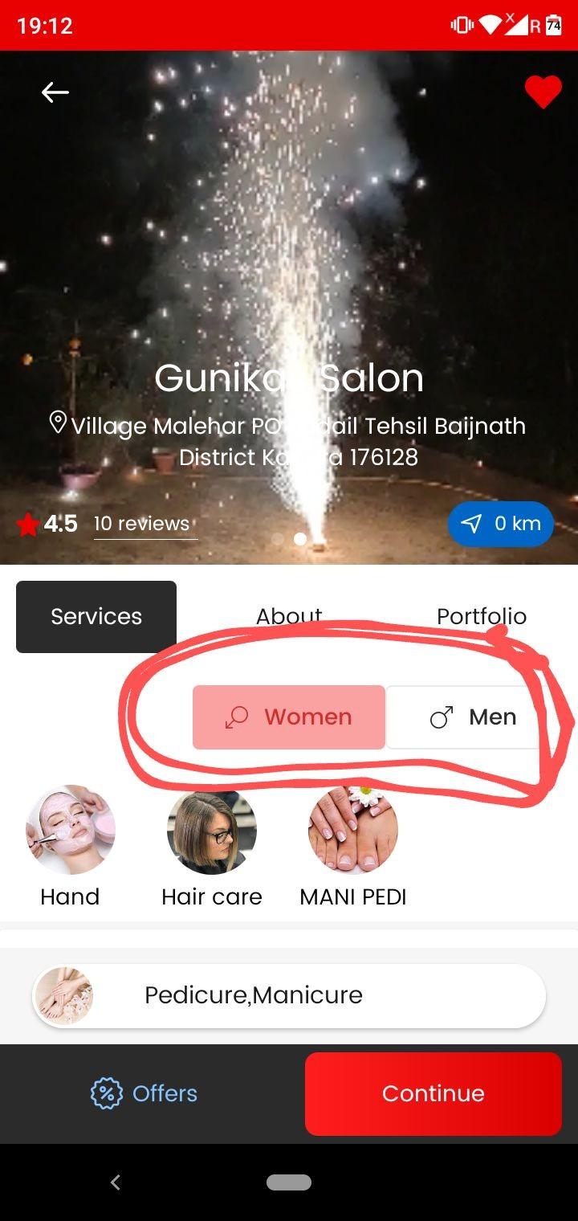

As marked in screenshot
Jab koi salon Unisex hai tab hi men and women ka section dikhaaai degaa….otherwise single gender salon mein koi section nahi dikhaayenge ..
Direct services

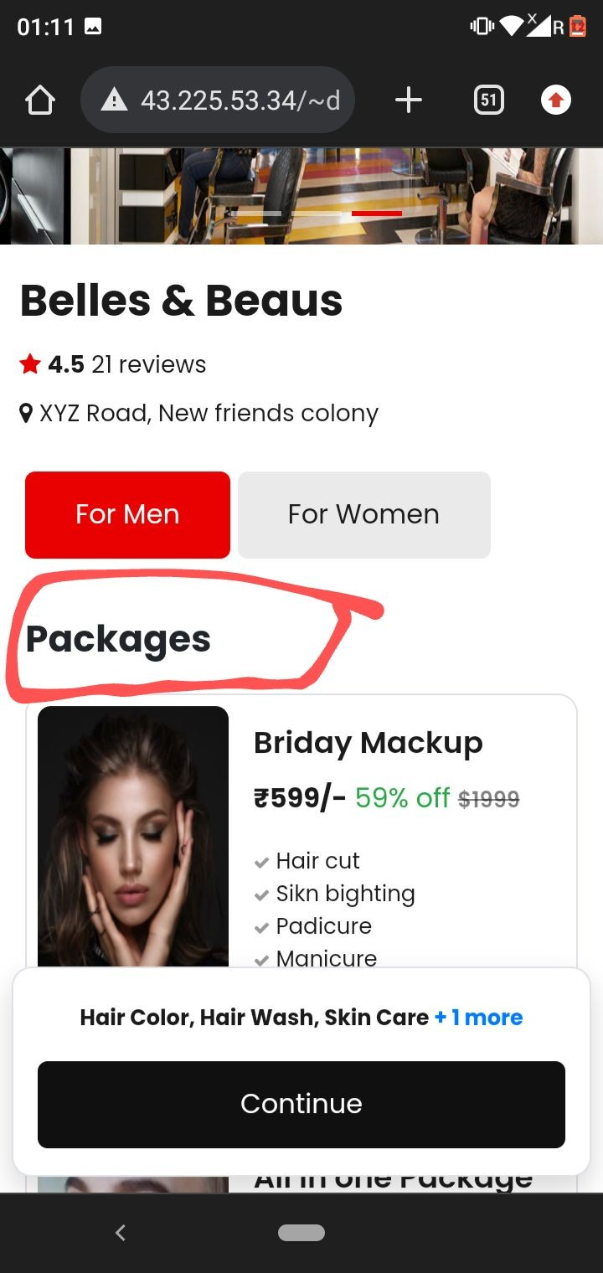
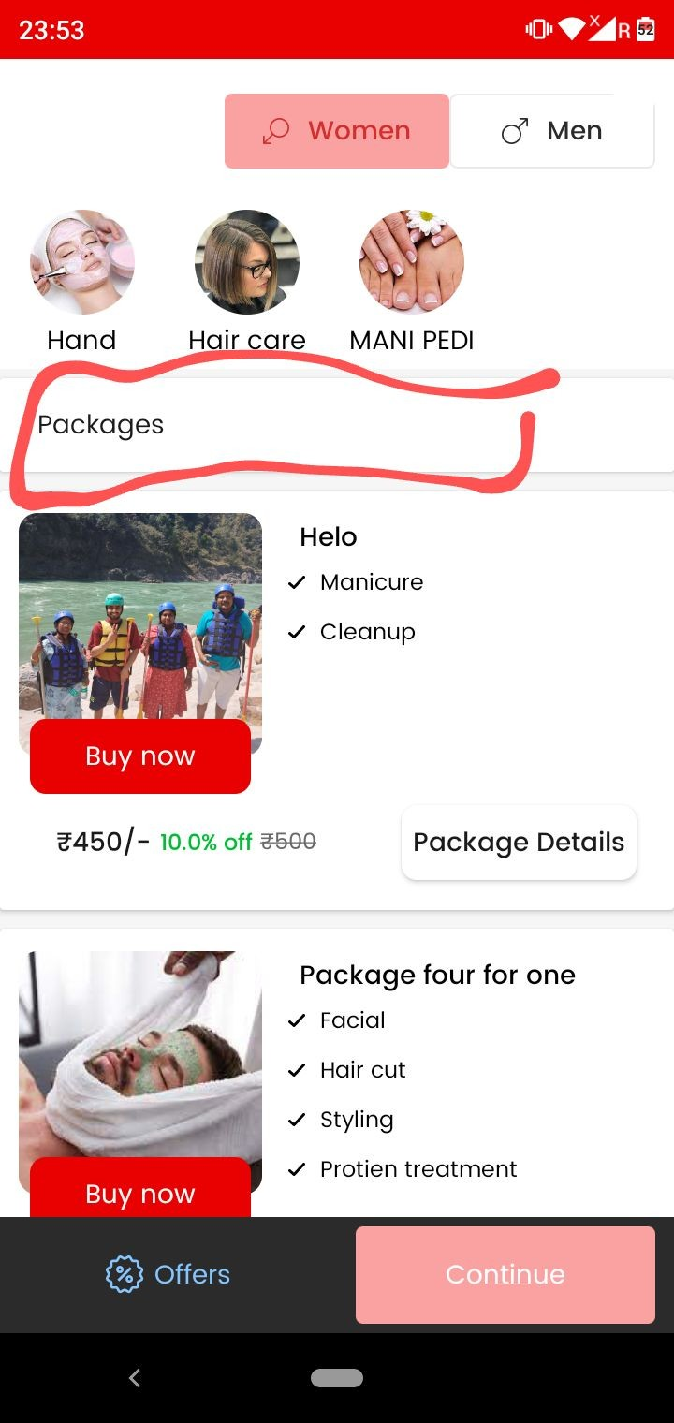

As marked in screenshot one
      - Make package heading more big in size and dark bold in text and color …. As done same in screenshot two ..

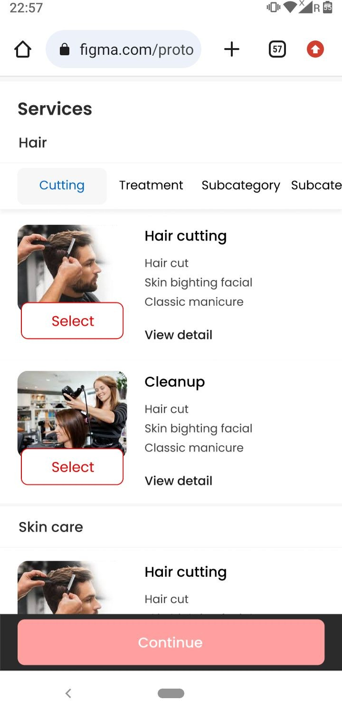
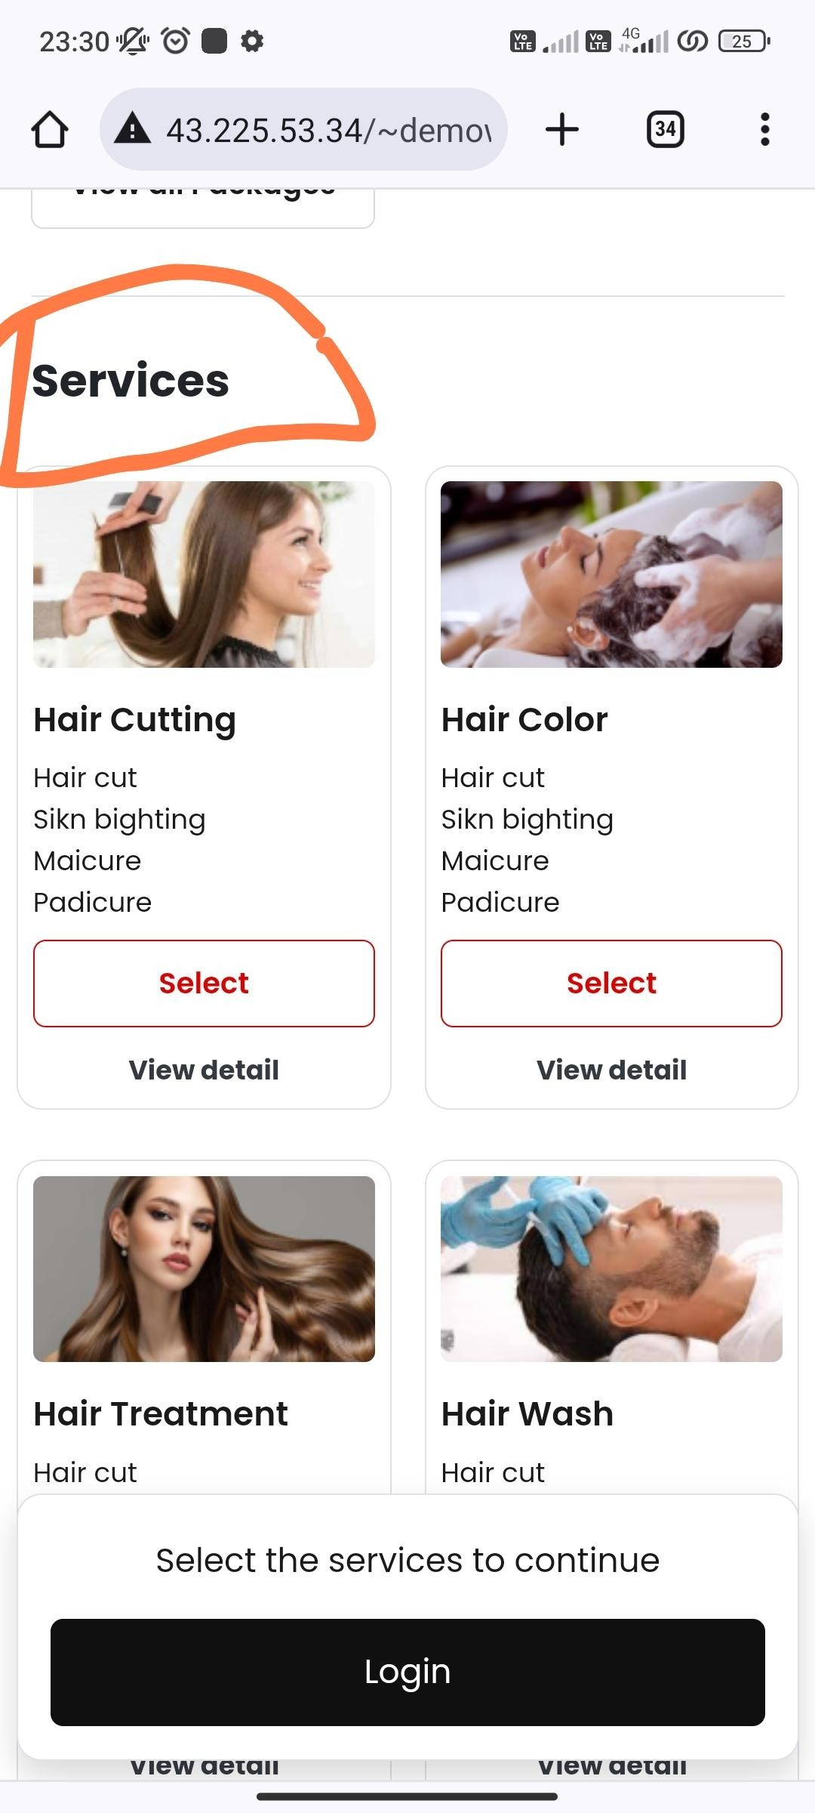
Make like this - Ki packages khatam hone ke baad…..Services ki ek big heading aaye and after uske neeche services start ho .
As shown in screenshot one

- And ye services ki heading tabhi dikhaai degi jab packages honge otherwise guest user ke liye direct services show hongi.. (No service heading)
Service heading ka size screenshot two ki tarah big and bold rakhnaa.

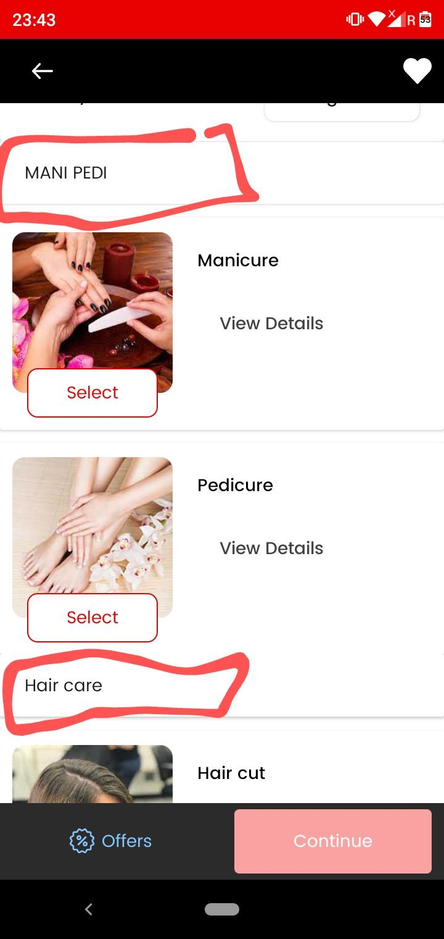

As marked in screenshot one service category heading ko more bold dark in color mein kar do…

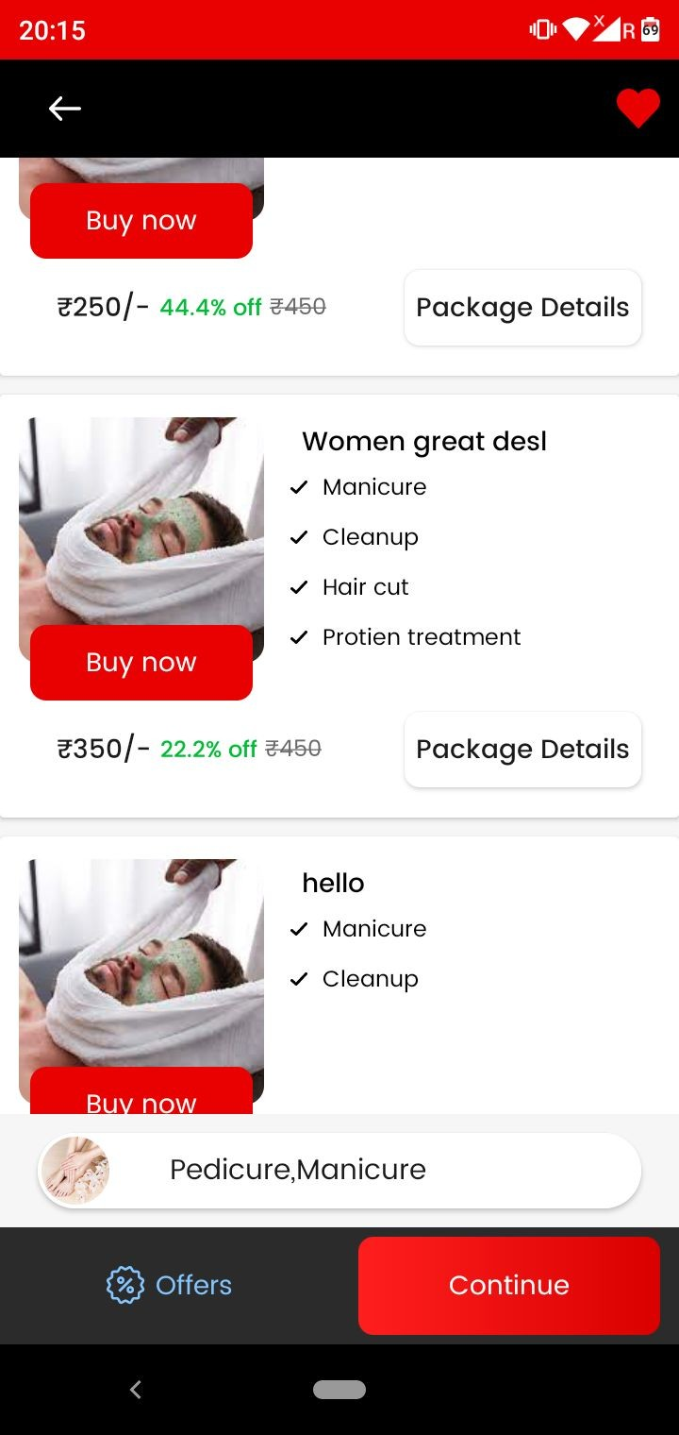

Humm packages mein three services ki limit lagaayenge….that is agar package mein three or more than three services hongi tabhi package dikhaai degaa…otherwise not.

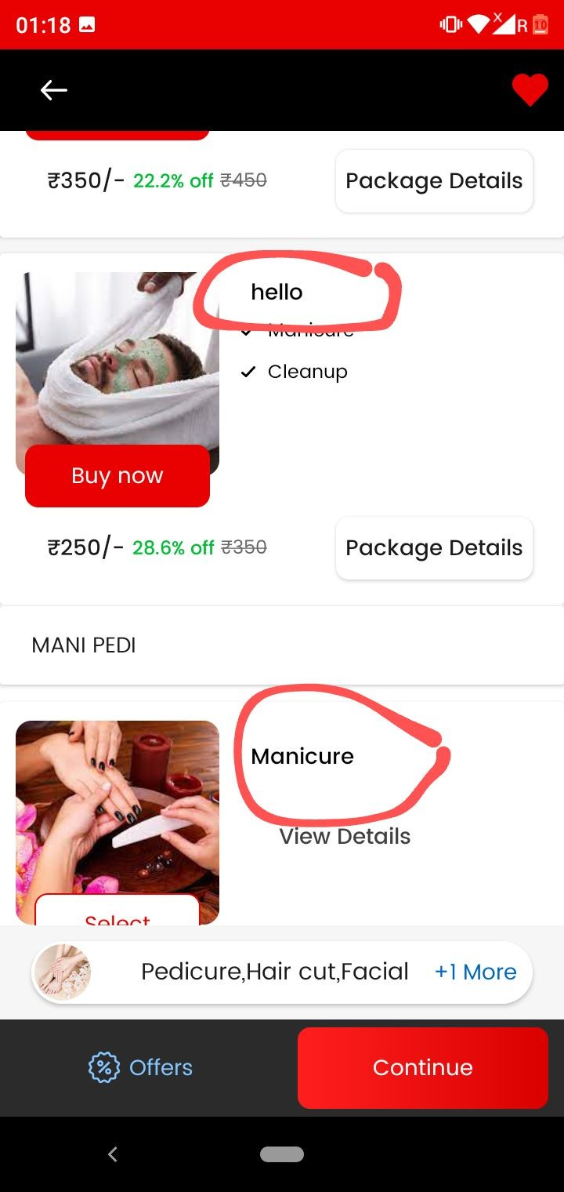
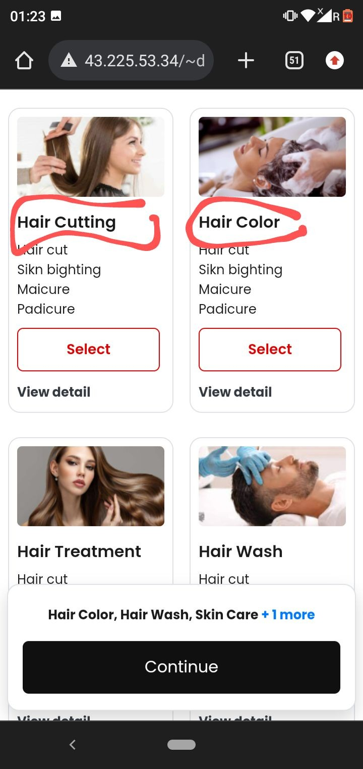

As marked in screenshot one Package Name and Services Name ko bhi dark in color mein kar do.. As done same in screenshot two

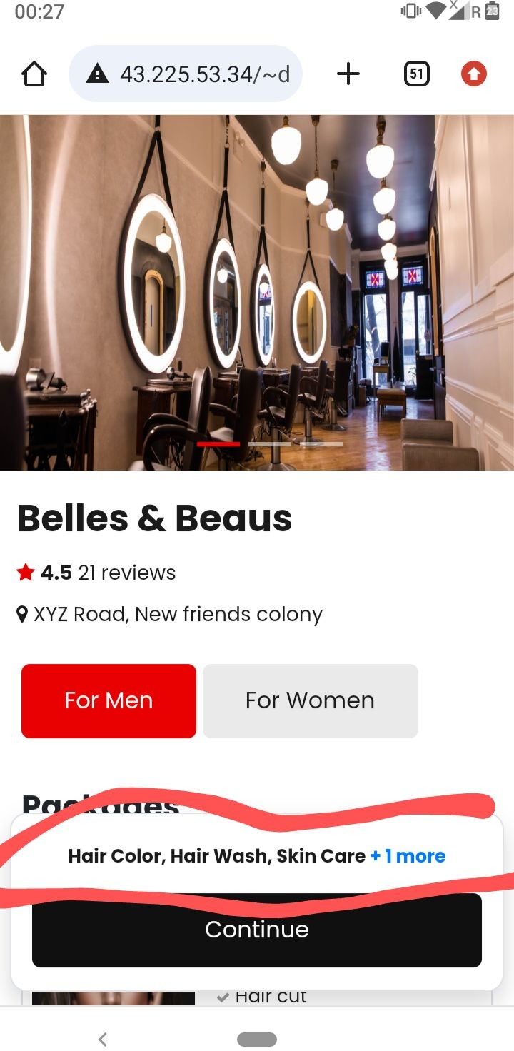
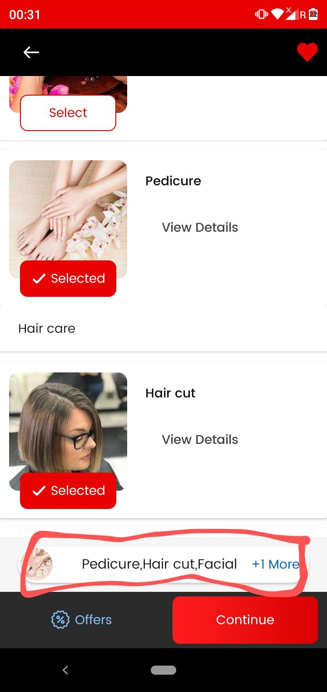

As marked in screenshot one ye jo single services selected and +1 more hai isko little dark bold in color mein kar do jaise screenshot two mein kiya hai.

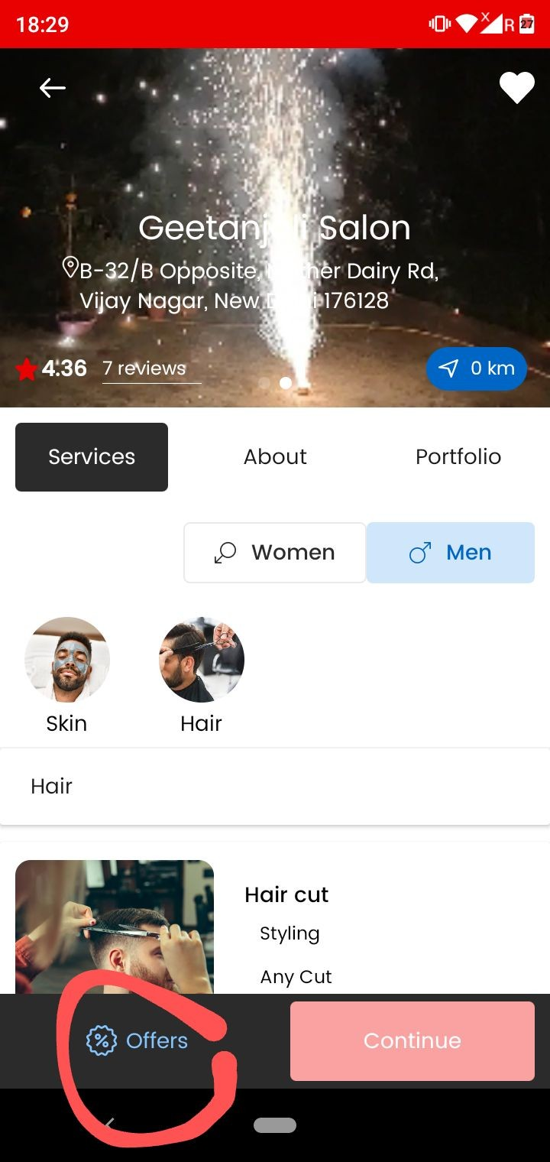
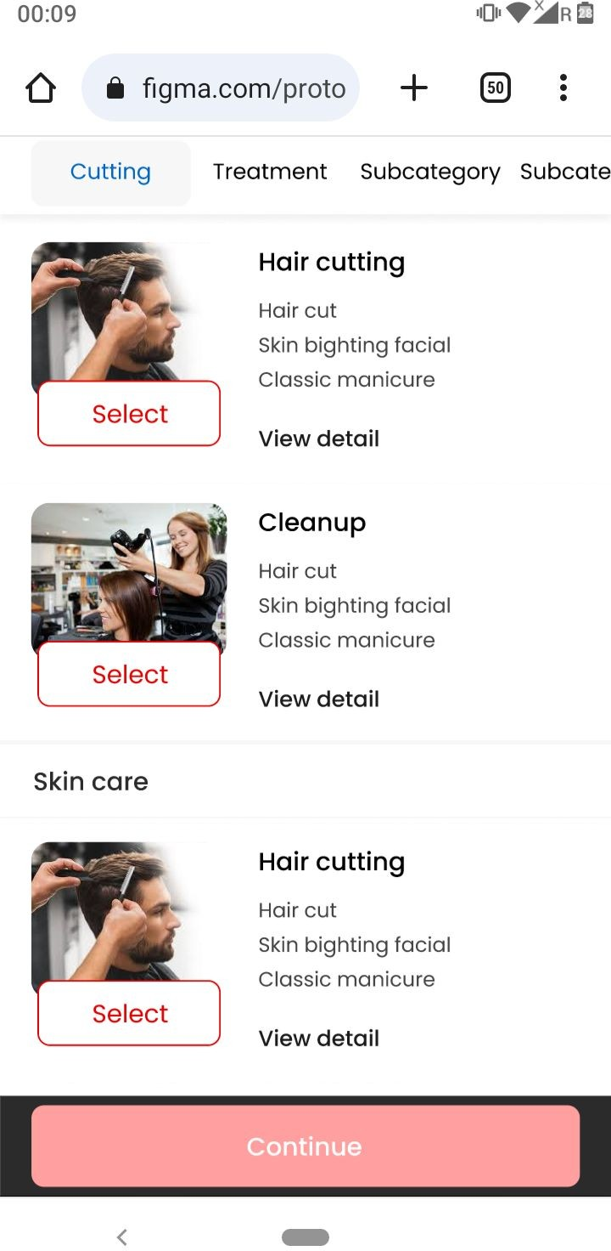Ye jo marked offers button hai tabhi dikhaai degaa jab issme vendor ne offer daala hoga other wise nahi ……

    - Make like this - jo continue button without offers screenshot two ki tarah long and stretch ho jaayega but working same rahegii

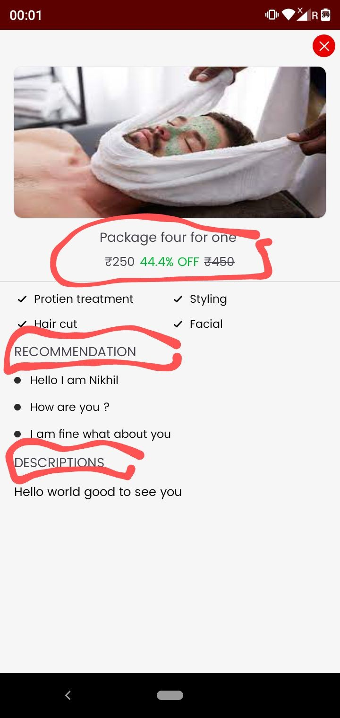
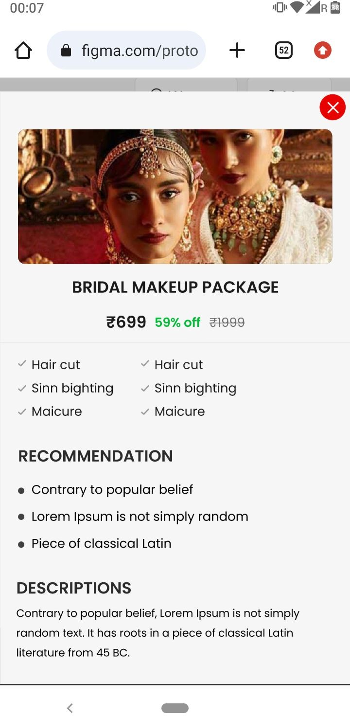

Package details
As marked in screenshot Package name and price , Recommendation, Description ko dark bold in color mein kardo…..jaise design mein kiya hai as shown in screenshot two

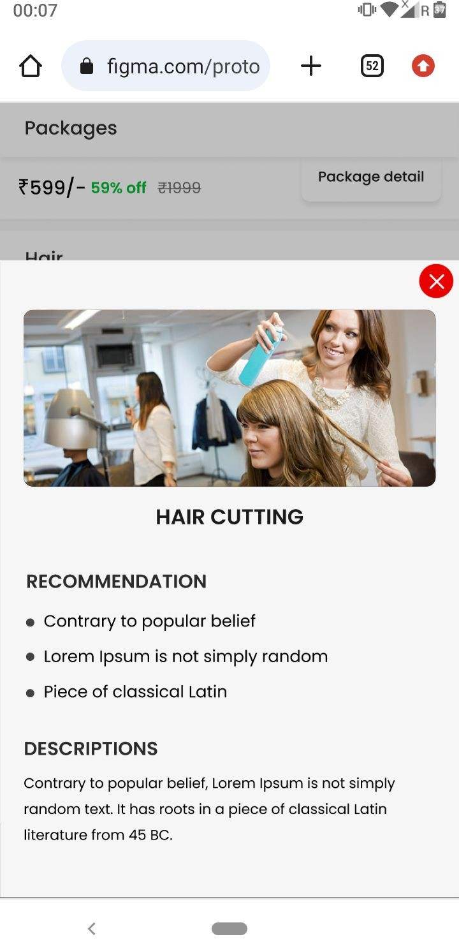
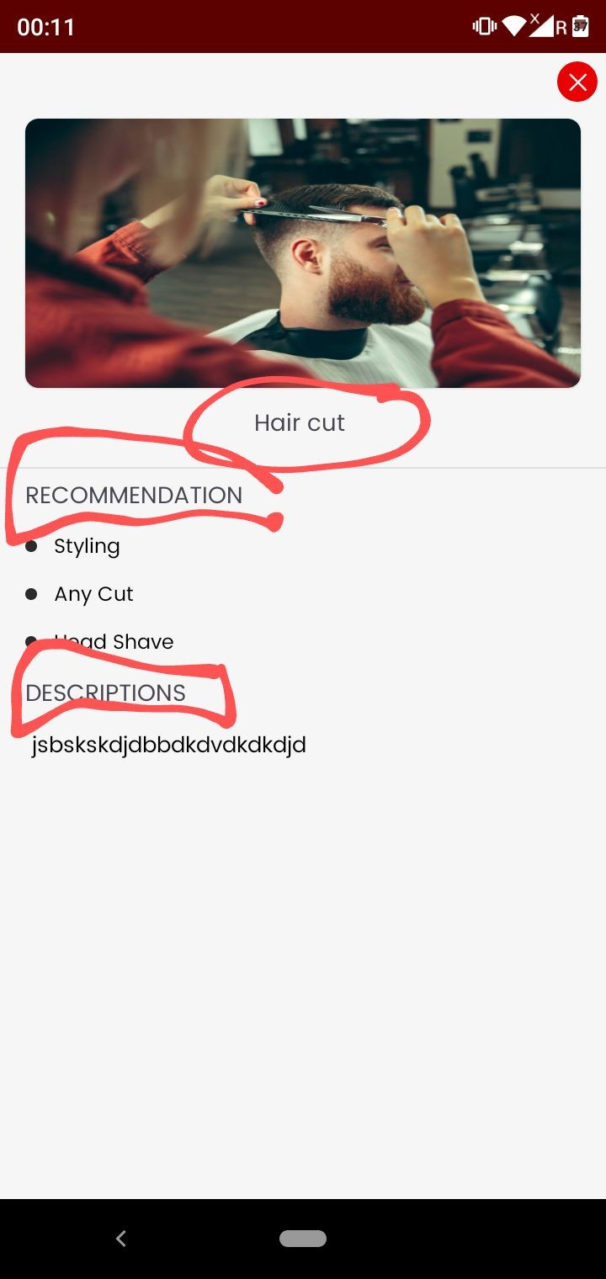

As marked in screenshot Service name , Recommendation, Description ko dark bold in color mein kardo…..jaise design mein kiya hai as shown in screenshot two

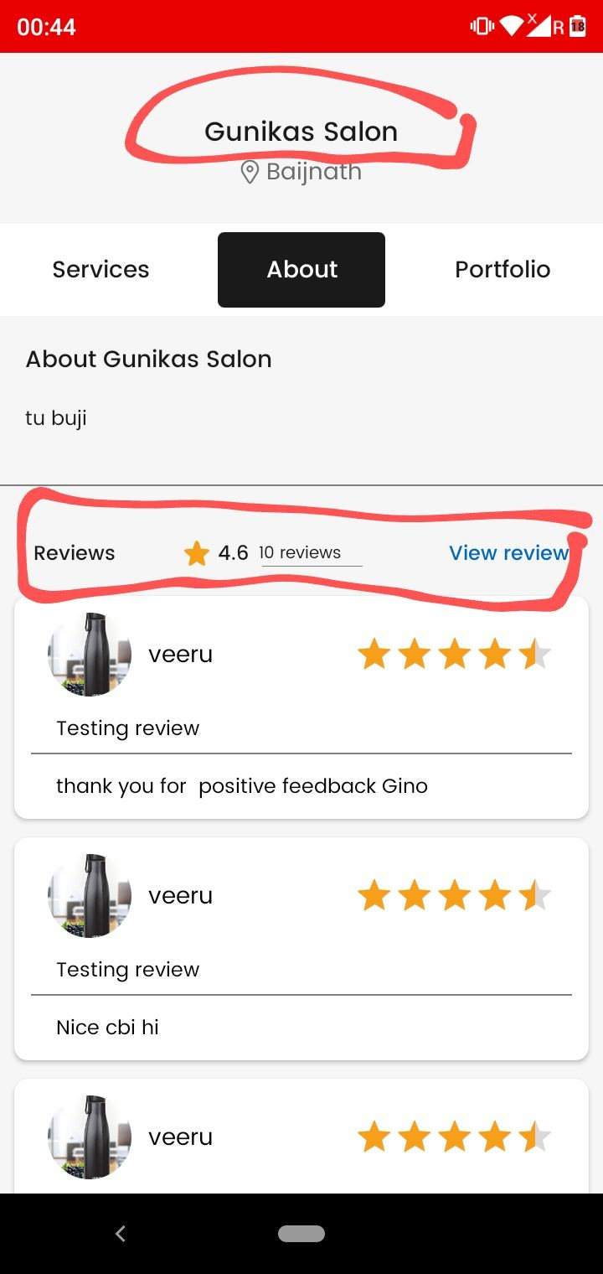
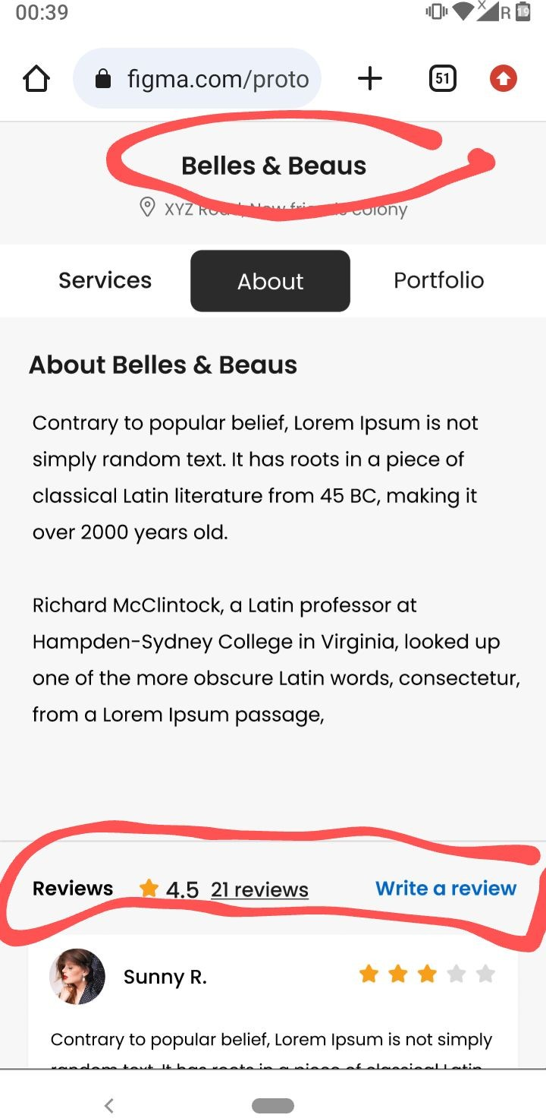

As marked in screenshot one salon name ko bold kar do jaise screenshot two mein kiya hai….
And reviews section ka size bhi thodaa badaa kar do.

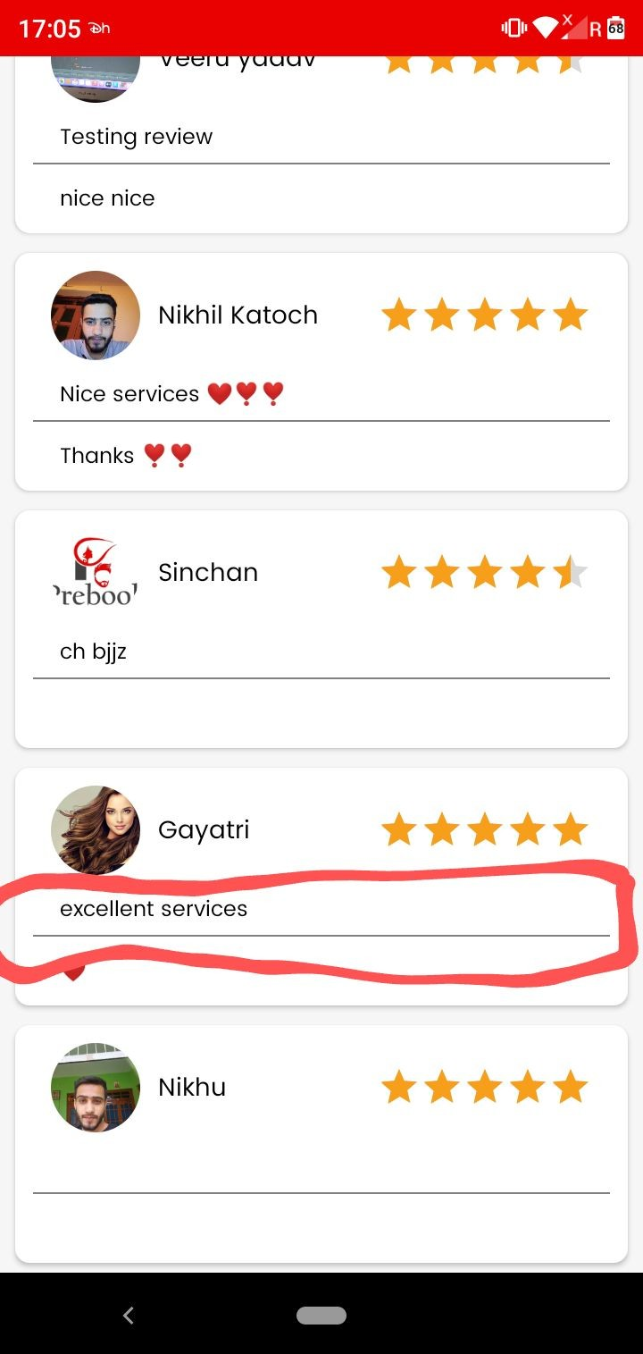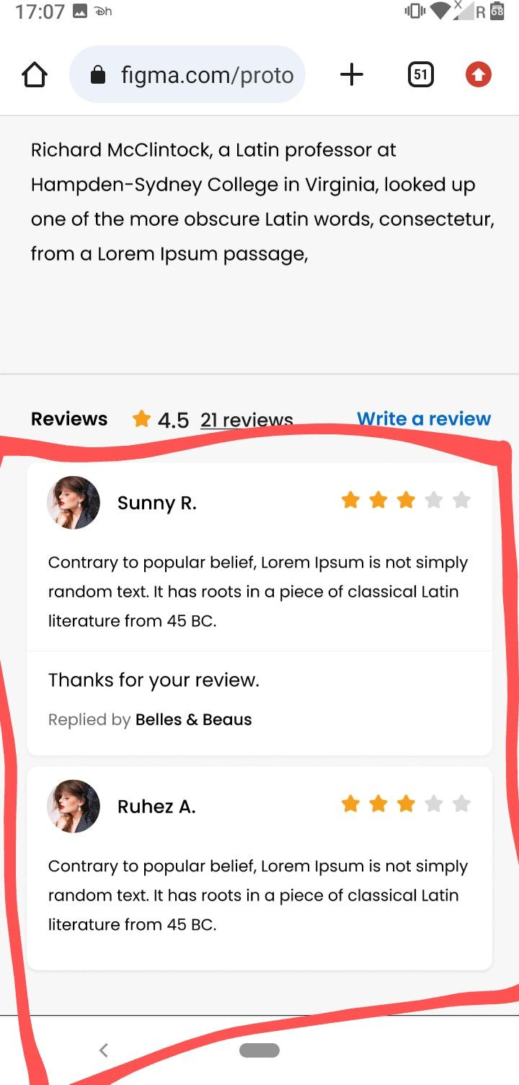Reviews - User app
    - As marked in screenshot one jo line user review and salon reply ko differentiate ka rahi usse light in colour kar do….jasie design mein kiya hai. Screenshot two

    - Jab salon ne review pe reply nahi kiya hoga .. tab line bhi show nahi hogi…example second review in second screenshot. ( as done same in Design)

    - Jab salon ne review reply kiya hogaa …tab wahan pe replied by salon name show hogaa …… second screenshot first review.

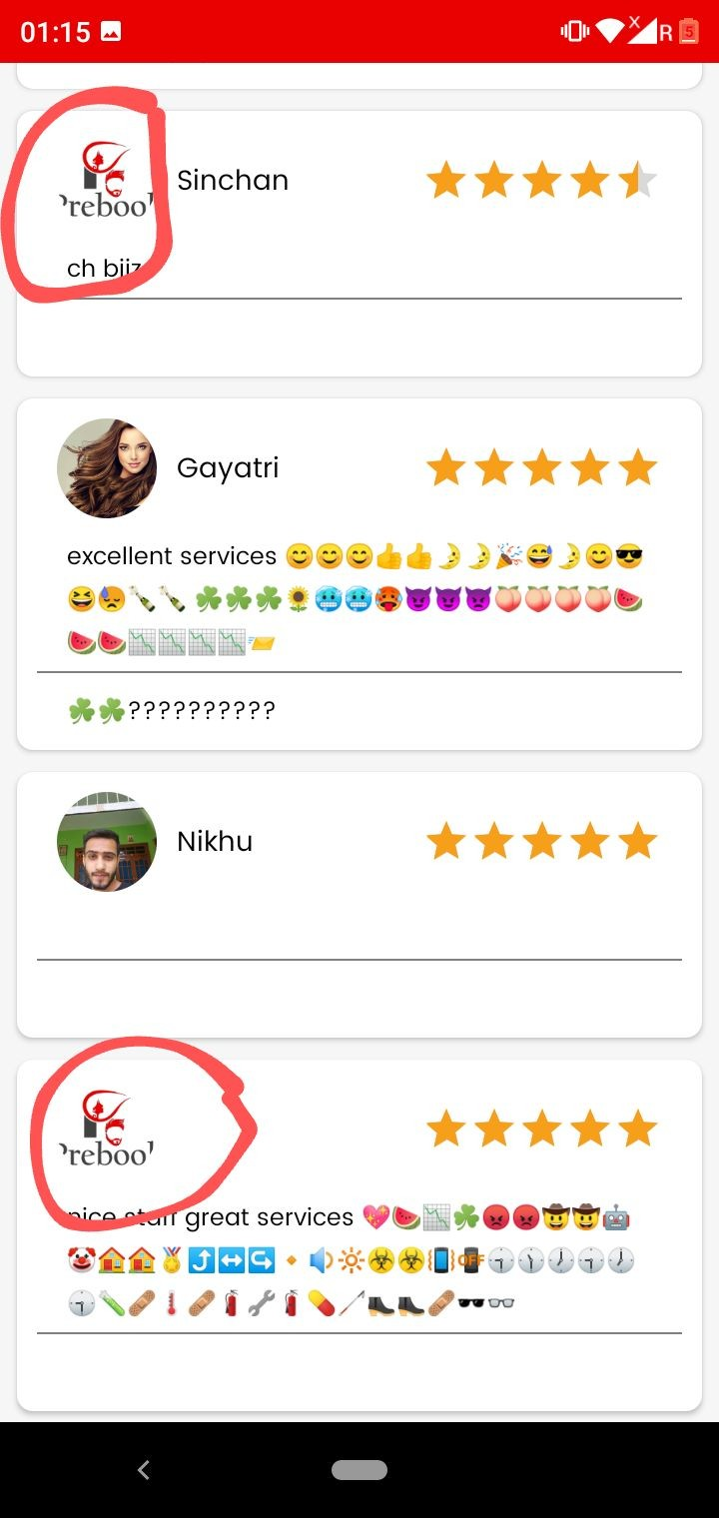

Reviews - User app
As marked in screenshot jab user ne profile image add nahi ki hogi tab reviews pe profile icon dikhegaa..shown in screenshot two

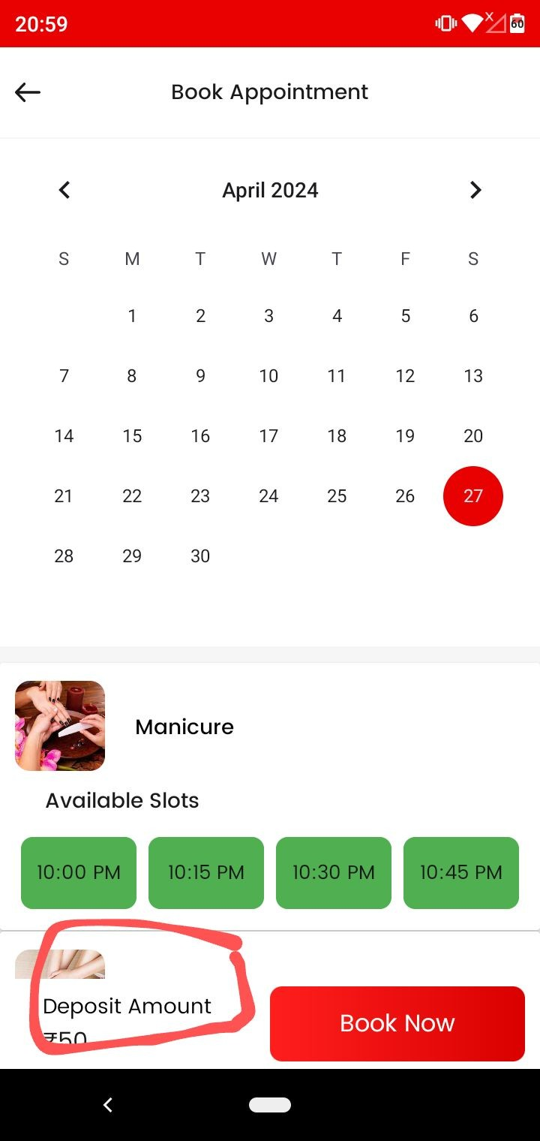

      - As marked replace the word Deposit amount to Deposit.

      - Make the word deposit in dark bold letter..

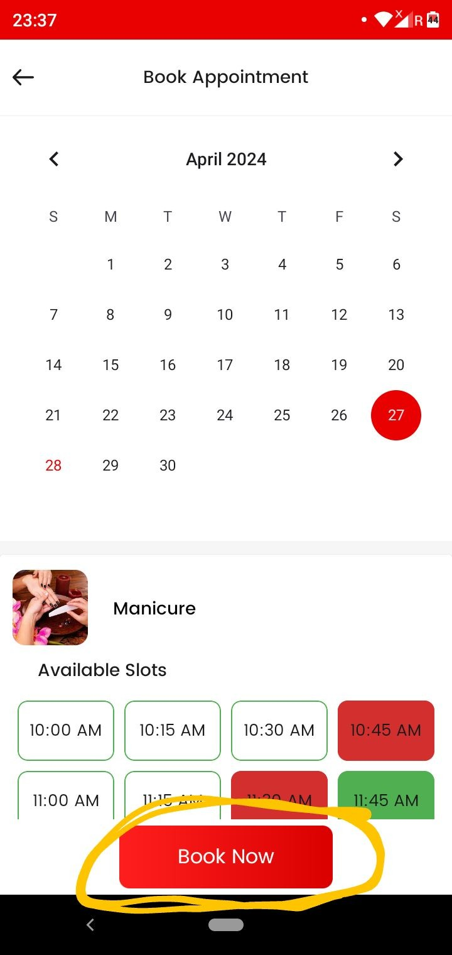
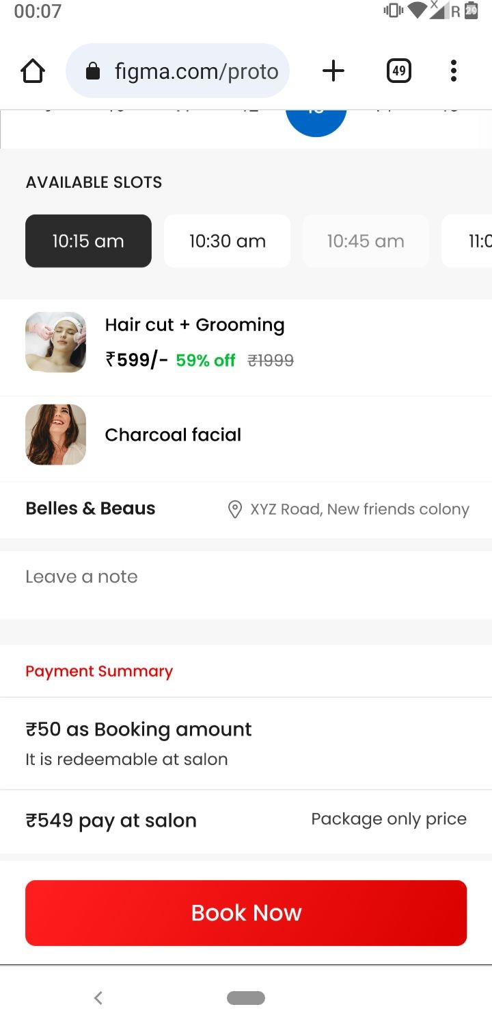

Deposit zero amount - Case
Jab deposit amount zero hogaa tab book now ka button long and stretch ho jaayegaa jaise screenshot two mein kiya hai …

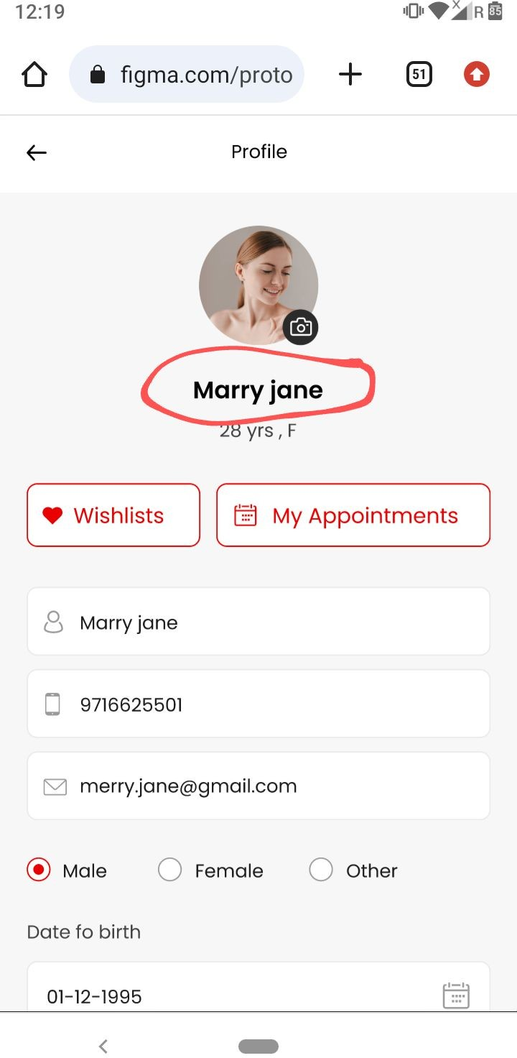
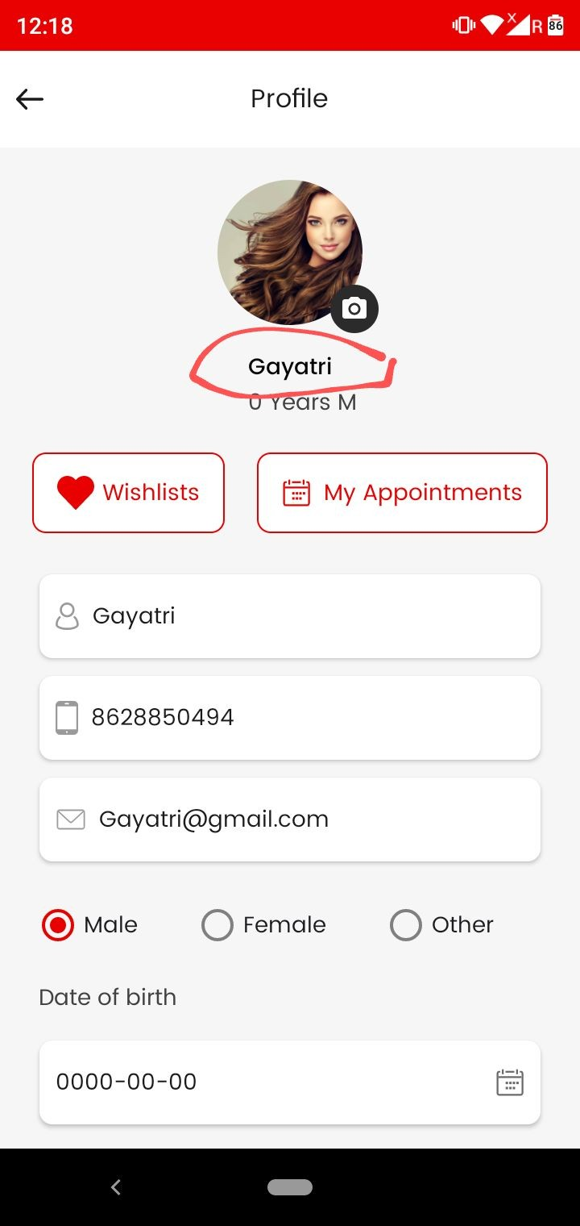

User app
As marked in screenshot one name ko bhi dark bold color mein kar do…. Make like as done in design shown in screenshot two.

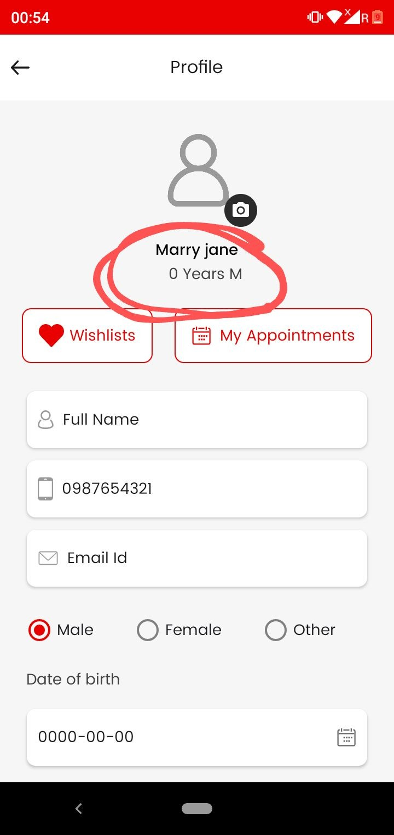

As marked in screenshot jab tak full name , gender and date of birth add nahi ki hogi tab tak kuch bhi nahi dikhegaa.
Marked area pe.

Jab add karenge tab dikhegaa other wise only profile will show

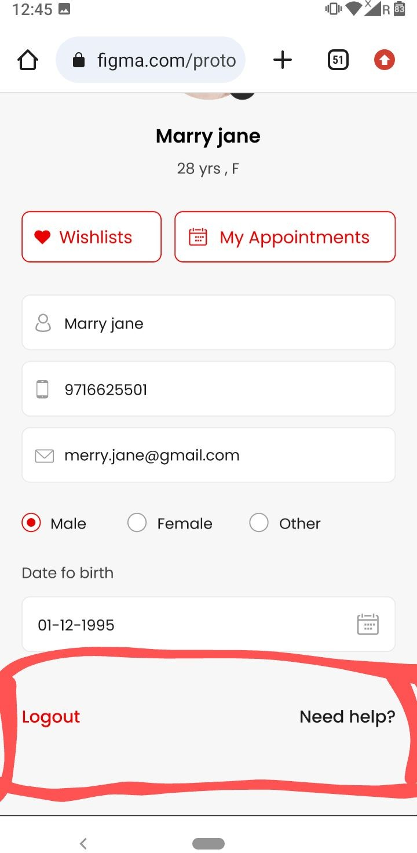
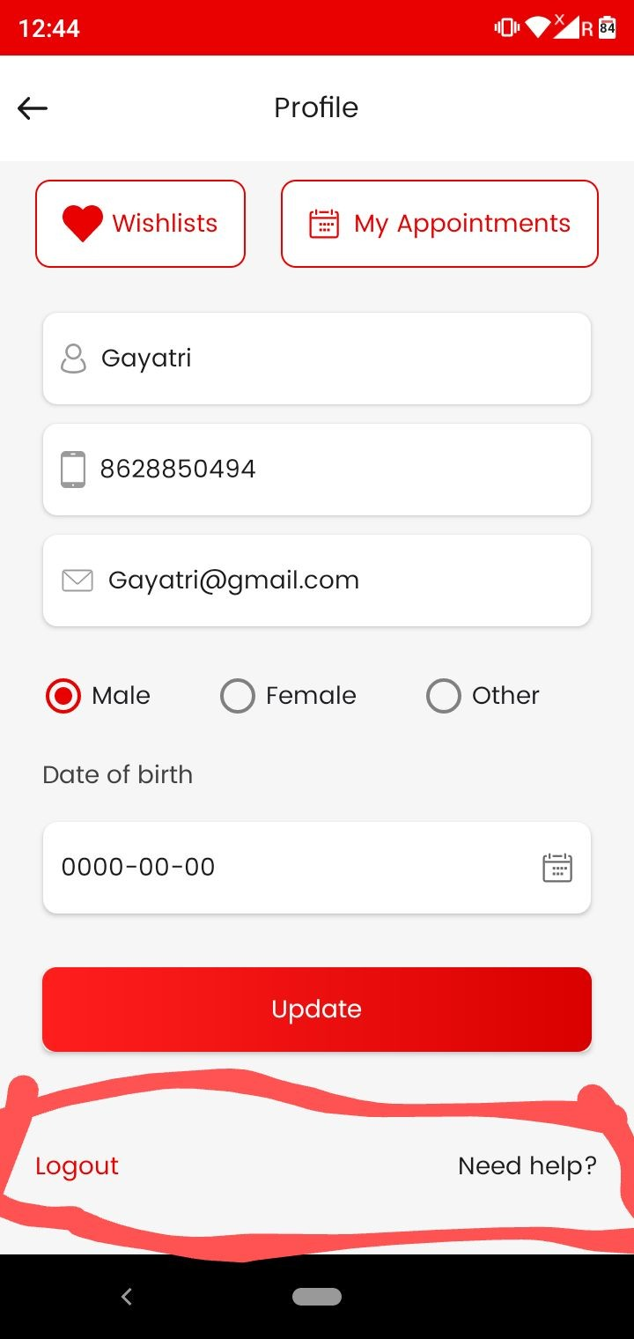

As marked make logout and need help dark bold in color shown in screenshot two.

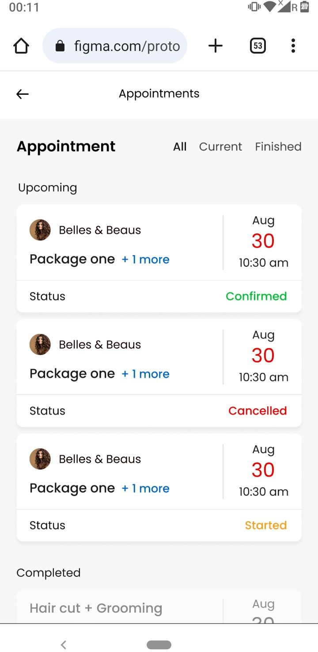
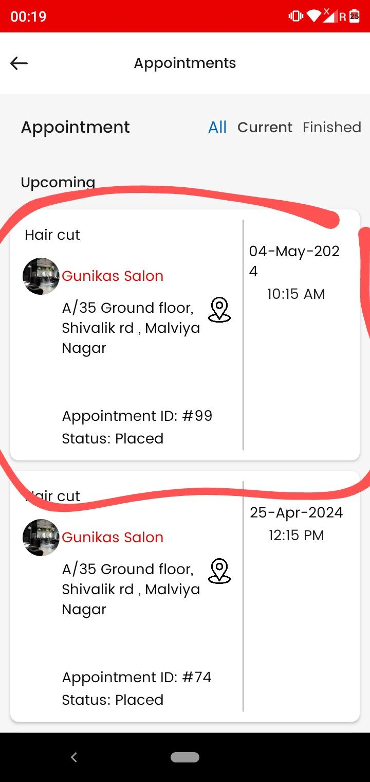

https://www.figma.com/proto/4Ch7JRtBOgWB3dCMg KyGIn/Prebook?page-id=0%3A1&type=design&node-i d=209-1423&viewport=-5079%2C-292%2C0.76&t=wA
UOx8sFqIAIzQcS-1&scaling=scale-down&starting-poi nt-node-id=26%3A686&mode=design

      - As marked in screenshot one appointment box presentation ko …..screenshot two ki tarah kar do….You can see it also at figma for more clearity mention above the link.

      - Status ( Confirmed , Started, and completed/cancelled) all three cases ko screenshot two ki tarah kar do

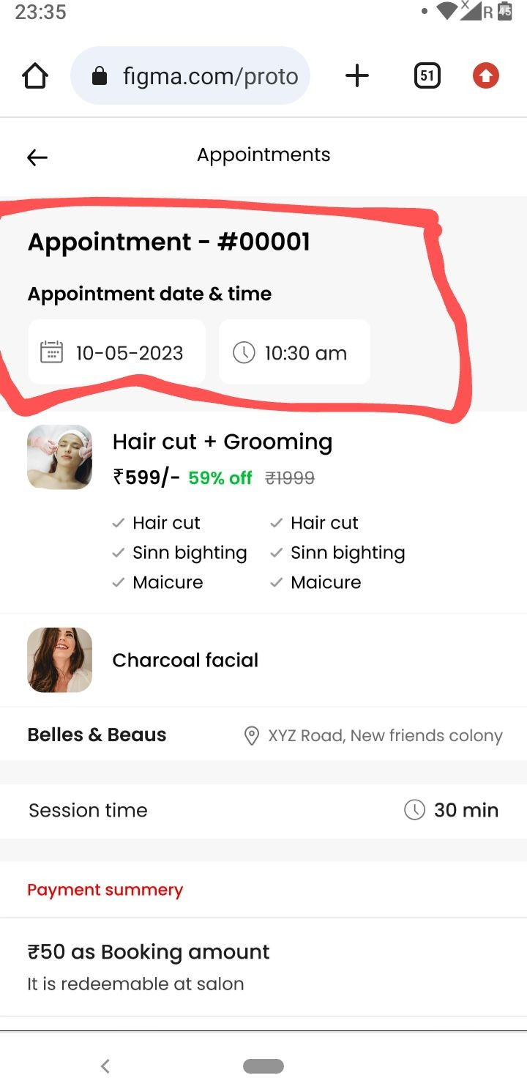
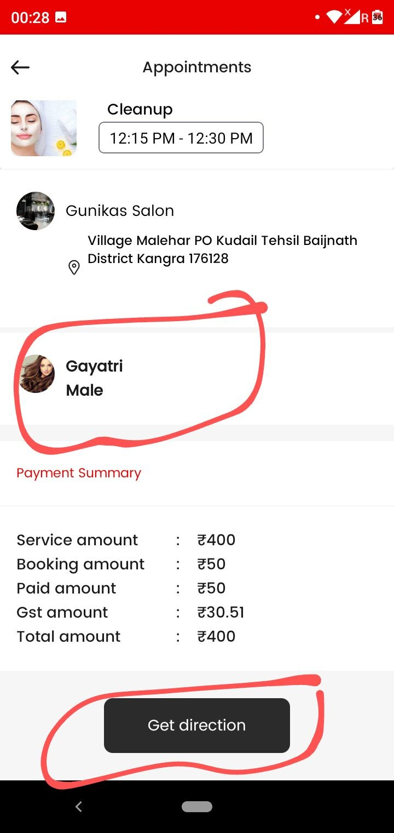
Appointments- User app
    - Represent (Appointment id and Appointment date and time ) in user app at top as done in design and shown in screenshot one.

    - Remove the marked as shown in screenshot two.

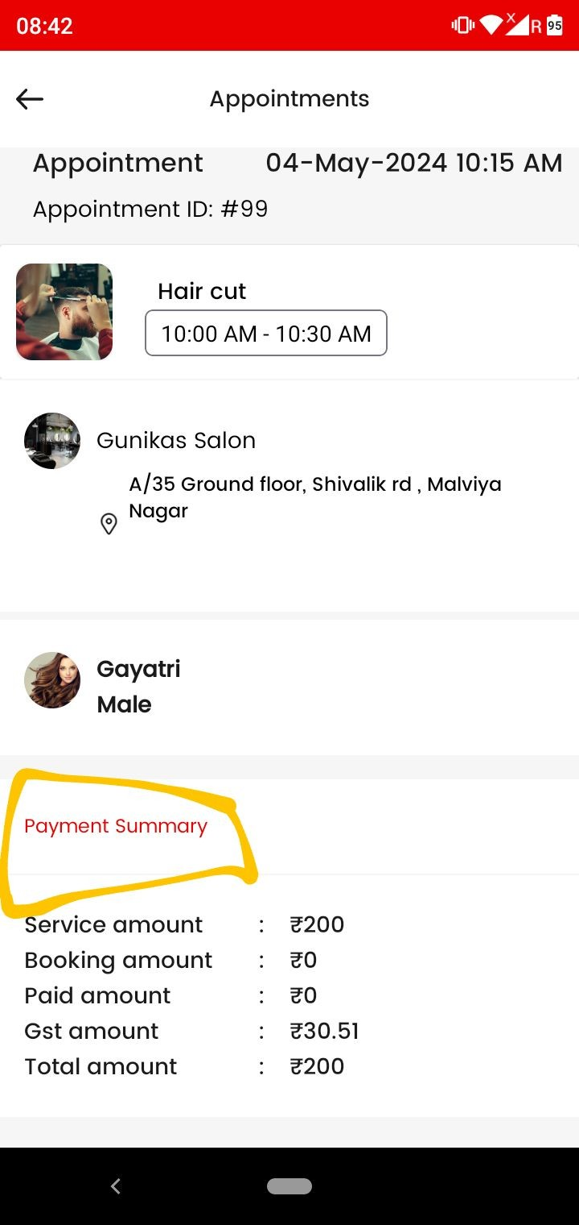

As marked payment summary make this dark in color

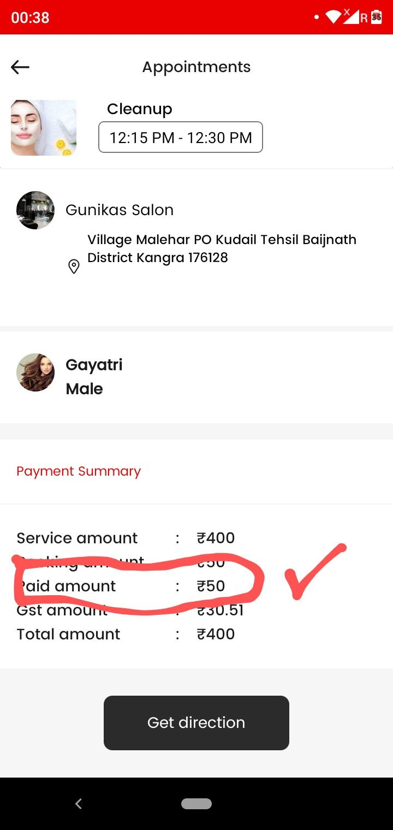

Appointments- User app (Payment summary)

Single services case -;
In single services we will only show Paid amount and remove the rest .

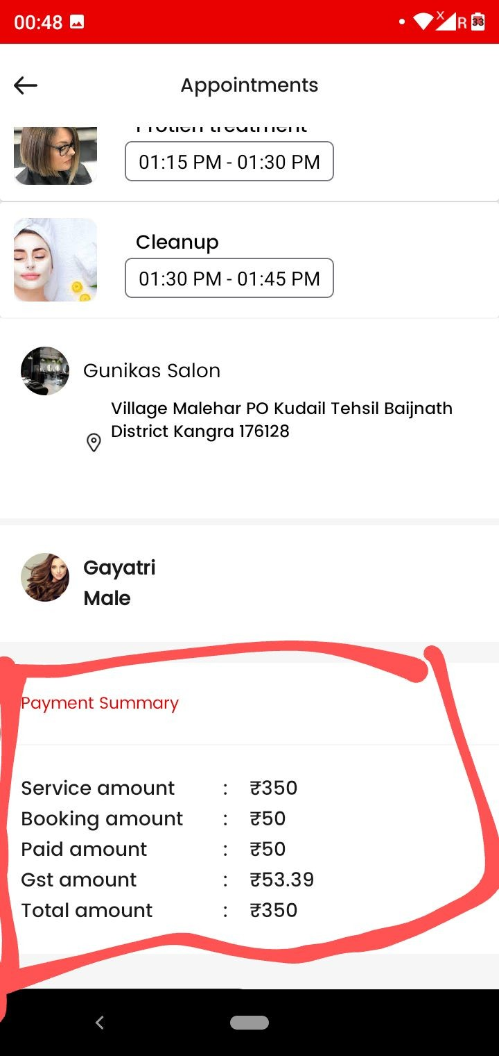

Appointments- User app (Payment summary)

Package case -
In this case we will show only Package amount , Paid amount and Amount left to pay.
Make the payment summary like this.

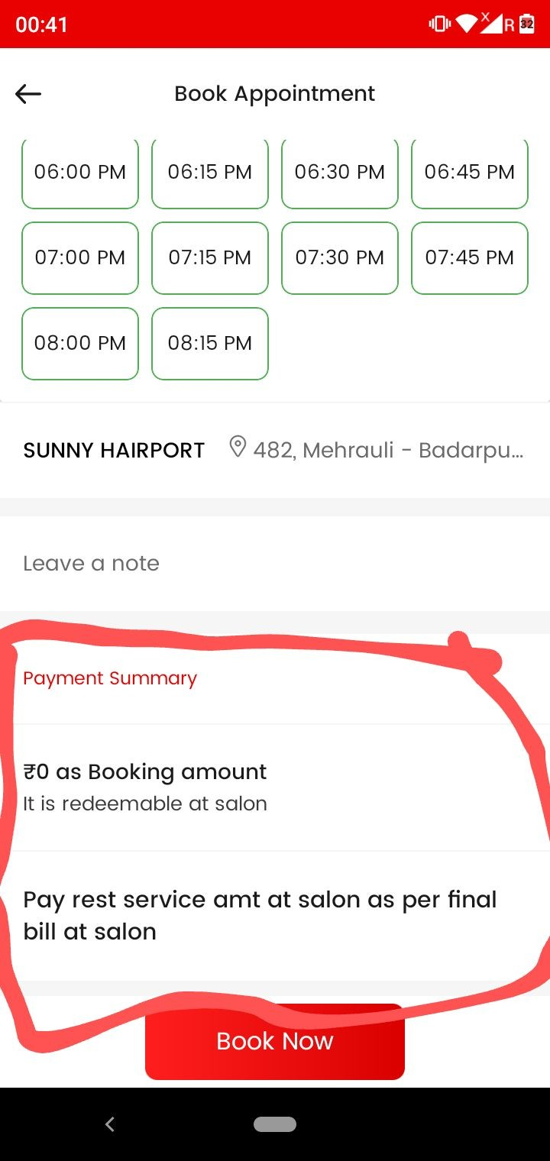
Appointments- User app
(Payment summary)

Jab bhi booking amount zero hogaa…tab payment summary nahi dikhegii

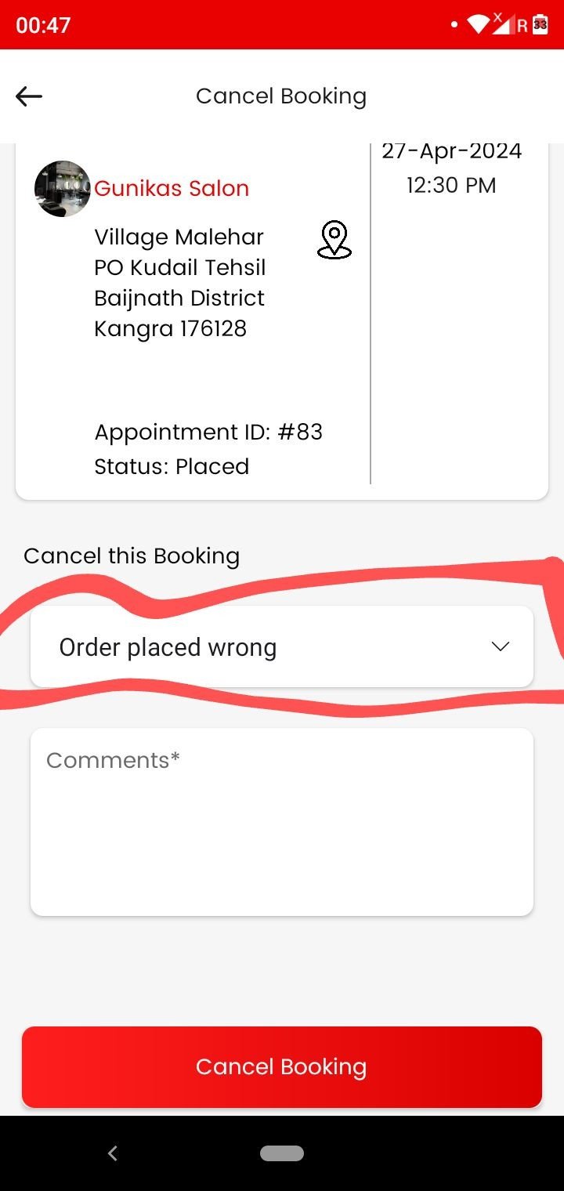

Cancel booking
Remove the marked in screenshot.

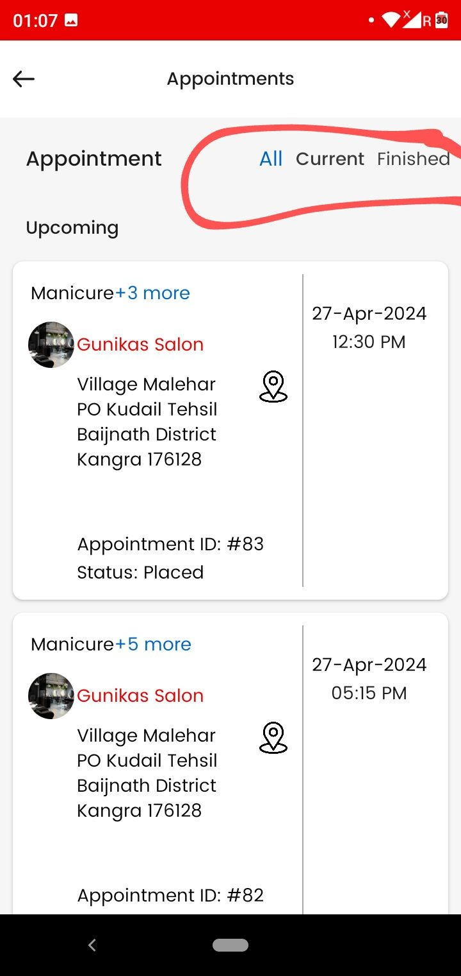
As marked in screenshot
      - (All ,current ,finished) is not working properly
That is ki jo marked hai in screenshot uska working rahega….ALL - pe upcoming appointments……Current - pe jo bookings vendor ne start kar di hai wo…..and Finished pe jo bookings completed ho gyi hai….Make like this

User app

Aisa ho raha ki jab humm finished se , current and all pe ,, jaa rahe to completed appointments bhi all and current pe show ho rahi.
Marked section not NOT WORKING PROPERLY

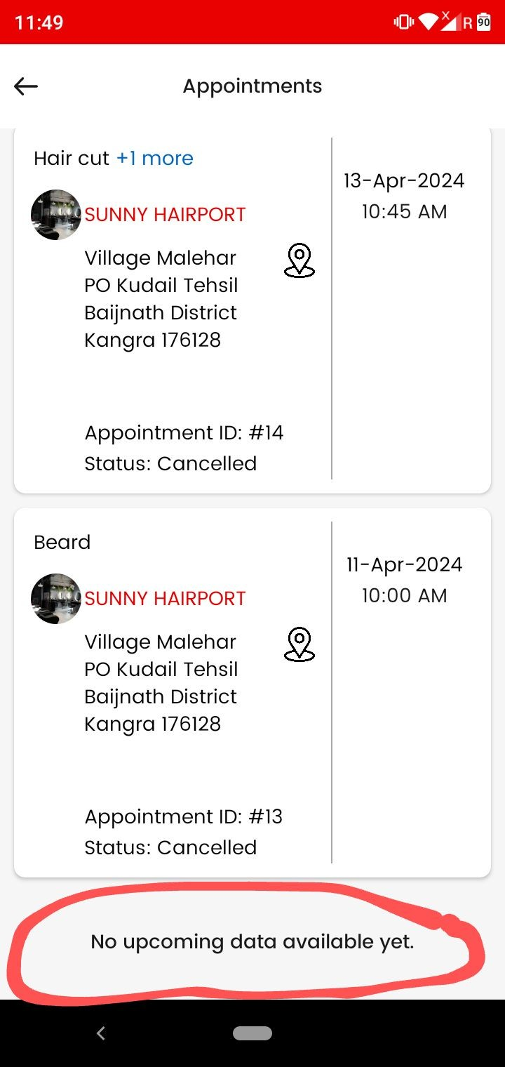
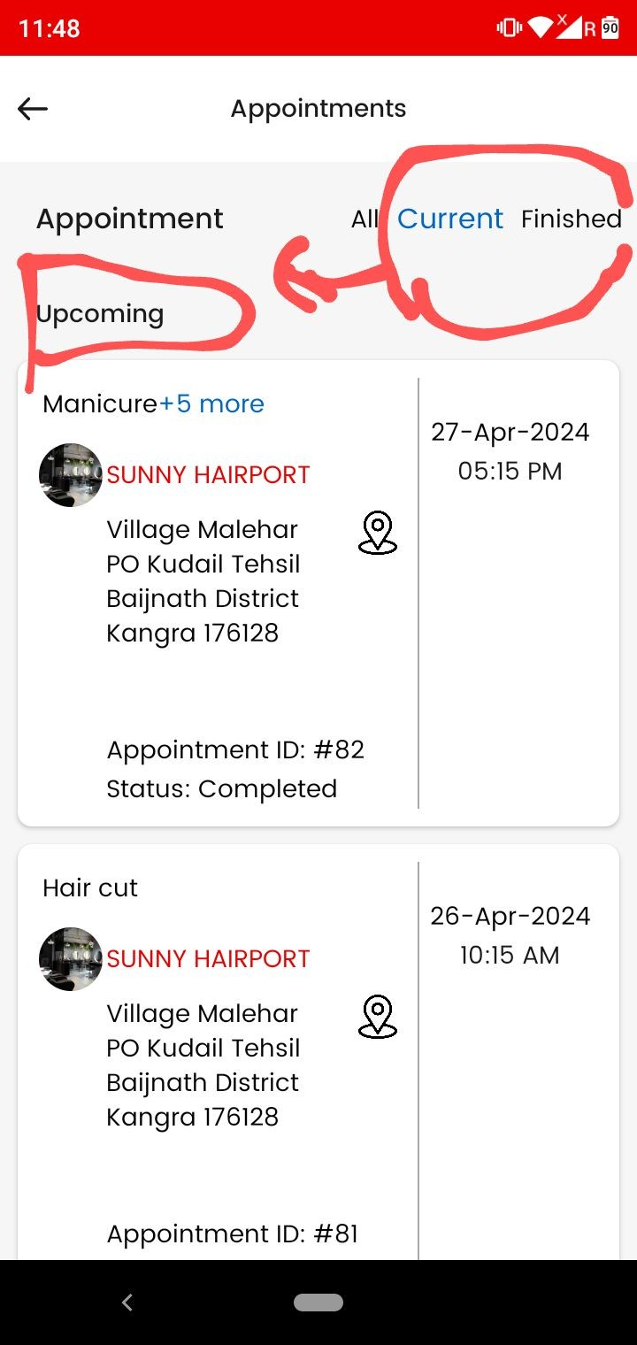

User app
- As marked in screenshot one current and finished pe bhi upcoming likhaa show ho raha….remove this… ALL pe hi Upcoming show hogaa.

- As shown in screenshot two (current and finished) pe appointments hone ke baad bhi neeche ( NO upcoming data availabe yet
) show ho raha remove this.

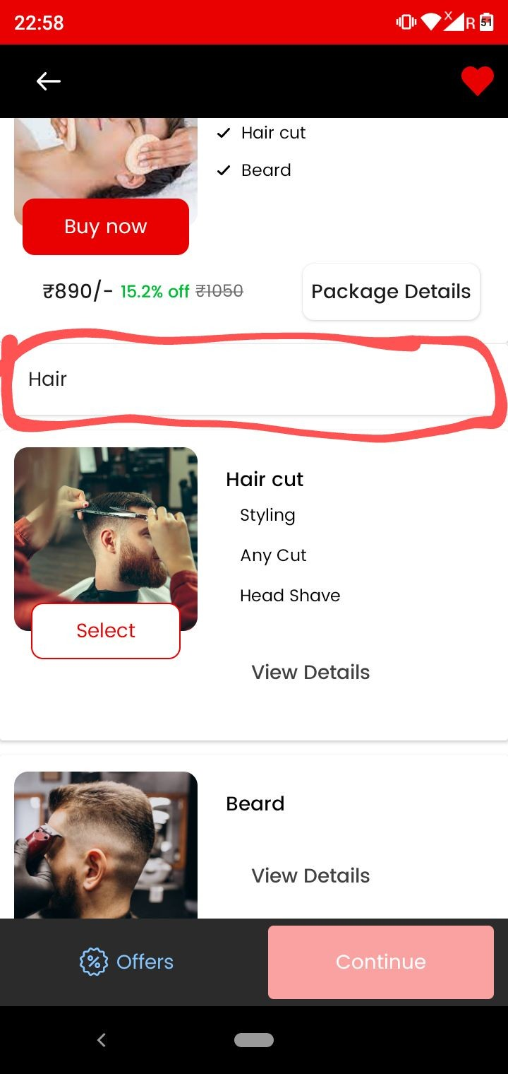
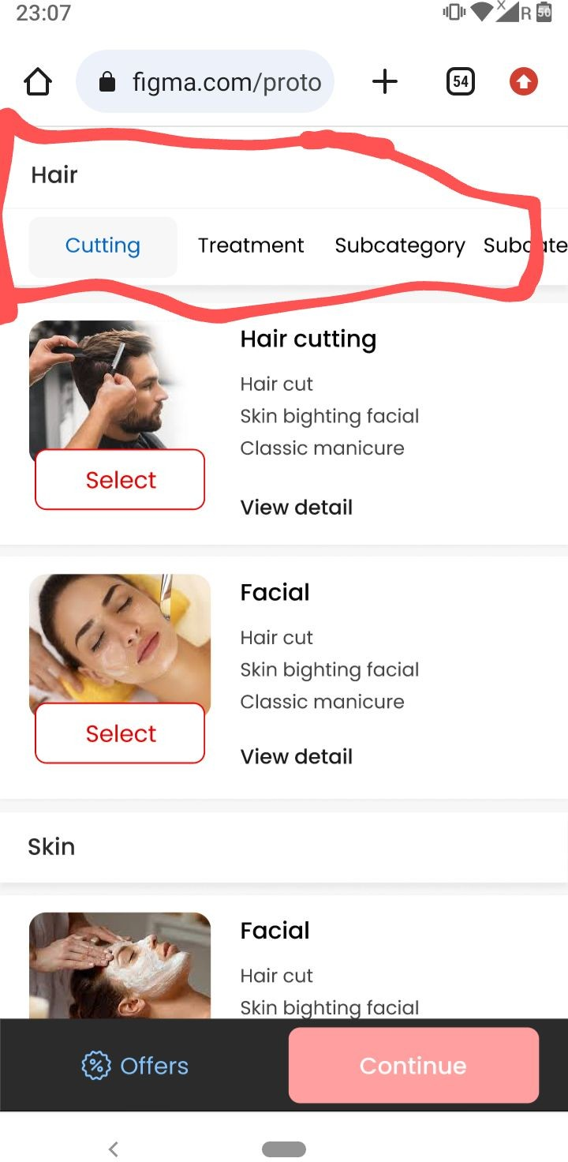

As marked in screenshot Hair ki subcategories and uski services show nahi ho rahi…. Admin se humne inhe bnaake rakha hai…
Example screenshot two.

Vendor app starting

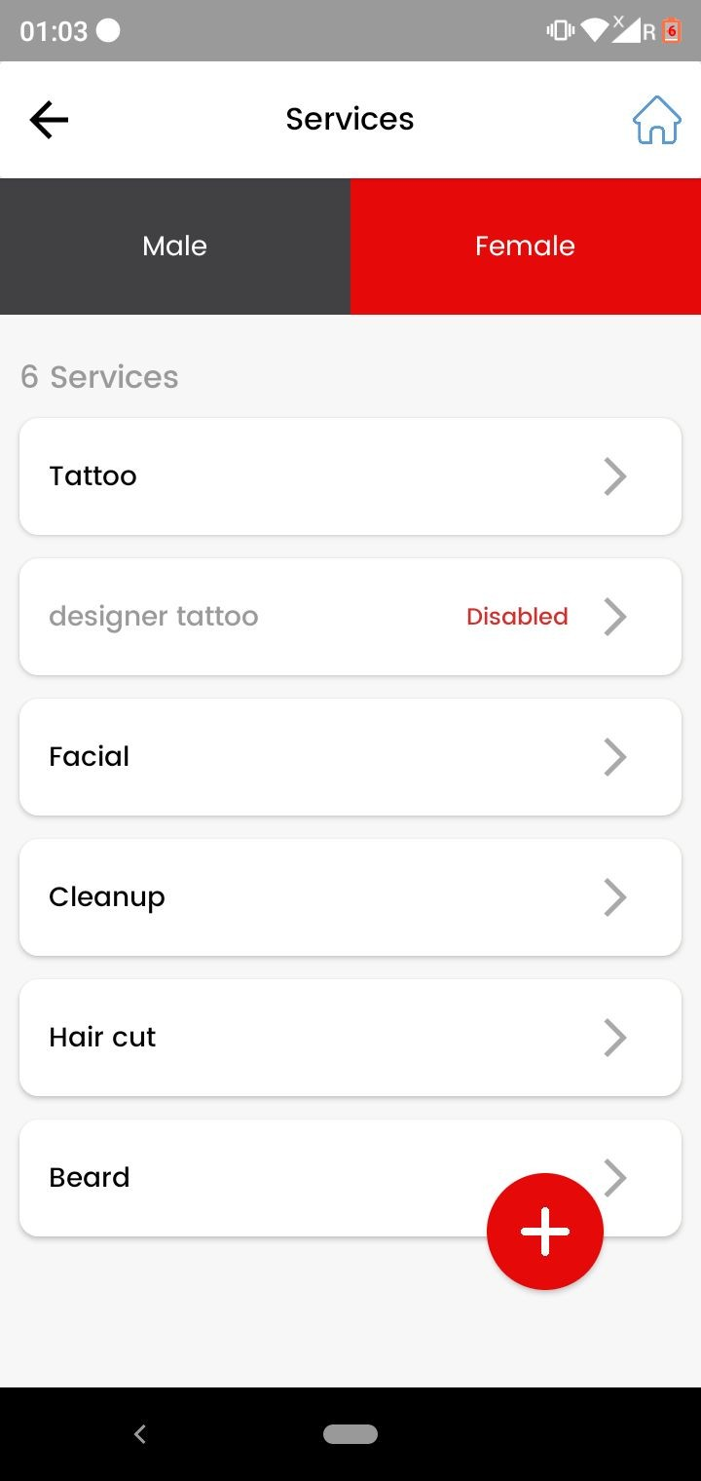

Case - only male services selected
As shown in screenshot male section ki services female section mein dikhaai de rahi.
Vendor app

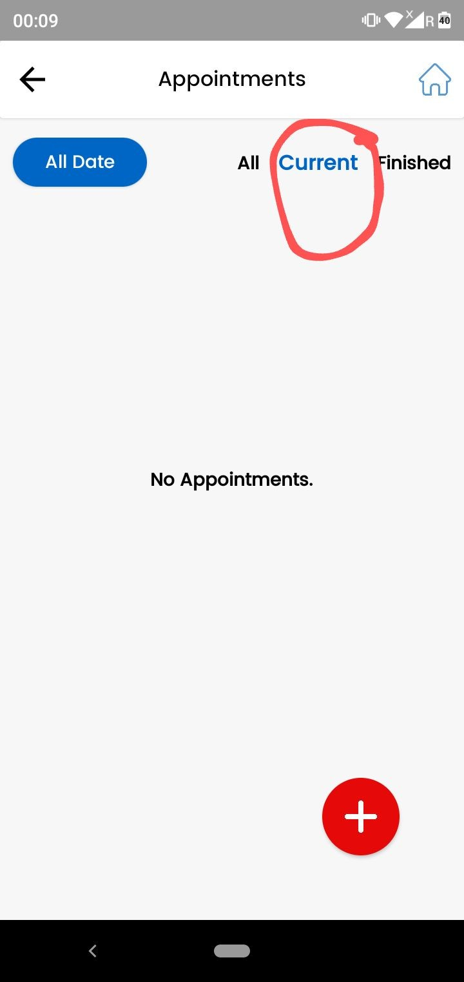
Vendor app - Appointments
As marked in screenshot jab vendor booking start kar raha to
…..Booking current pe nahi jaa rahi but waha se gayab ho jaa rahi…..

Make like this - ALL - pe upcoming appointments……Current - pe jo bookings vendor ne start kar di hai wo…..and Finished pe jo bookings completed ho gyi hai….Make like this

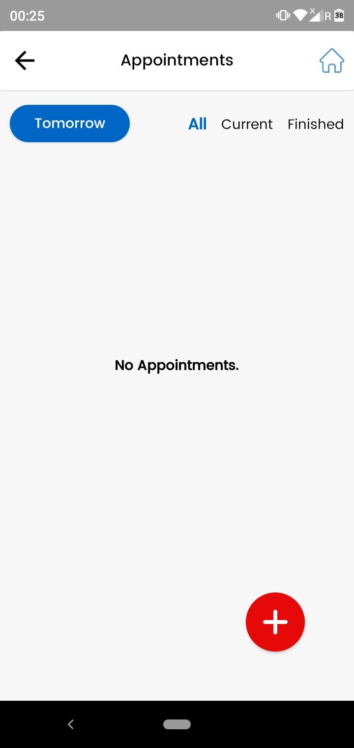

Vendor app - Appointments
- As shown in screenshot tomorrow filter is not working.

- As marked remove this plus button from appointments

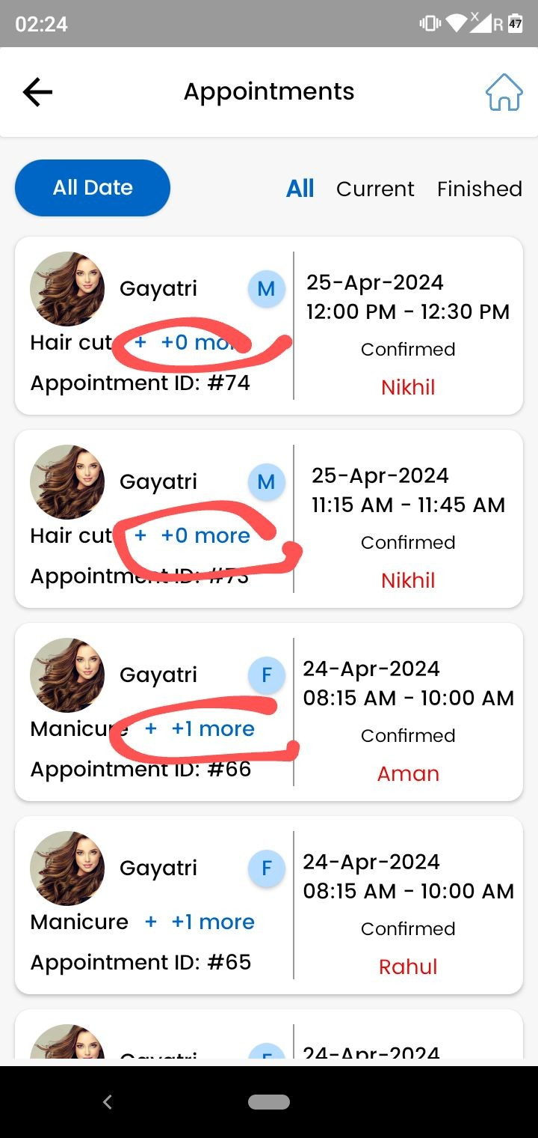

As marked in screenshot make this working properly.

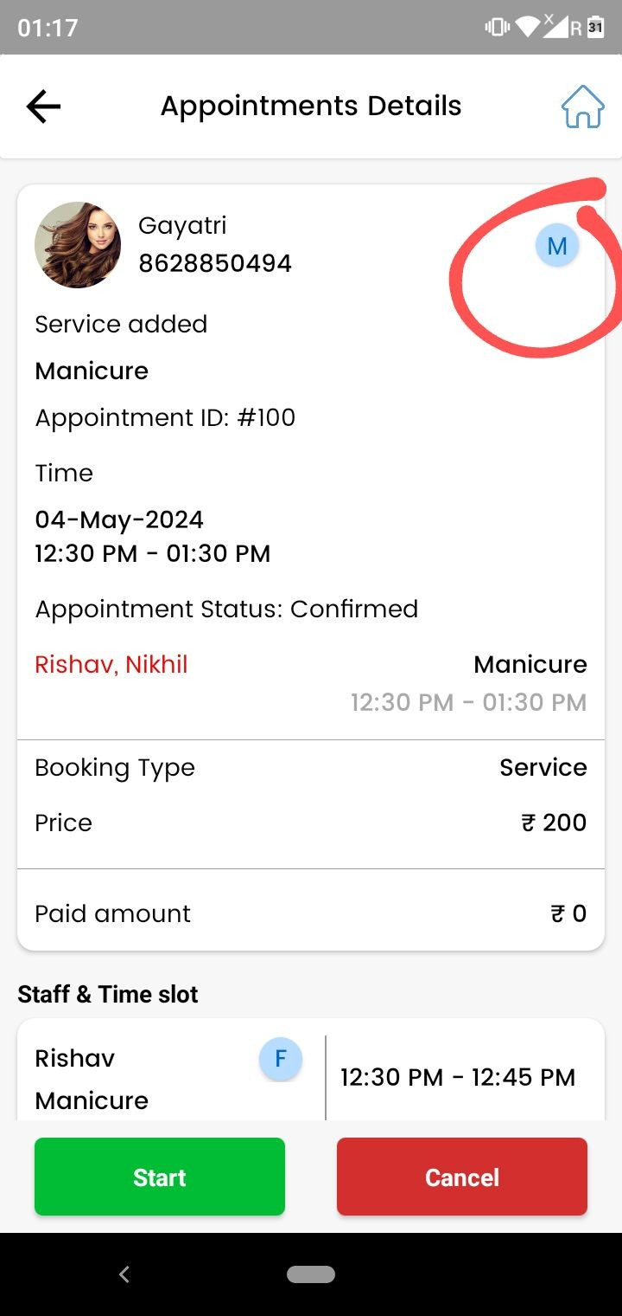

As marked in screenshot appointment ke another wala marked (M) is not working
….. And every other is working properly.

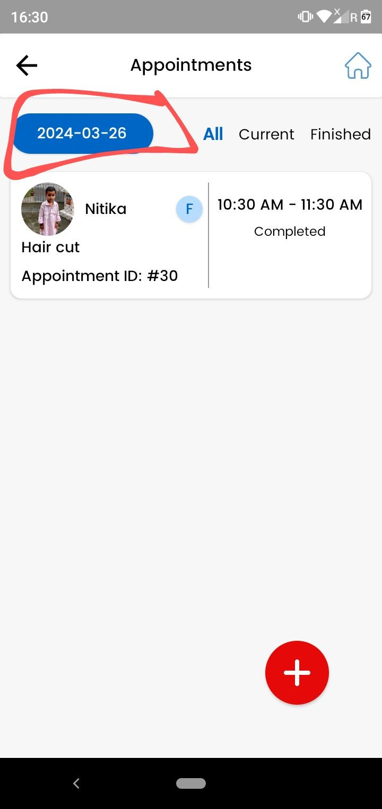

- Jab humm filter mein later pe ( Screenshot ) kisi another date ko select karke, uss date ki bookings pe click kar rahe , and then back kar rahe to uss date ka filter remove ho jaa raha …..Do like this ki jab humm appointment detail page se back karein to jo filter pe jo date selected h wahi rahe.

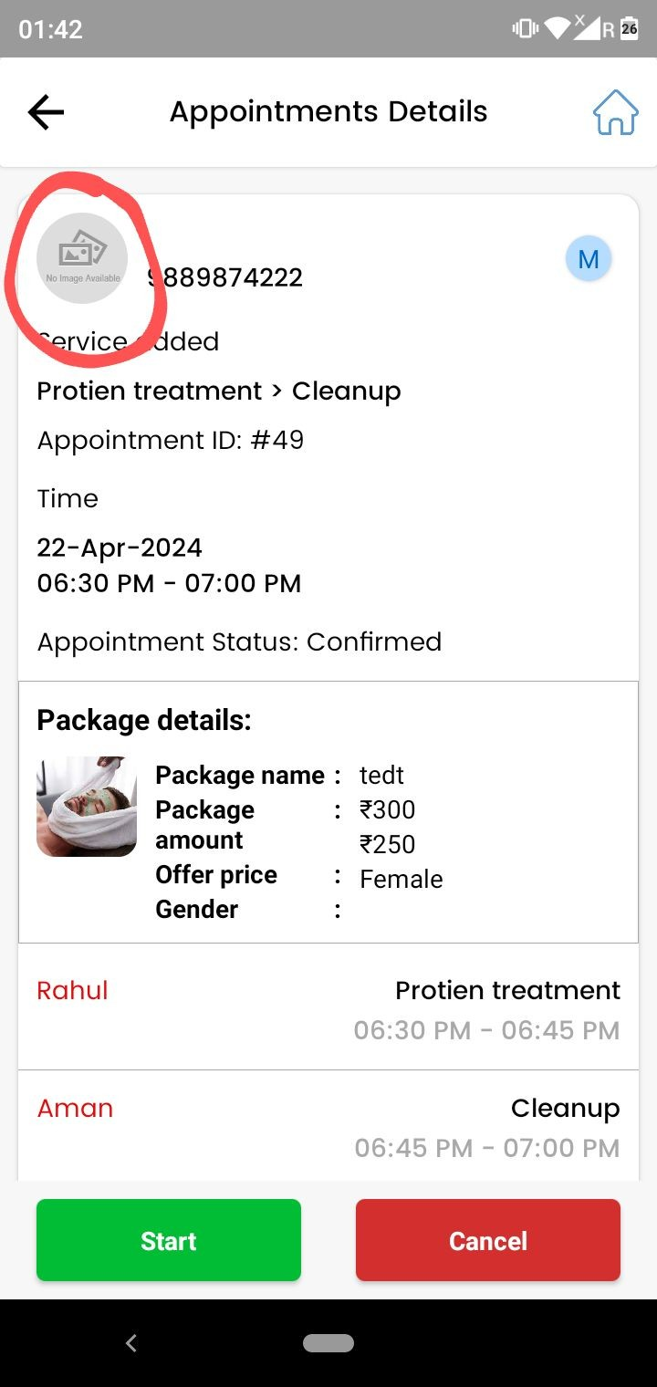

As marked jab kisi user ne profile image nahi daali hogi tab vendor app pe appointment ke andhar profile icon dikhegaa… jo user app mein hai wo waala.

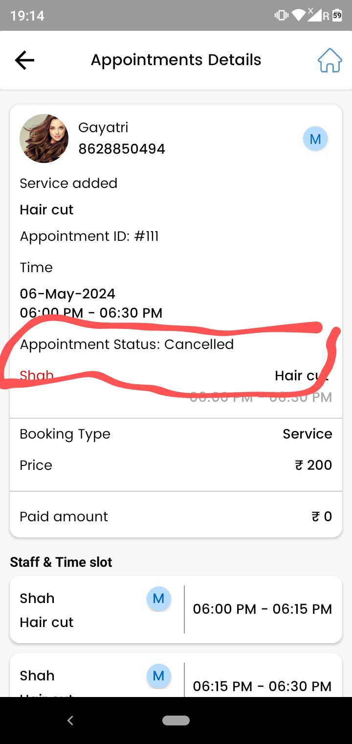

Jab booking cancel hogi tab humm vendor app pe cancellation time bhi show karenge…. For refund enquiry ke liye

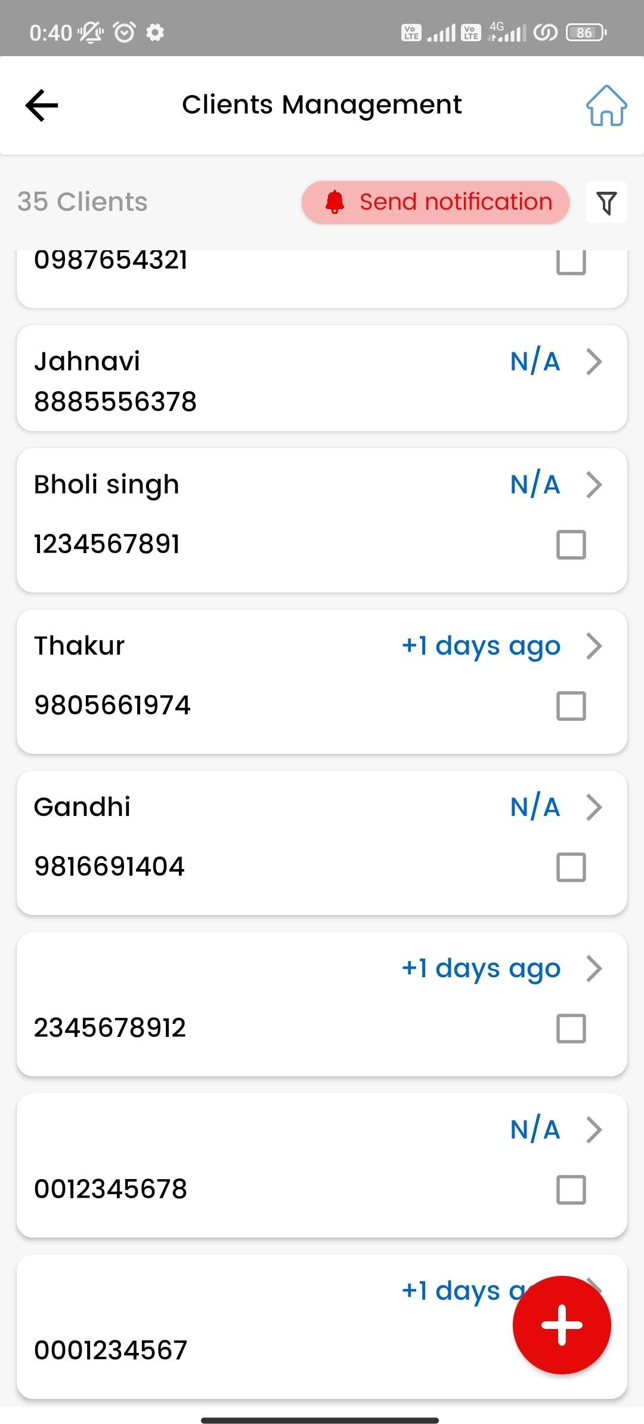

Client management
Jab guest user kisi salon mein booking le raha tab uski details client management pe nahi show kar rahi…
Make like this - Guest user ki details client management mein ….uski booking jab vendor side se complete hogi tab dikhaai degi.

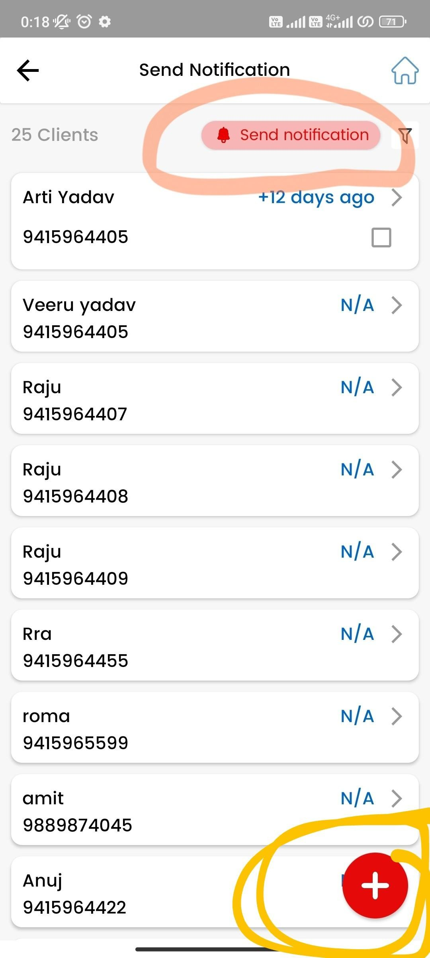
As marked in screenshot- Send notification
- Send notification for all clients is not working…internal server error aara.

- In send notification remove plus button
…issme client add karne ka page open ho raha.

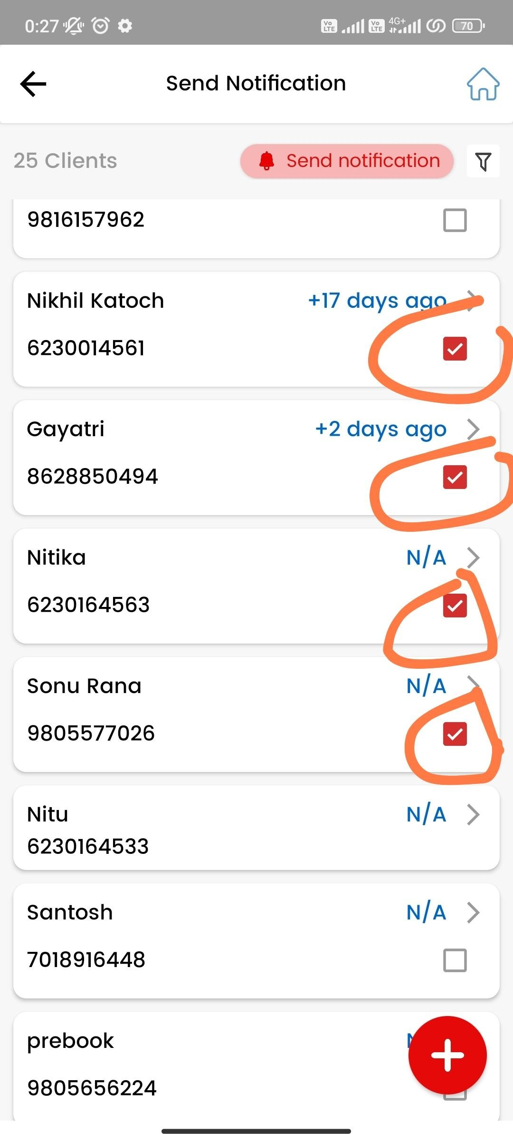
As marked send particular is not working

  - Jab humm client boxes select karne ke baad upside ki taraf scroll kar rahe to selection automaticallly remove ho jaa rahi…..

  - And send notification for selected client is also not working. Internal Server error aa raha

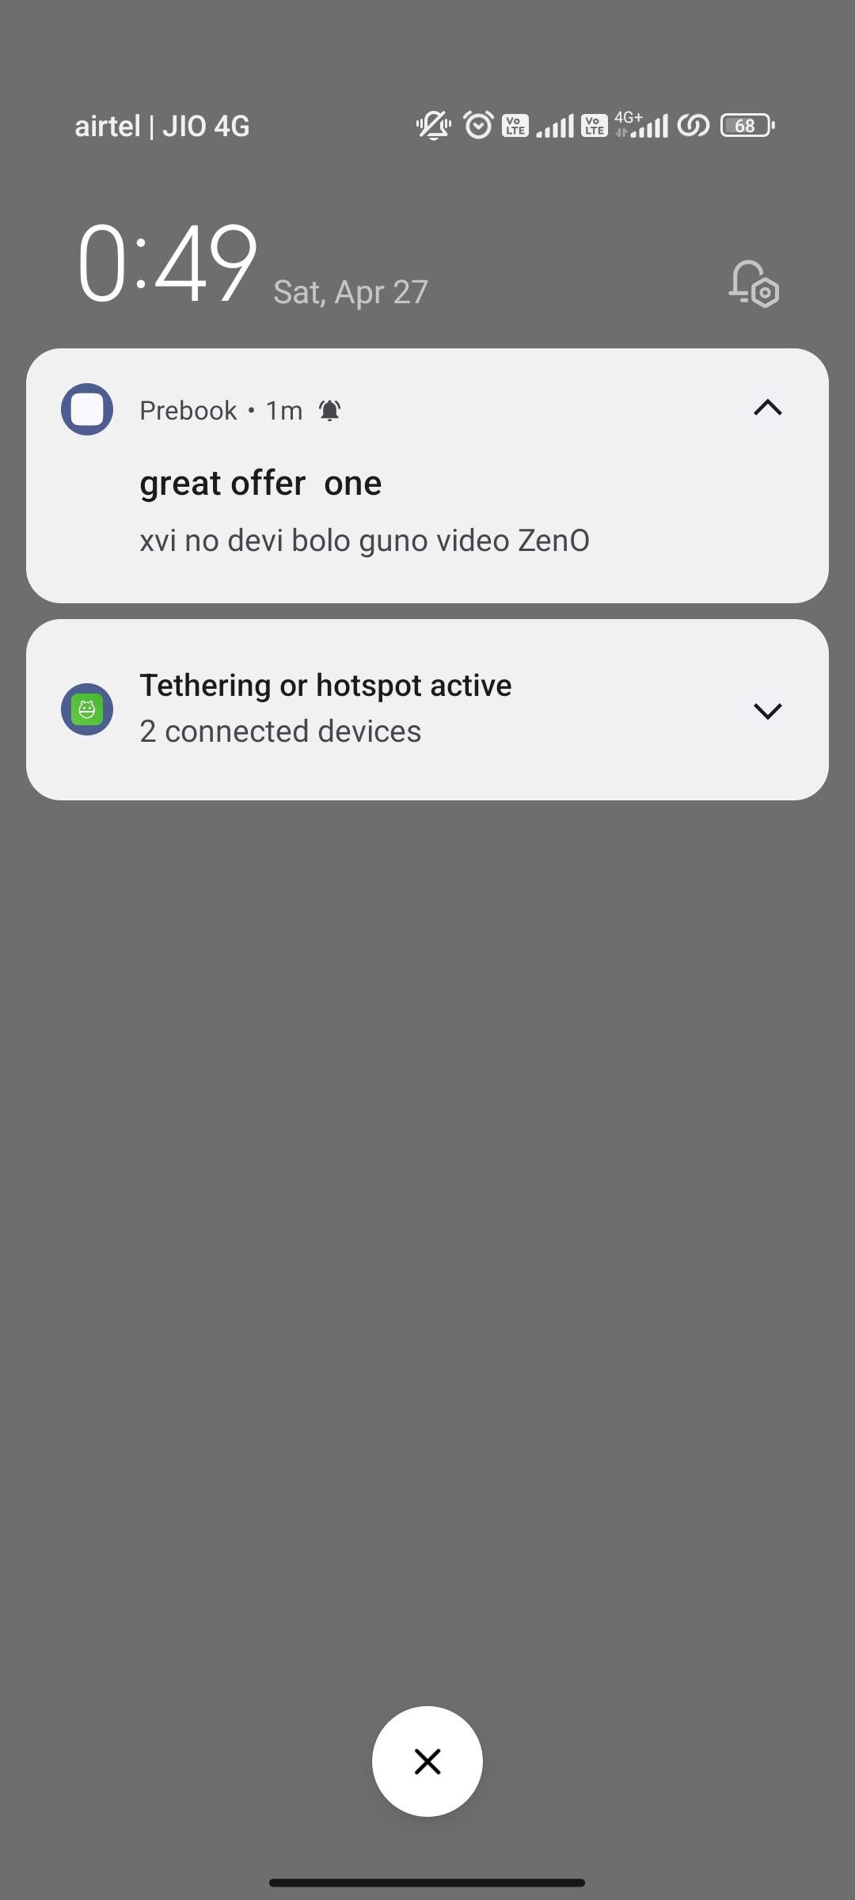Offers Send notification

- Jab Offers ki notification send kar rahe to offer image saath mein shoot nahi ho rahi app pe .. As shown in screenshot

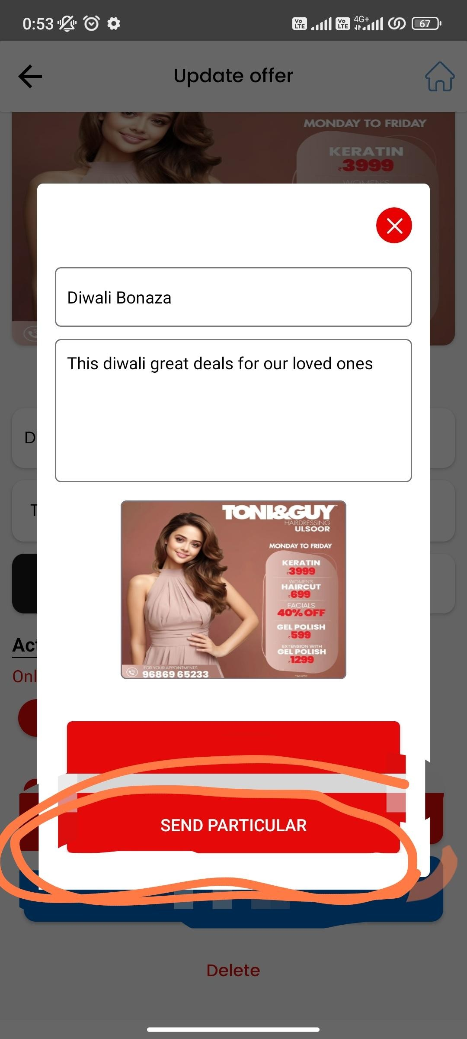

Offers Send notification

  - As marked send particular is not working
Jab humm client boxes select karne ke baad upside ki taraf scroll kar rahe to selection automaticallly remove ho jaa rahi…..
And send notification for selected client is also not working. Internal Server error aa raha

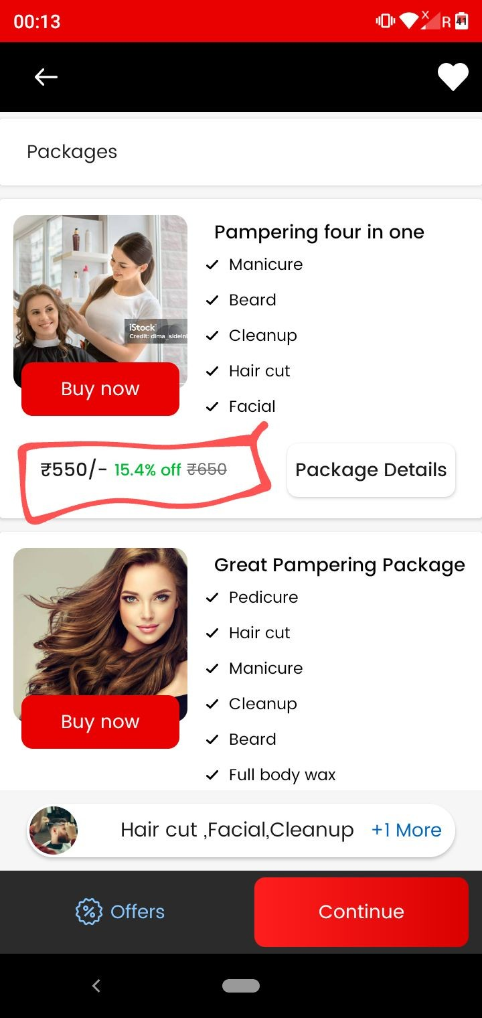
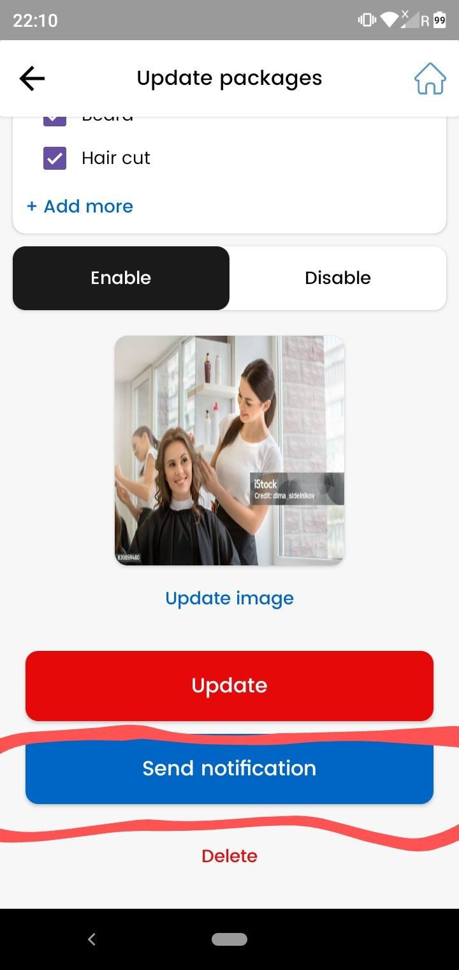
Package send notification

Package notification mein humm package name and price ko shoot karwaa kar dete…..
And jab notification pe click karegaa user tab package wala page open karwaa dete.

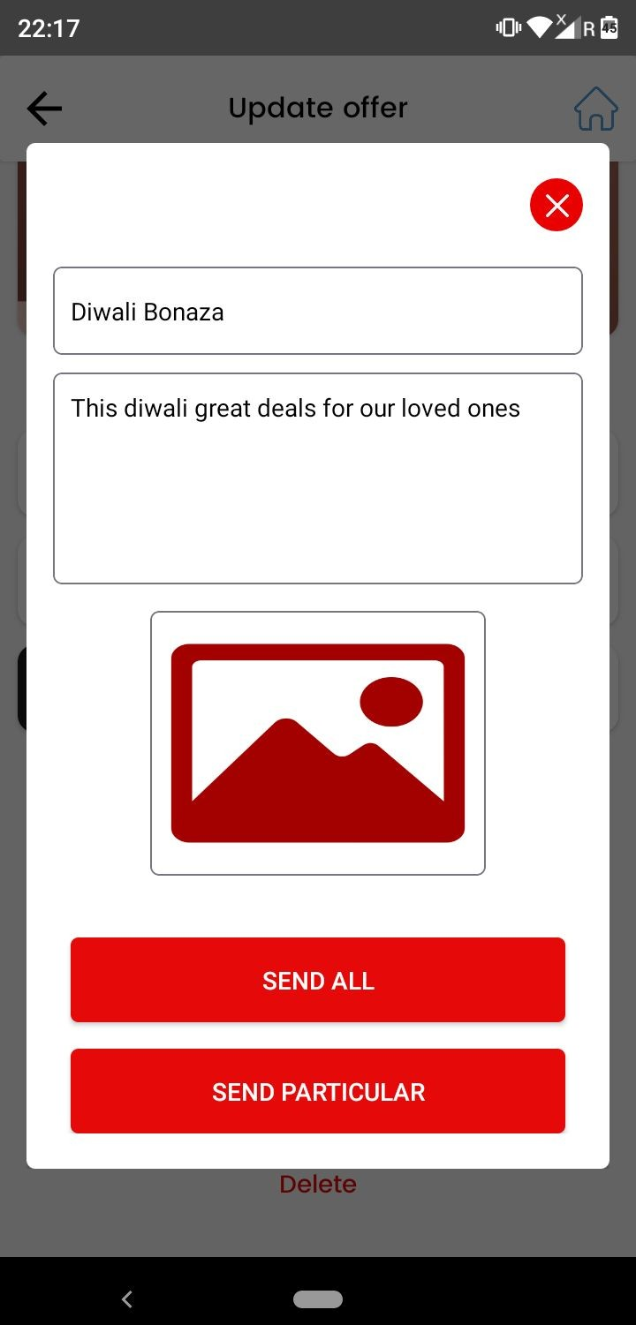
Offer/Package notification
  - (package and offer se send all kar rahe to sabhi vendor ke user ko notification chali jaa rahi…. That is all users of Prebook getting notification
Make like this sirf particular vendor ke sabhi client ko notification jaani chaiye send all pe….

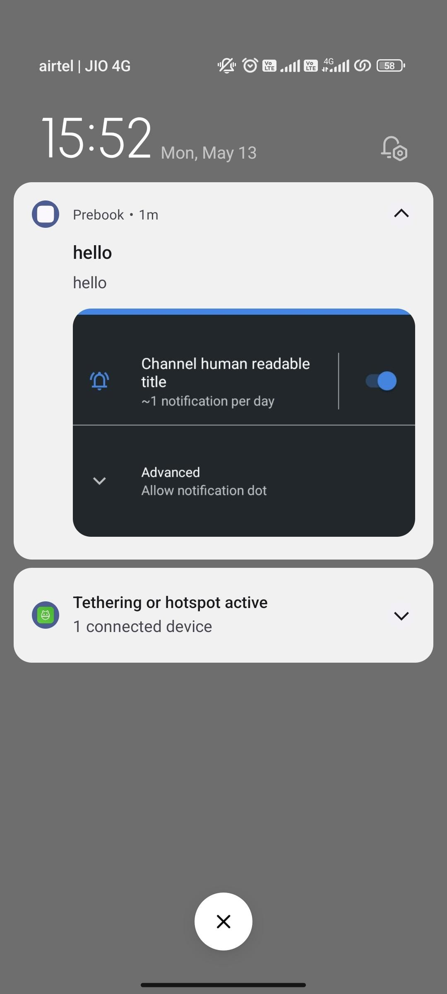
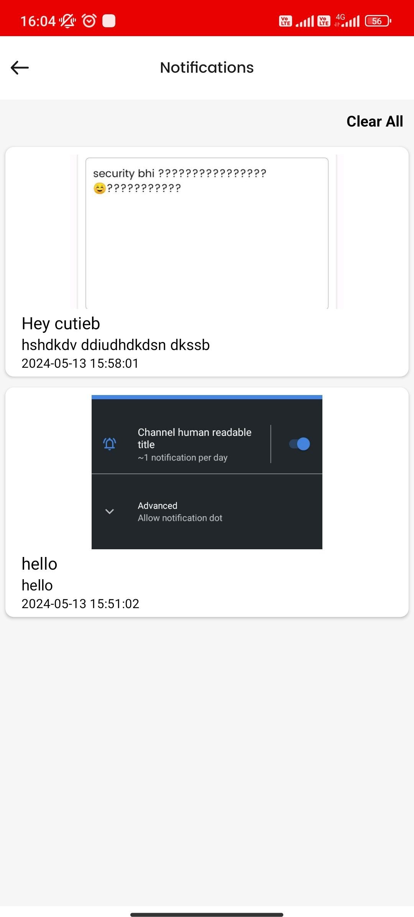
Notification Flow
  - As discussed with Vijay sir jo bhi notification user app Prebook pe jaayegi wo with salon name jaayegi… salon name ko bhi screenshot one and two mein lgaao

  - Jo notification prebook user app pe aa rahi tab phone vibration call ki tarah jaa rahi….. Iski vibration whatsapp and instagram chat ki tarah kar do
⇒> Checked in 3-4 devices sabhi mein call ki tarah aa rahi…. And other apps in my mobile notify like chat only.

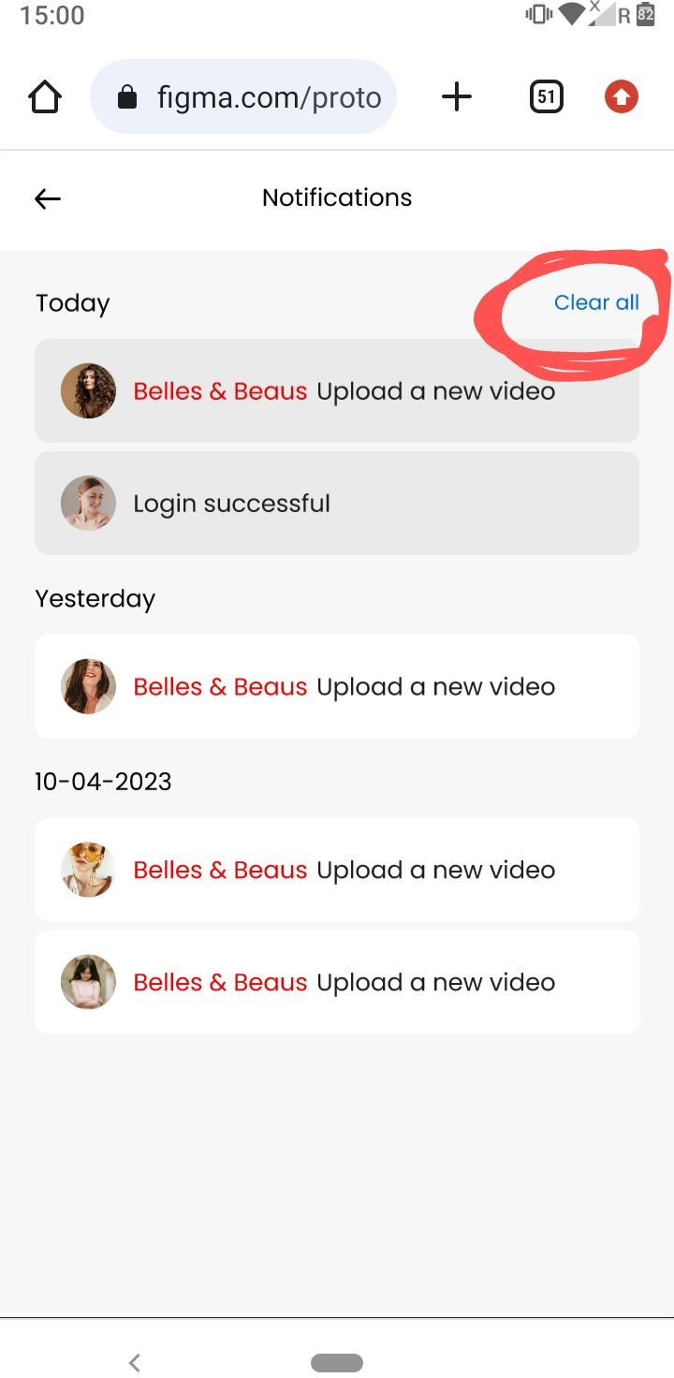

Vendor app notifications
  - Vendor app pe bhi Clear all ka bhi button add kar do issme. As marked in screenshot two…...
And blue color mein rakhna isse.

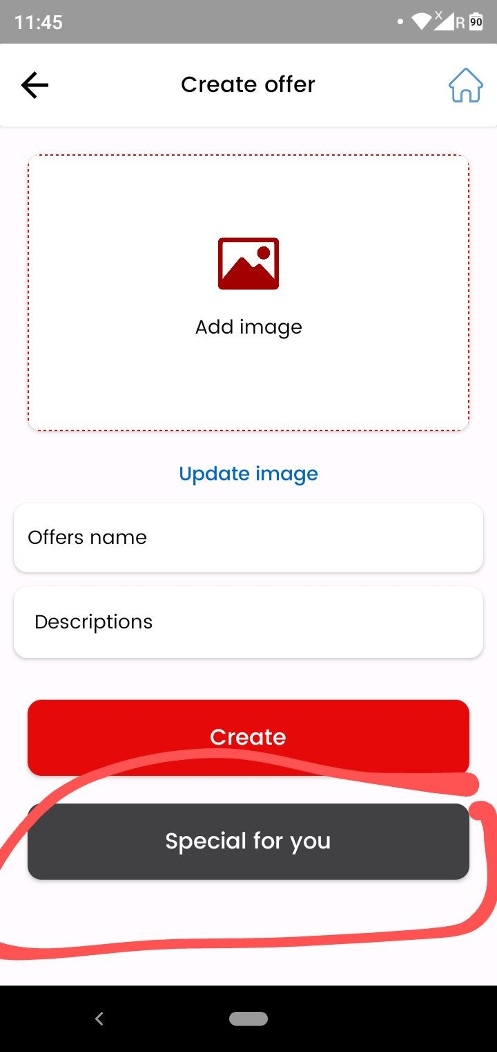

As marked remove the (special for you) while creating the offer

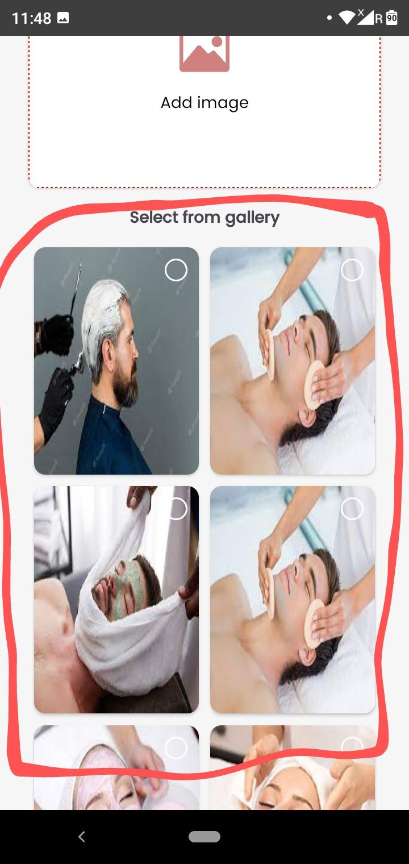
Vendor app
services and packages gallery
As shown in screenshot ye jo gallery hai issme bhi images add karne ka option de do admin pe….jahan pe images upload ho and reflects in vendor app.

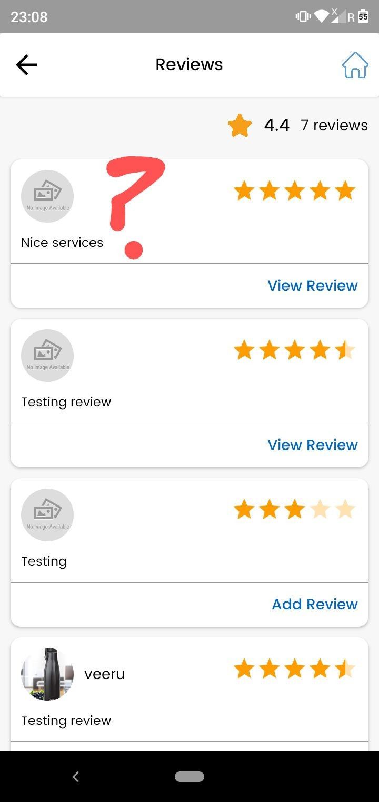
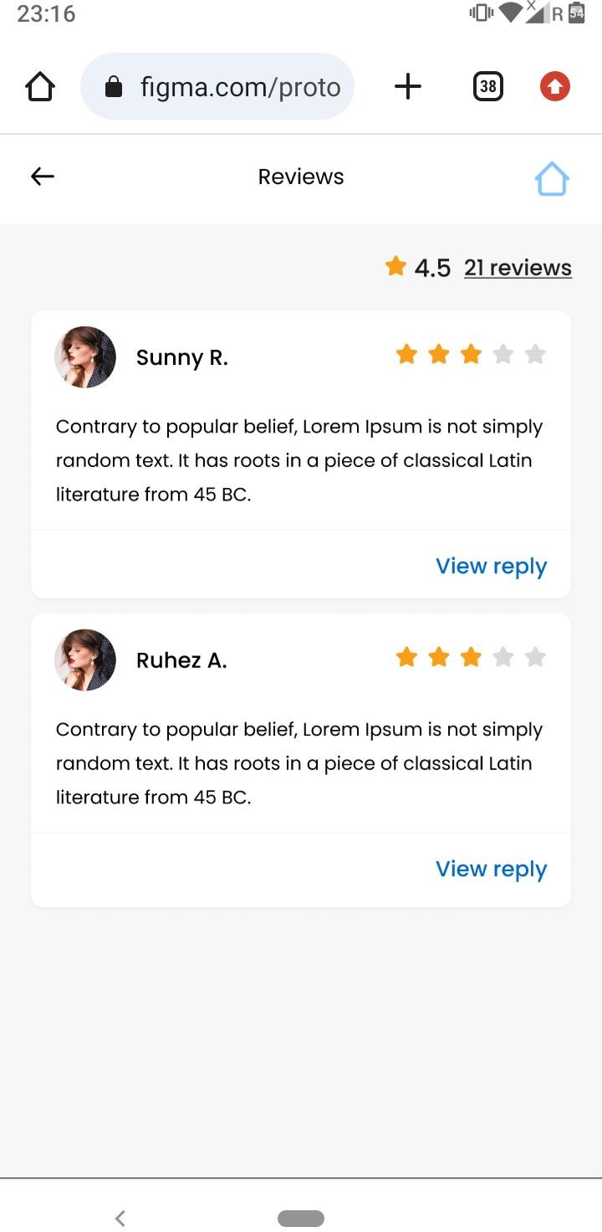

Reviews - Vendor app
- Reviews pe user name , user image nahi show ho rahi … show this as done in design. Vendor app

- Emojis add nahi ho rahe within chat also.. in vendor app

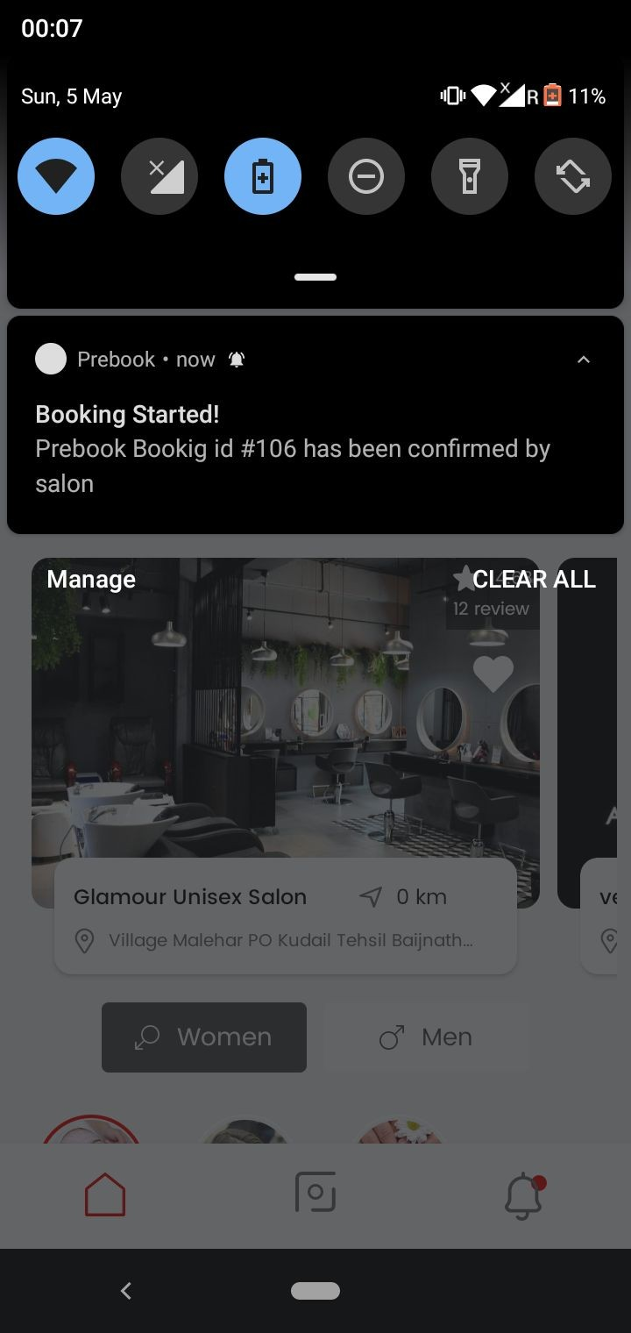

Jab booking vendor start karegaa
As shown in screenshot replace
(Prebook booking id #102 has been confirmed by salon) to (Prebook booking id #106 has started.)

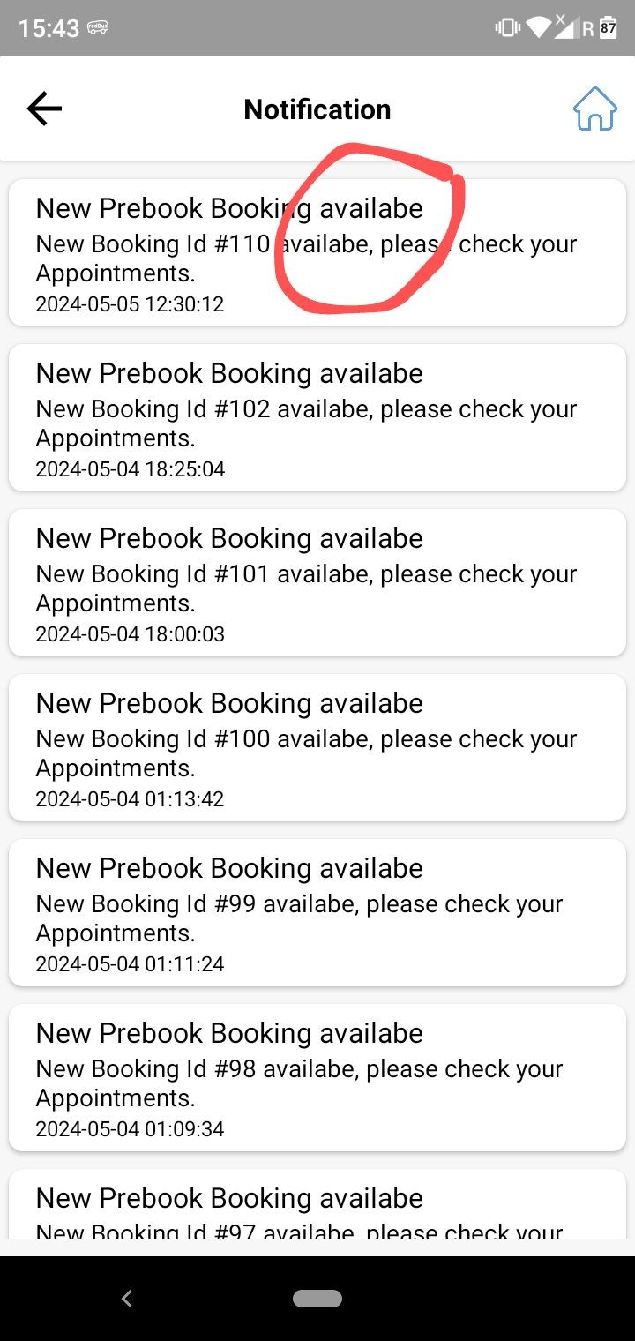

Vendor app notification
As marked in screenshot correct the spelling of available.

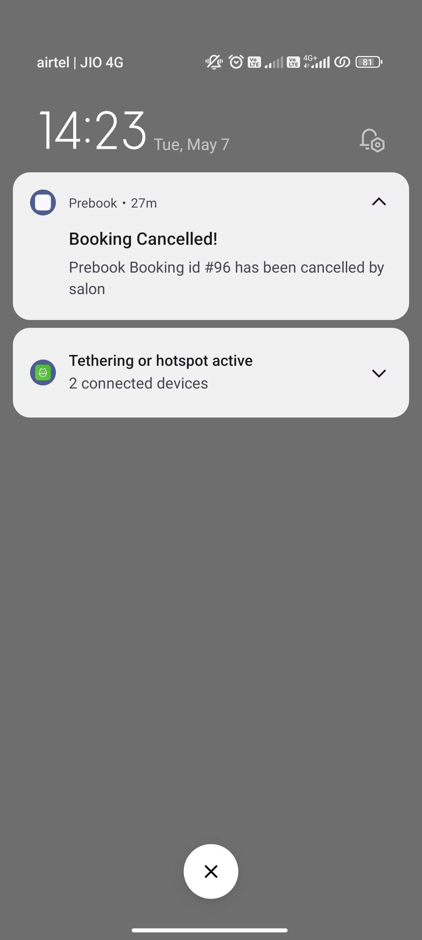

Jab user booking cancel kar raha
Replace (Prebook booking id #96 has been cancelled by salon) to (Prebook booking id has been cancelled)

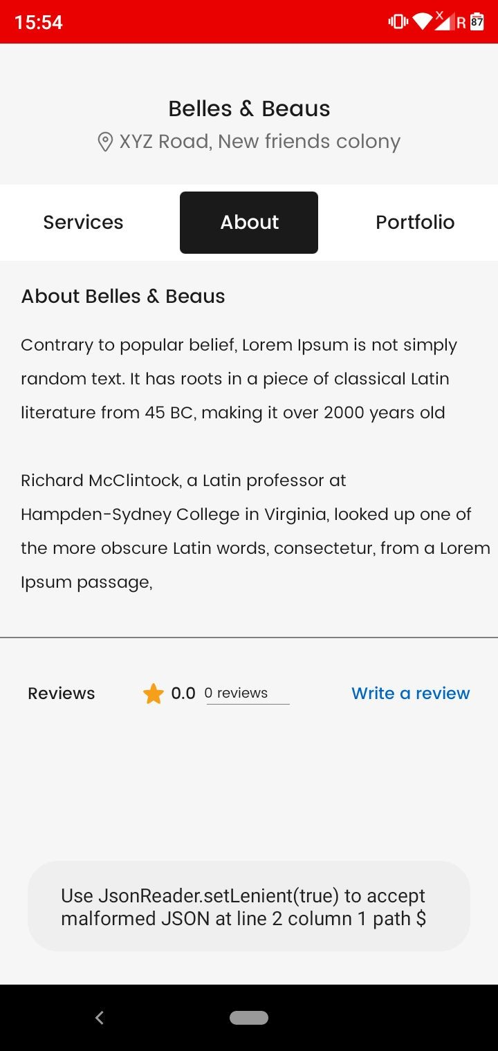

As shown in screenshot ( About and Reviews ) section is not working in Veer1 salon.

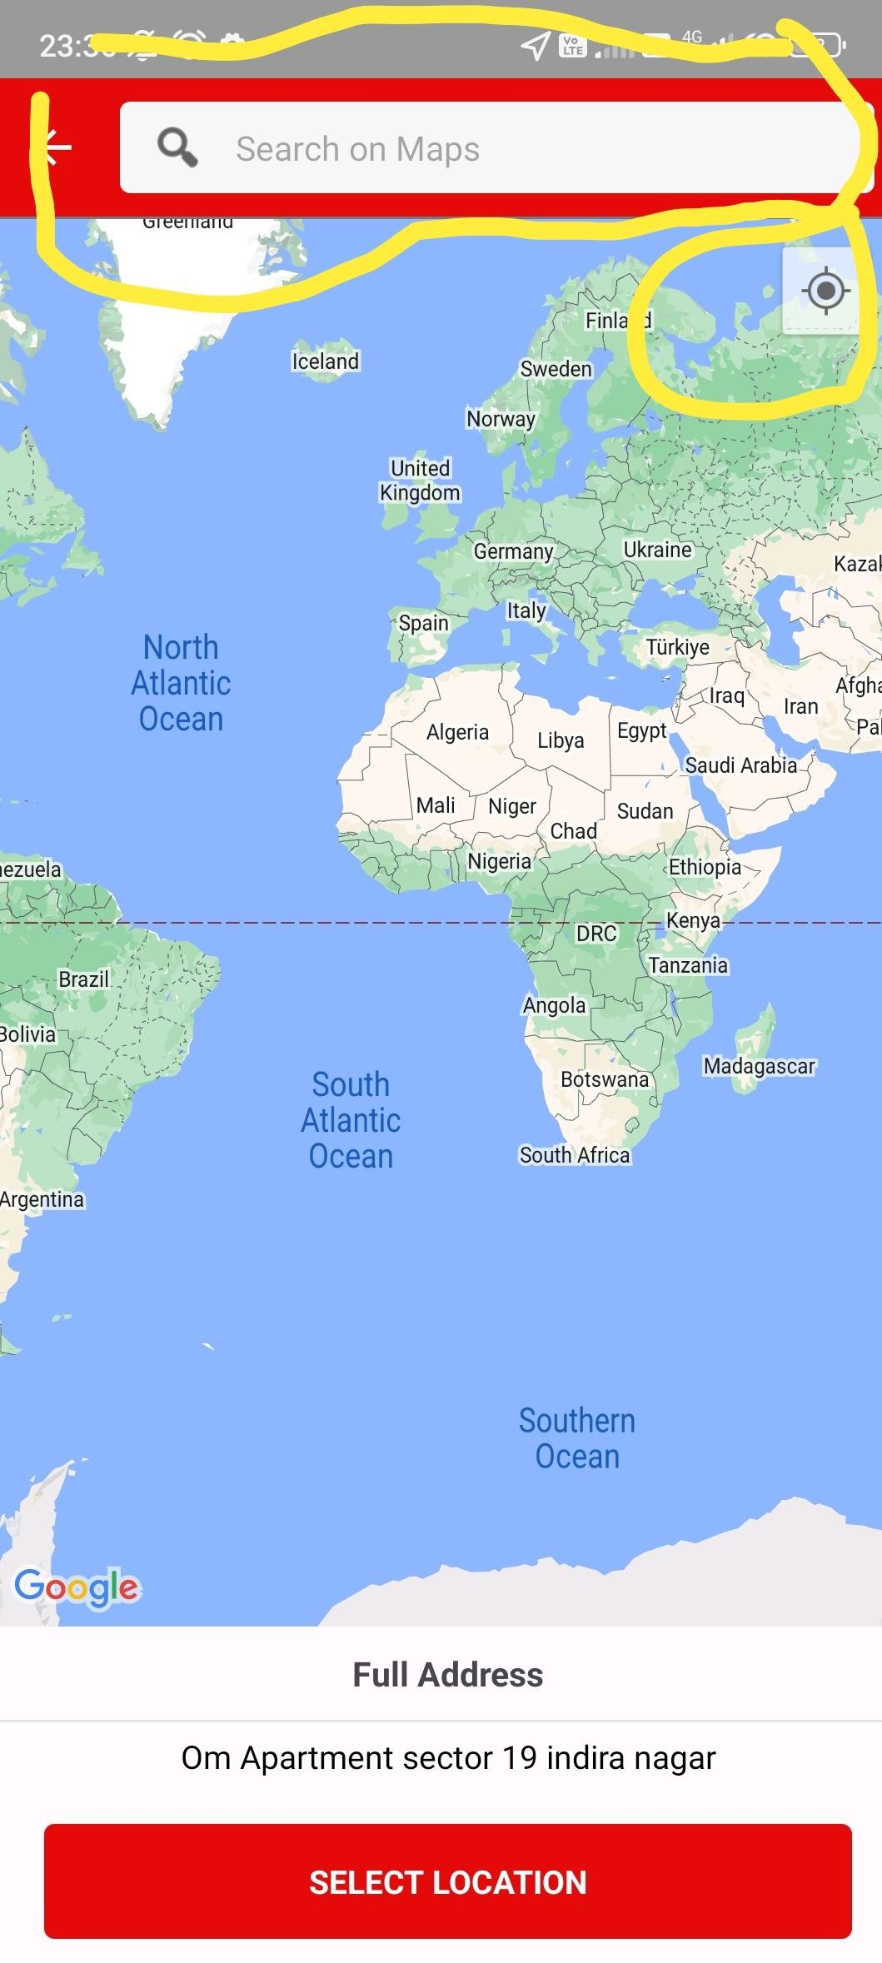
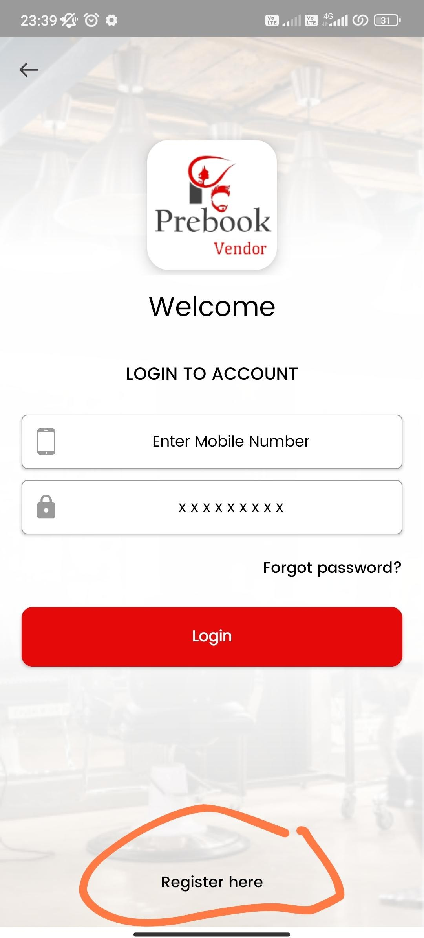

Vendor app -Register here

As marked in screenshot two both (Search on maps and current location )is not working properly .

Location selection mein issue aa raha

MANAGEMENT SYSTEM

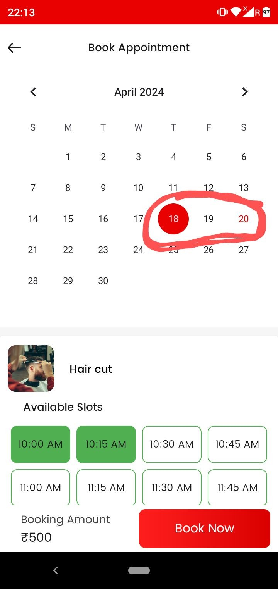
Staff management
  - Jiss bhi service ke saath staff link nahi hogaa wo service user app pe nahi dikhaai degi….

  - As marked in screenshot previous date select kar rahe to uss date ka bhi slot dikhaai de raha… previous passed dates ke slots nahi show karne chahiye.

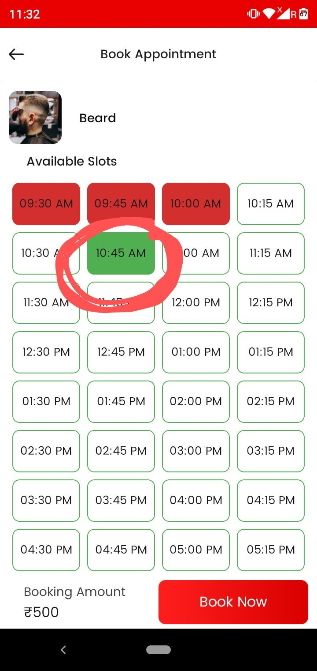

As shown in screenshot jab humm (10.45AM) ka slot select kar rahe …. To booking previous available slot pe place ho jaa rahi…. That is of (10.15 am) slot….. …. Jo slot select kiya hai ussi mein booking place honi chaiye.

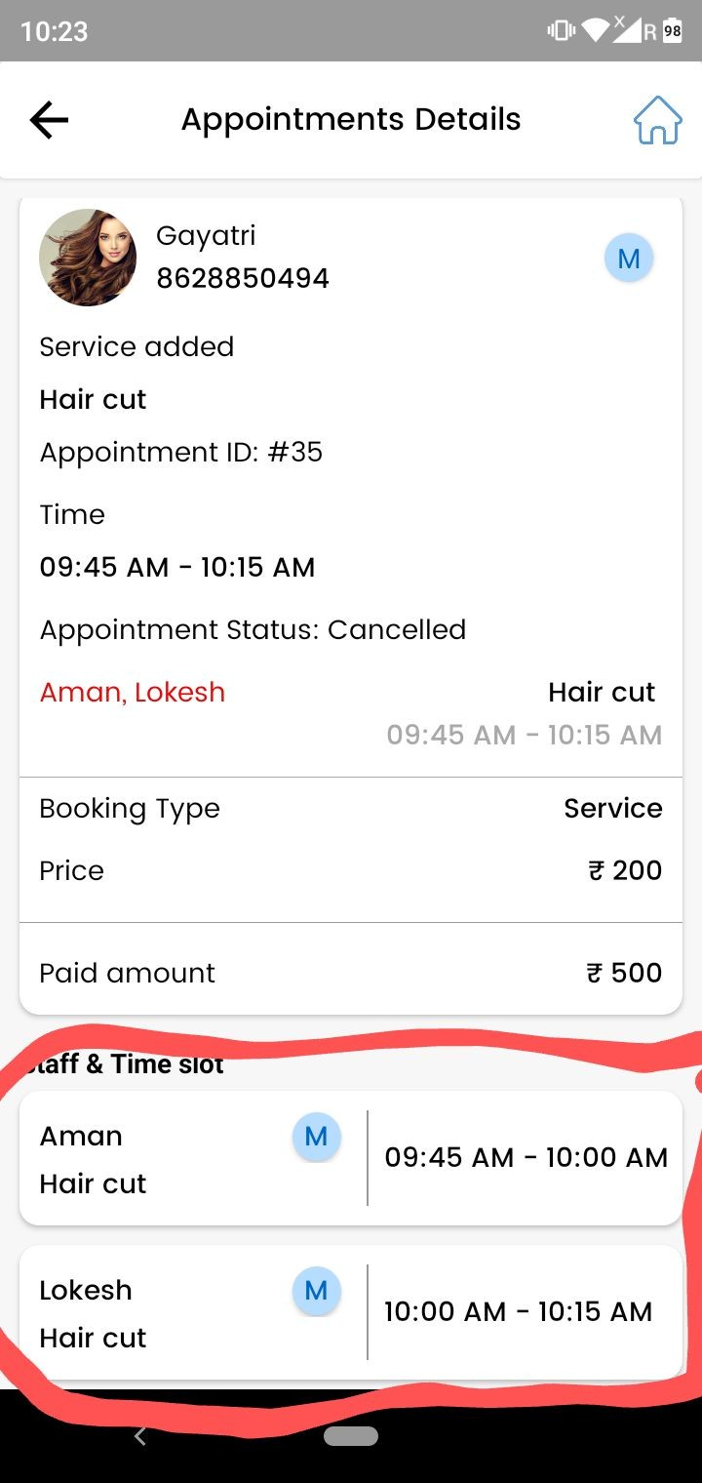
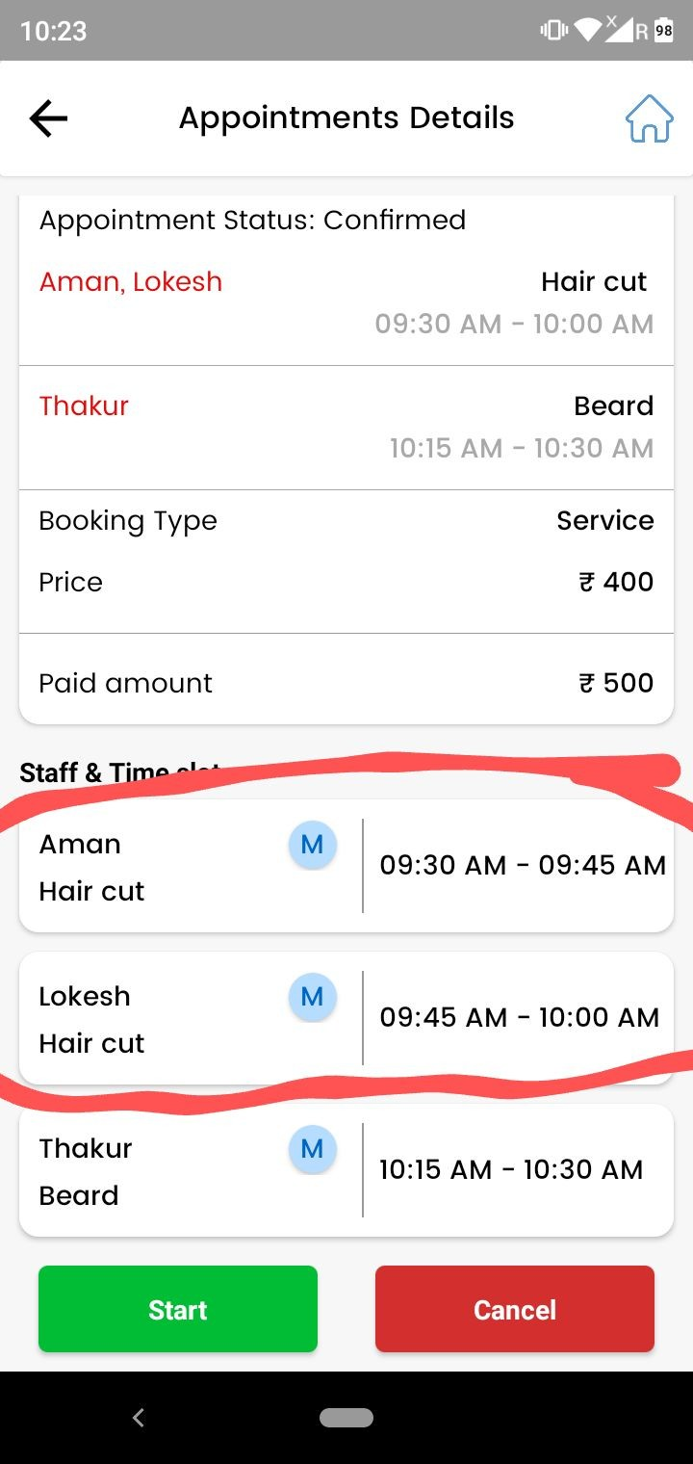

As marked in screenshot one and two
Issme particular ek service ke liye two different staff assign ho jaa rahe ….that is not possible….. Ek service pe ek hi staff assign hona chaiye.

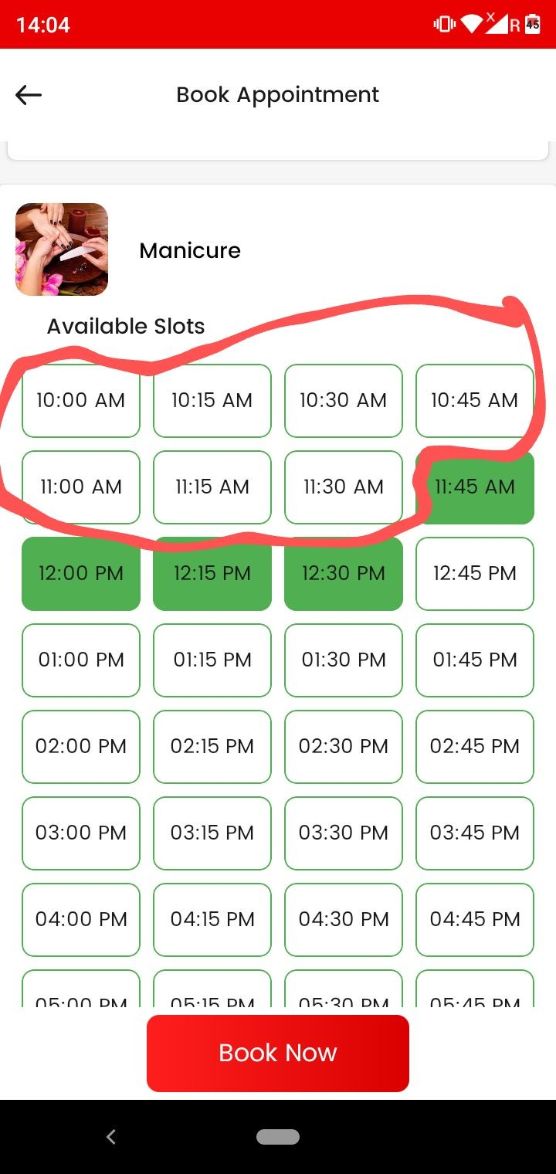

As marked in screenshot
Inn slots pe multiple staff members ki availability hai…butt firr bhi slots select nahi ho rahe…. Automatically aage waale choose kar le raa and slot boxes khaali dikh rahe.

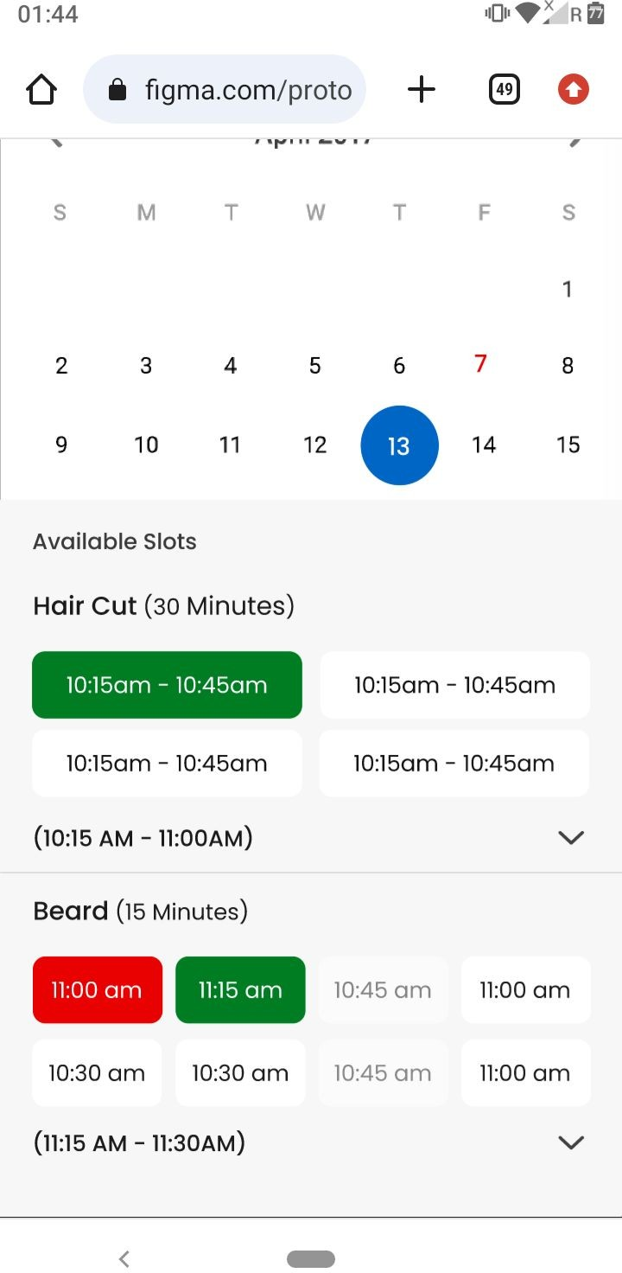
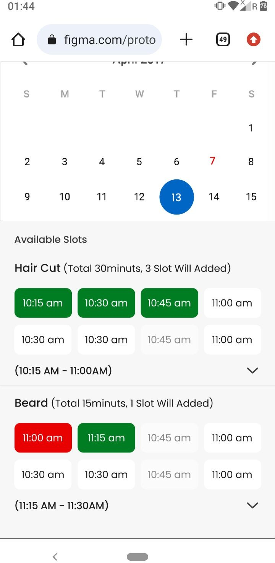
User app slots presentation
- As shown in first screenshot
…kya aisa possible hai slots ko present karna….If it is possible to humm user experience more smooth kar sakte hai. ( First priority) waise ho sakta hai sir aisa kindly see if we make it happen

- If above the case is not possible to isse screenshot two ki tarah kar do..same

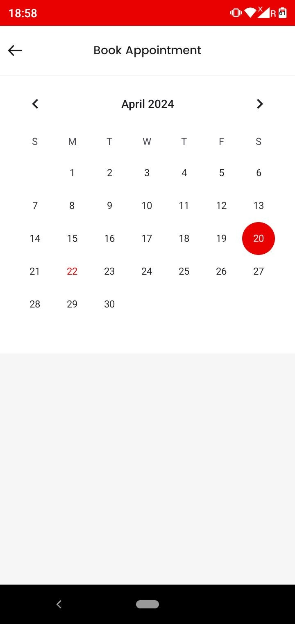
Make like this - As marked in screenshot jab salon holiday pe hai tub humm message drop karenge

“Sorry! We are closed on your selected date”.

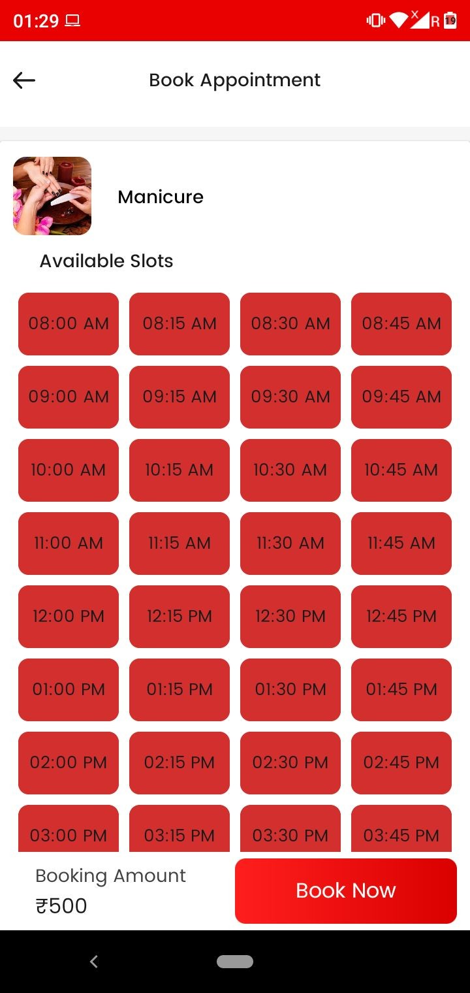
As shown in screenshot When staff is on holiday for a service message shows -

“Unfortunately, there are no available slots”.
Note - Please consider booking available and non-available services separately, Or adjust your selection entirely.

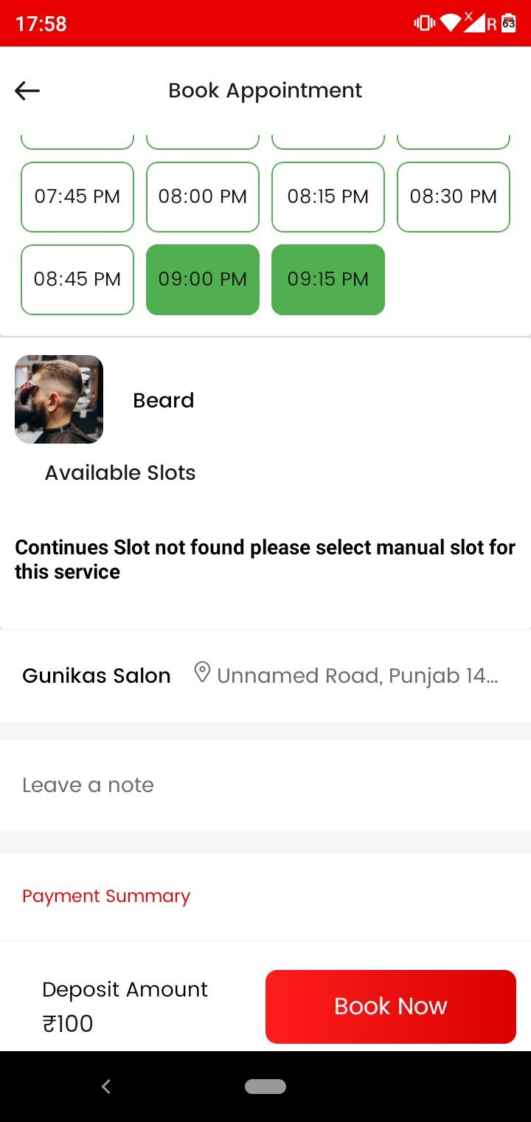As shown in screenshot
jab ek service ke slots available hai but next service ke nahi hai then message show
“Unfortunately, there are no available slots”.
Note - Please consider booking available and non-available services separately, Or adjust your selection entirely.

Jab sabhi selected services ke slots available nahi hai tab message show hoga
“No slots Available” Kindly change the selected date”.

Jab salon Time slots ka period khatam ho gaya ho tab humm
message show karenge

“No slots Available” Kindly change the selected date”.

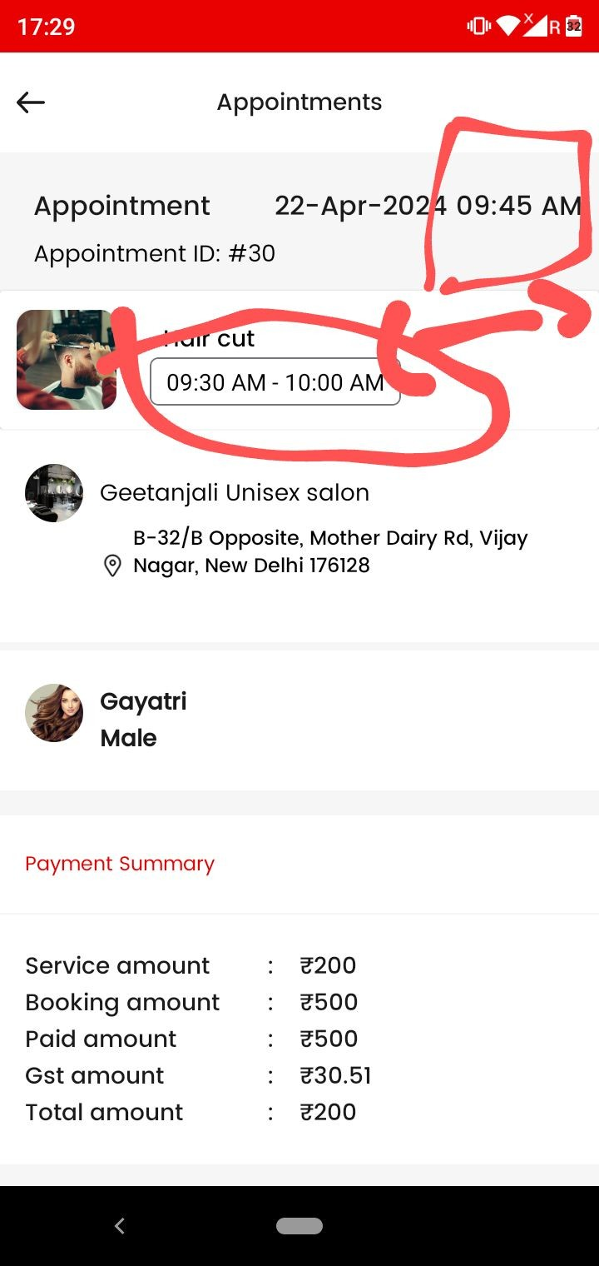
As marked in screenshot

Service start timing and appointment placing time different aara.

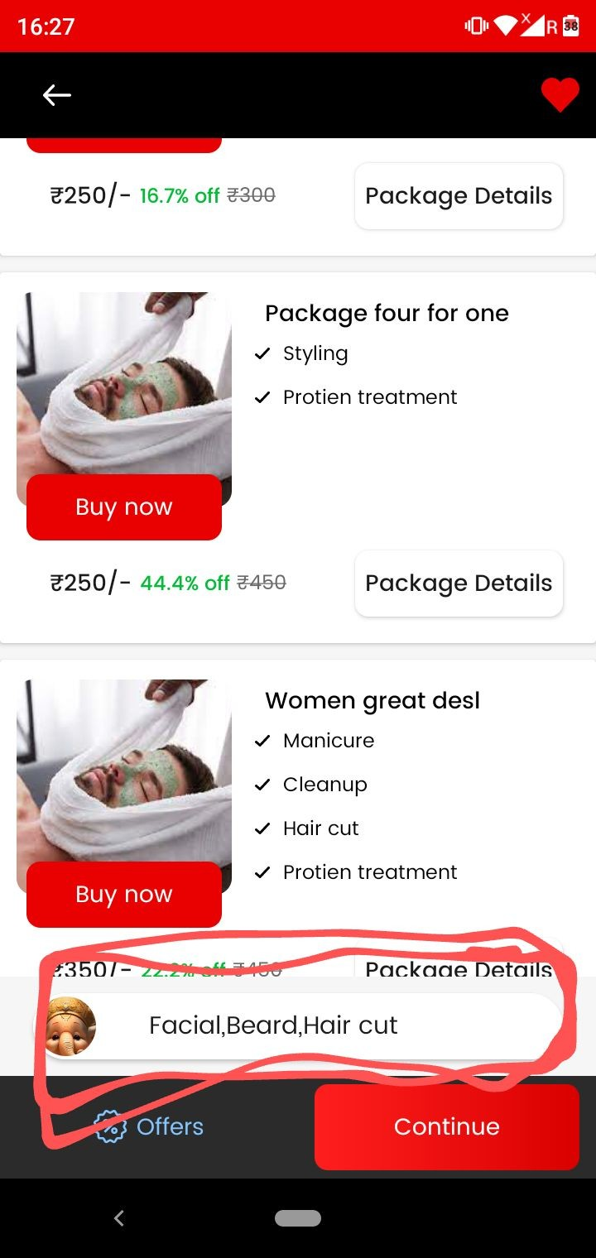

Make like this - Jab humm salon mein services select karne ke baad back home page jaaye…jo bhi services select ki hogi wo remove ho jaaye….
Again user ko services select karne pade

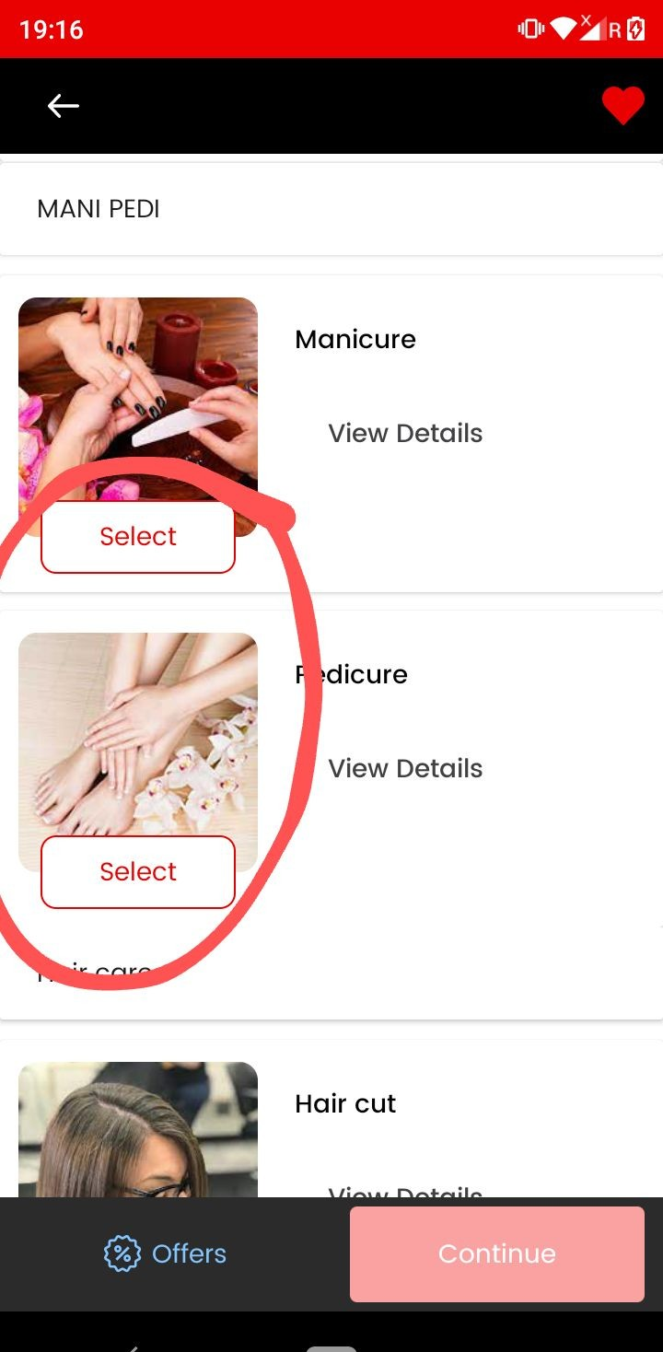

Jab bhi humm single services select kar rahe to
…wo select slow ho rahi
…Services selection and deselection must be fast.

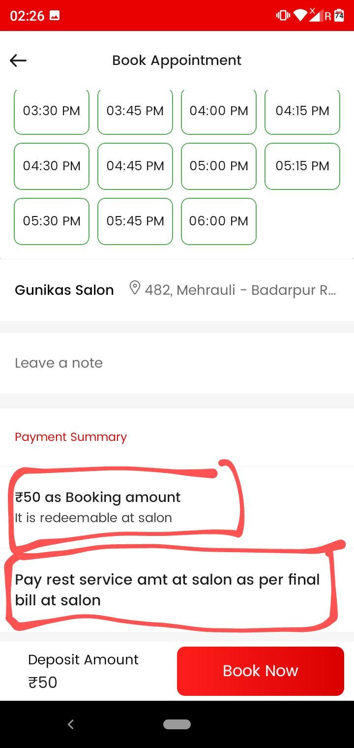Single services case Replace the linked
  - Pay 50rs as security deposit to salon

Note - This is the advance deposit taken by salon and will be adjusted at the time of final billing.

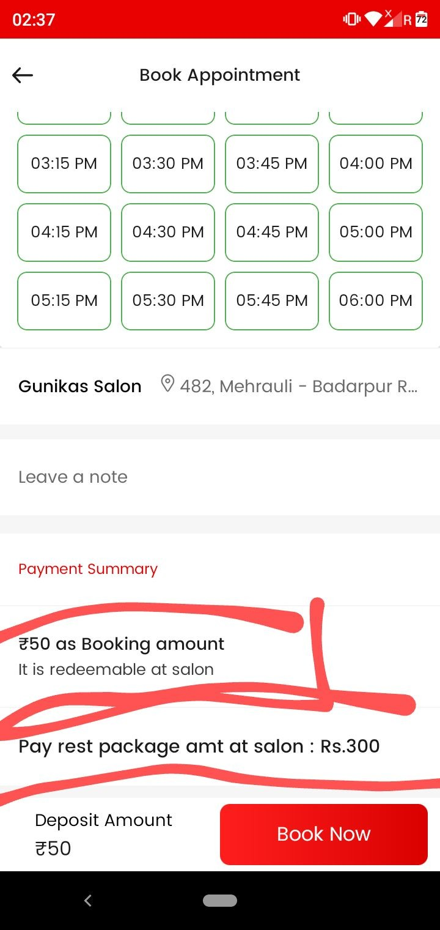

Packages case Replace the linked

    - Pay 50rs as security deposit to salon

    - Remaining ; Rs 300 pay at salon

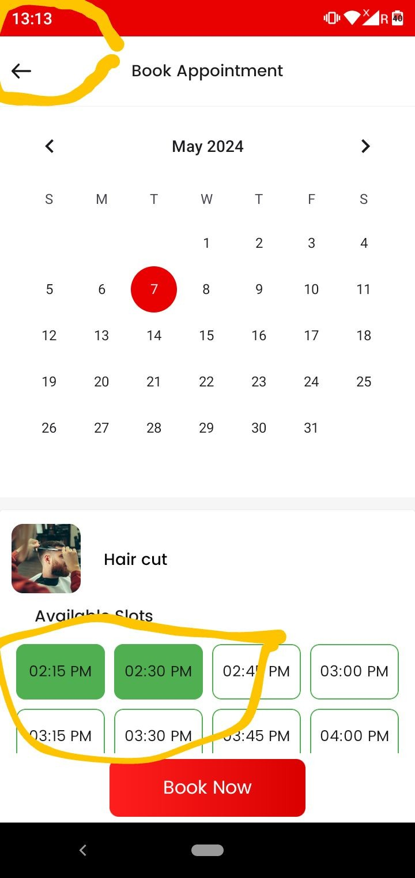

Management system
As marked in screenshot phone time and slots show time ….mein 1hour gap..
That is-
Jo bhi slots show ho rahe user ko….wo uske current time ke 1hour ke baad show ho rahe.
Make like this - Phone time and slots gap ….15 Minutes ka ho

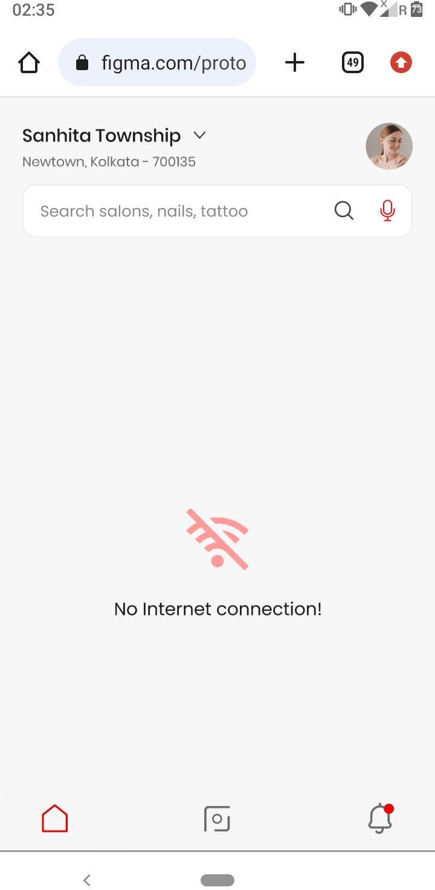
Make like this -Jab no internet connection hogaa

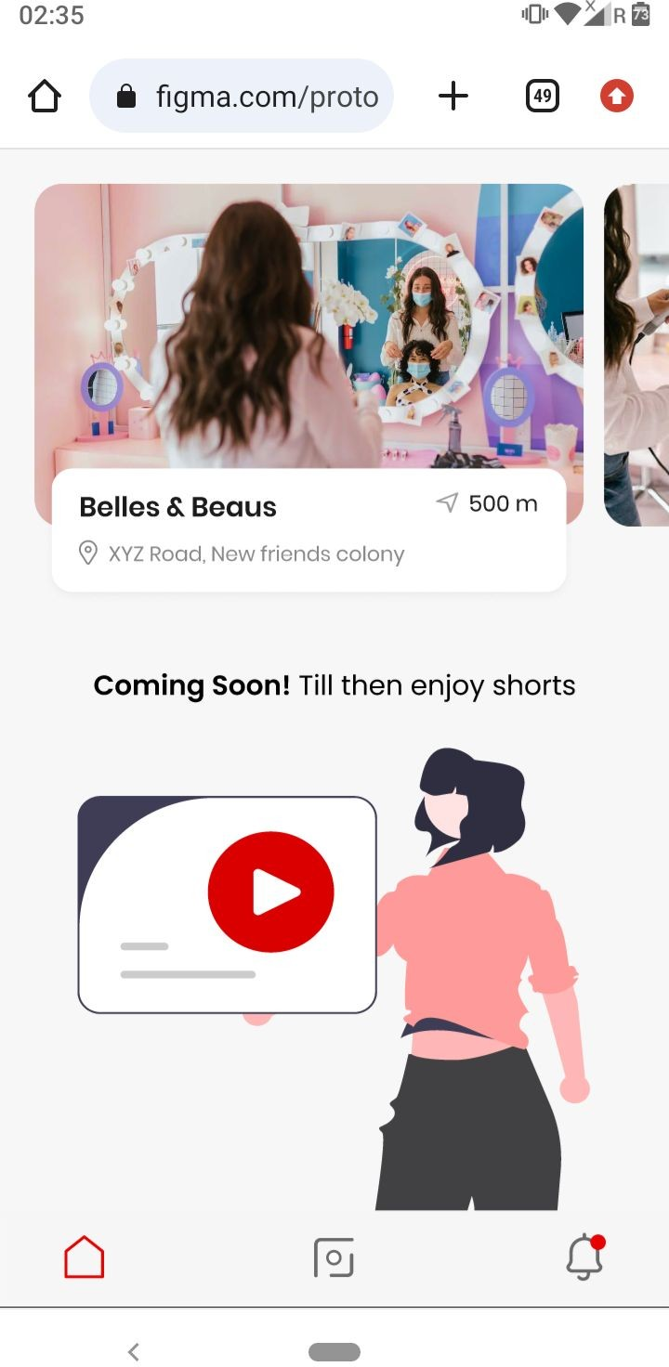

Jab kisi location pe salon list nahi hai waha iss tarah ka message show karegaa

