* **The APP is crashing frequently=>Done**

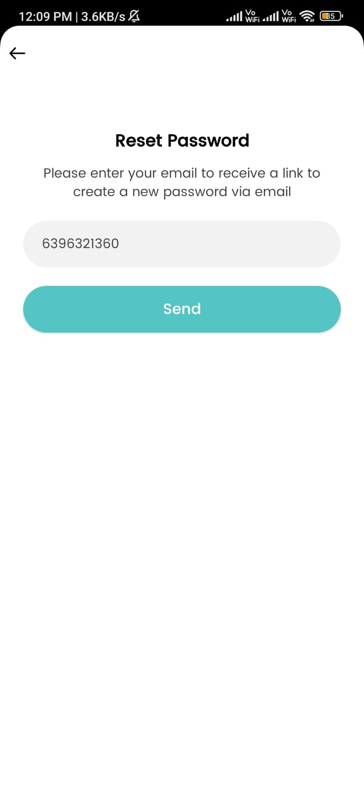

* **The reset password function is not working yet=>Done**

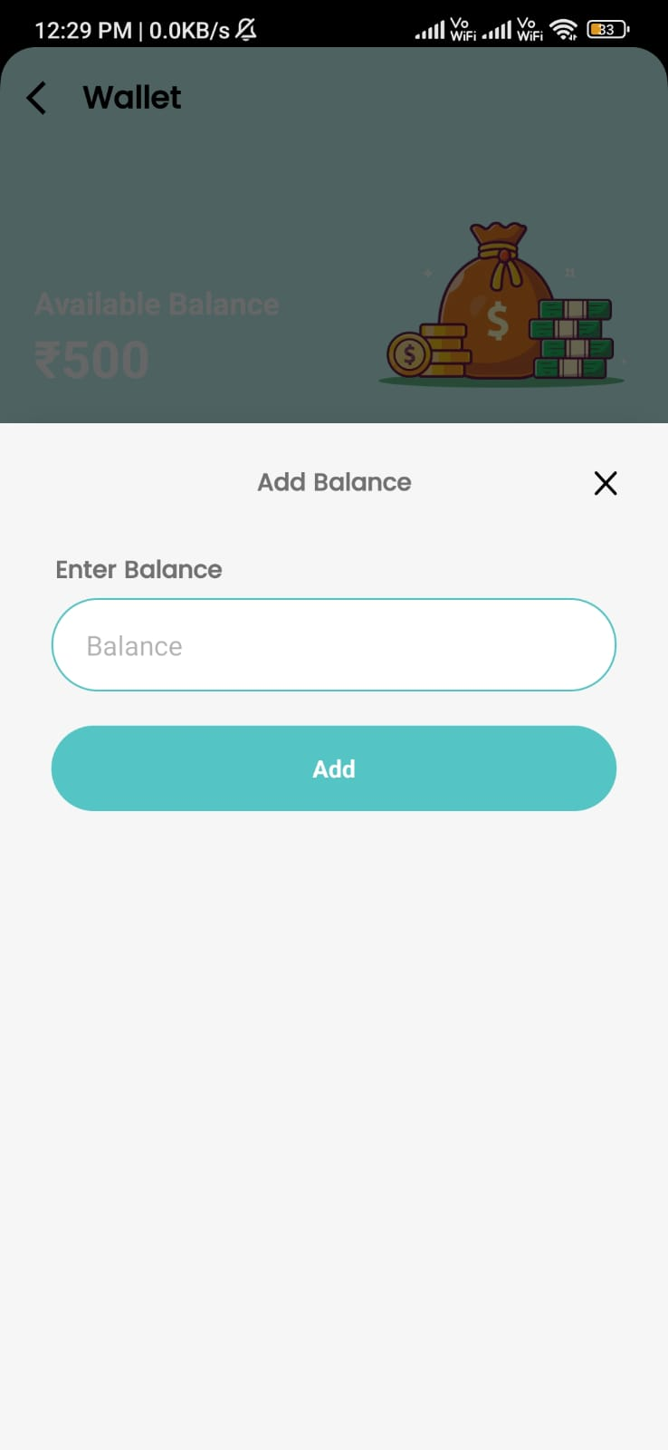

* **In wallet transactions, When the user adds an amount, the amount (Money) is not deducting from the real account yet.**

**=>Done**

* **“Call/add photos/share photos”** no section or option for the customer in the App. =>Photos option out of scope

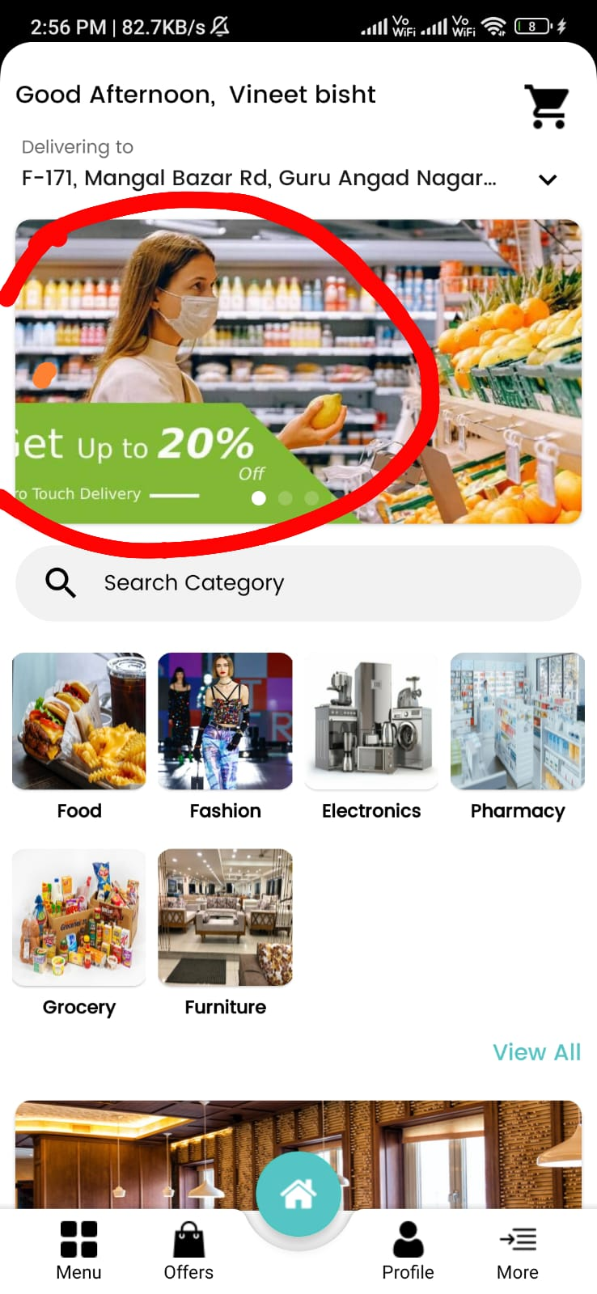

* **The picture is not showing properly which is under the red circle.=Done**

* **“Good Afternoon, Gourav Sharma”**  It should change with time.
* Done

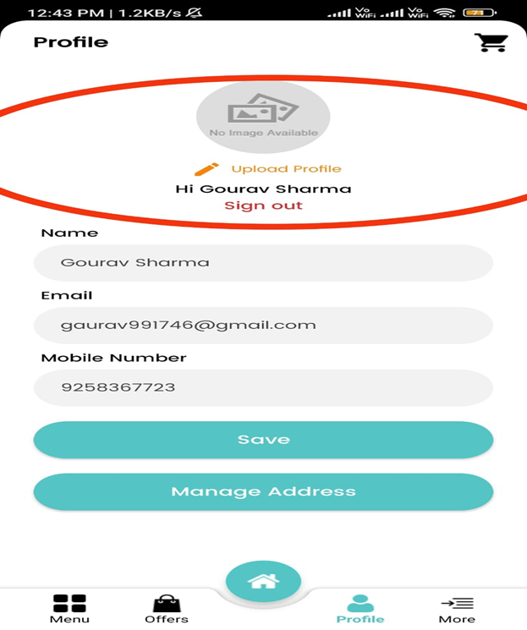

* The text “**Upload Profile**” is not in the center of the Image section.
* Done

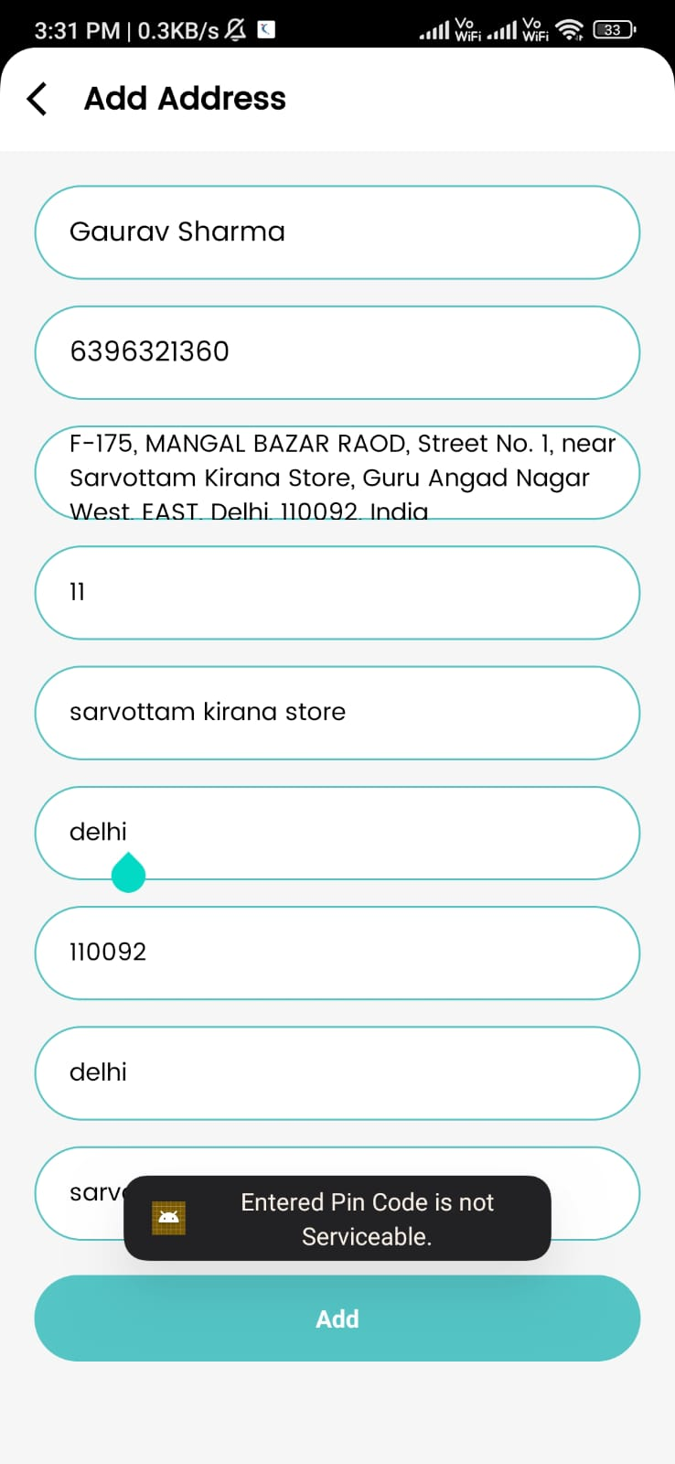

* + - I entered the correct pin code but it is showing that **“Entered Pin Code is not Serviceable”**.=>Done
* **The Application is crashing sometimes automatically and whenever we are shifting or switching in another app and then again switch the fibett it’s automatically crashing.=>Done**
* **“Internet connection is not available, the job was canceled”** the message is popping up most of the time when we are opening the app.
* Done
* **When we go to the “Menu” and search the category, the cursor is going down Like :(Shift+Enter).=>Done**
* **To modify Quantity, the option is not available or not showing up in My Cart.=>Not in scope as per design**